Learning Places Spring 2017

Development and Preservation

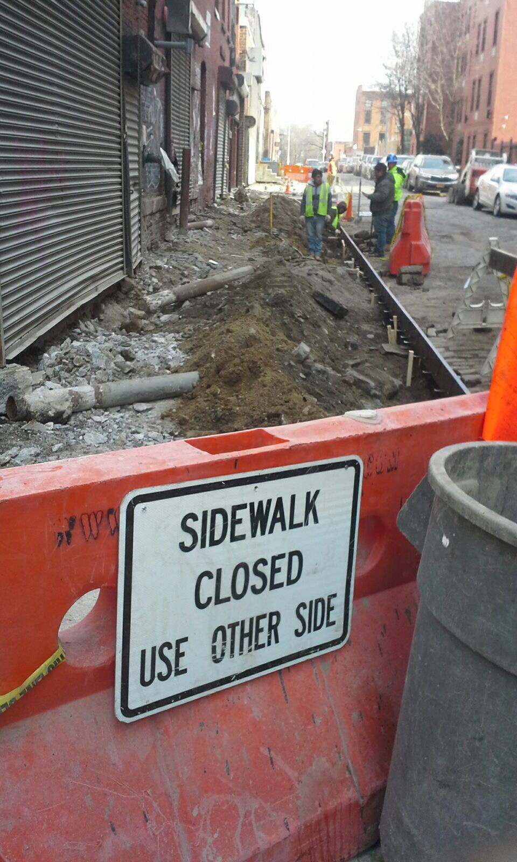

Stacey Battice
27 02 2017 INTRODUCTION
It seems like hardly any new developments are done in the Vinegar Hill. The area seems like a casual small neighborhood in close proximity to Dumbo, Brooklyn Navy Yard, Farragut Houses and a little more distance from Downtown Brooklyn. Vinegar Hill has quite a number of vacant parking lots, warehouses and family homes. According to signs seen in the area it looks like there is hope to get up zoning to construct apartments and businesses.
PRE-VISIT REFLECTION
This has been the class second visit however we have now been placed in groups and my group is to look at the development and preservation of the area, so prior to this visit I was hoping to go one of the construction site and be able to talk to employees about the new developments and renovations taking place.
Site Route: Start point from John Street (dead end) up Bridge Street, left onto Water Street, right onto Hudson Avenue, right on York Street, left on Bridge Street, left on Front Street, right on Jay Street, End at John Street
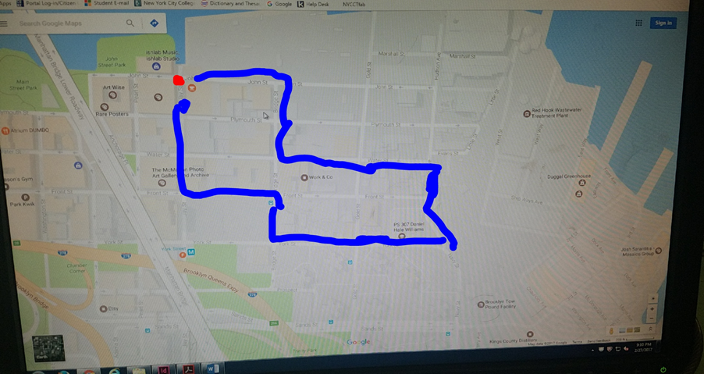
This photo is compliments of group member Pedro.
Site Photos

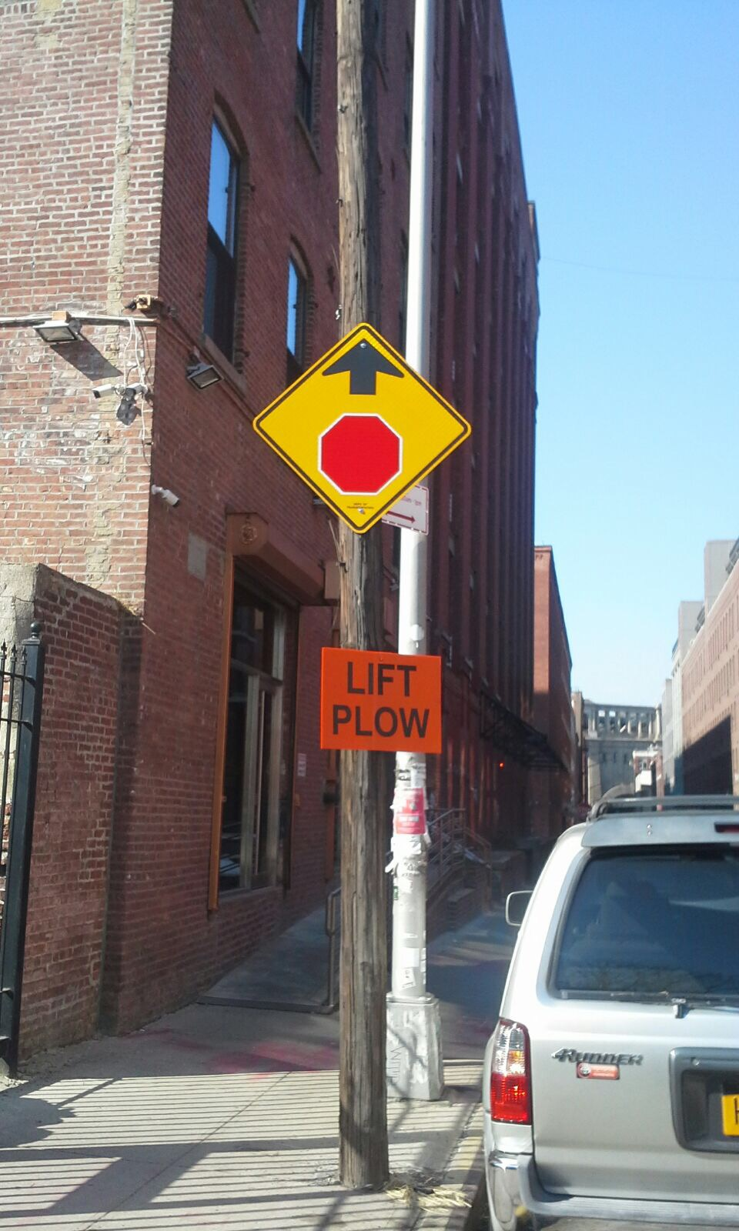
This image shows two lampposts along Water Street. It shows a silver aluminum looking modern post one and a very wooden traditional post. Here you can clearly see that although what looked like some renovations were done even to the sidewalk the old post was kept there. Look like it will be kept for street signs since it would not be possible to drill holes in the modern post which may have some electrical wires contrary to the wooden post that back in the day wires went from post to post.
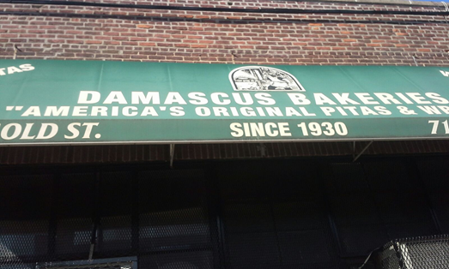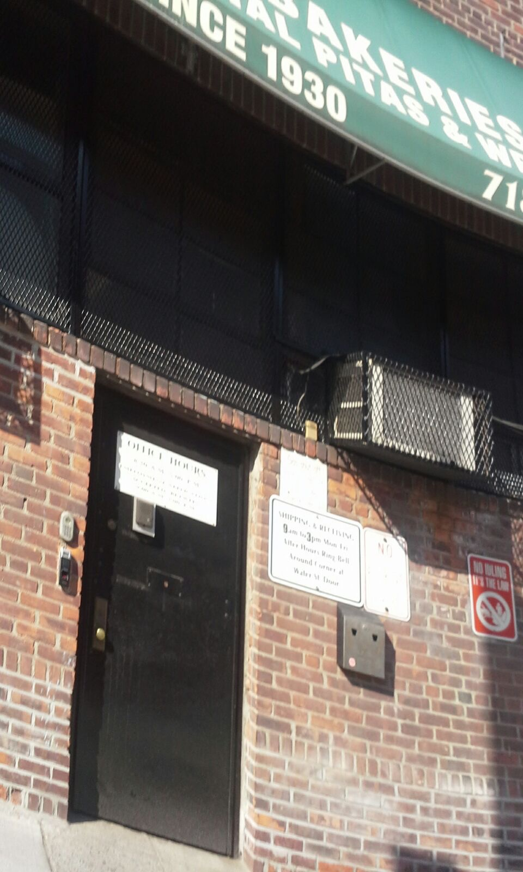
Photo shows the only bakery in the area on Gold and Water Street. We saw a delivery guy outside the door with a bag with what seems to be baked goods, however, we were unable to speak to him or even go inside to speak to anyone. This bakery seems to be commercial and sell in bulk as there is not an open glass door but a big black industrial door. From a good distance down the block the baked goods scent was very strong. The picture below shows the side of the bakery on Water Street with a big red door marked “LOVE” written all over it looks like where transportation trucks load the goodies.
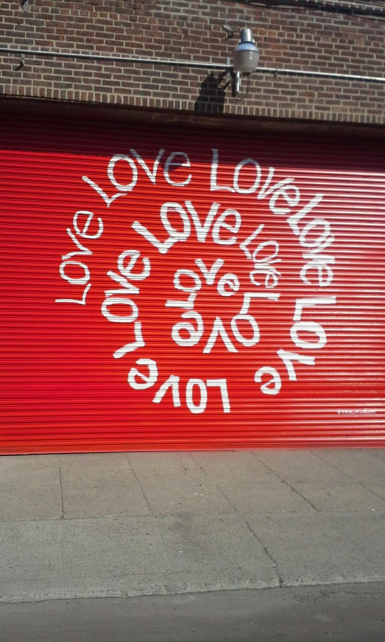

Photos along Hudson Avenue
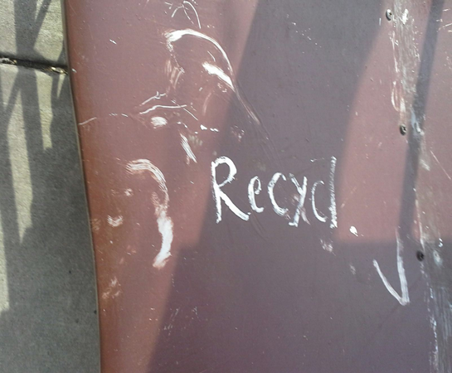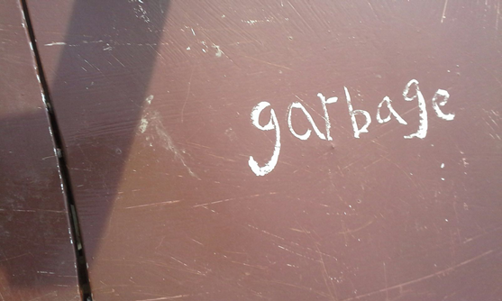
Photo shows garbage and recycle bins on Hudson Avenue. These bins were actually in front of a modernized home. They are built in a picket fence with red top covers roughly labelled. These are unlike the normal garbage and recycle bins seen in the Dumbo Area or other parts of NYC.
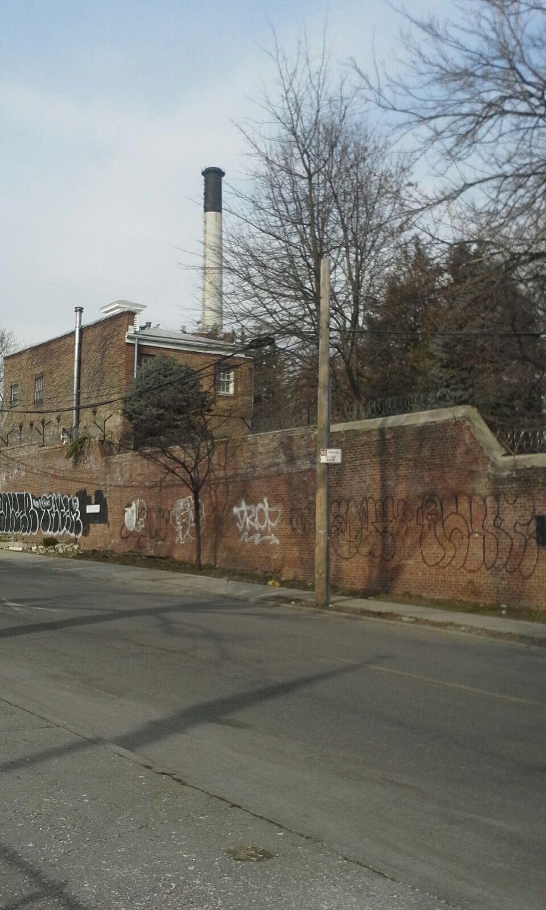
Chimney in the background of some occupied house. This is on Hudson Avenue close to the Brooklyn Navy Yard. Where the Chimney is located there is a very big gate and were unable to go in to find out if chimney is still in use.

Photo of an newly build or renovated building
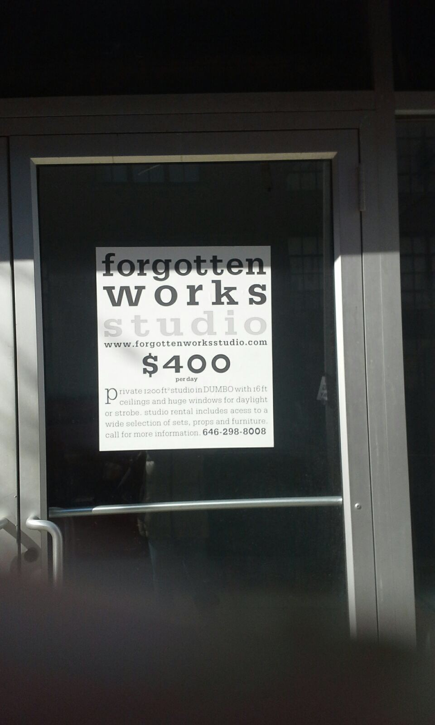
This sign was seen in the Vinegar Hill area clearly shows if and when this area is fully developed apartments and business are going to be very costly to occupy.

SITE OBSERVATIONS
- Empty parking lots if and when the up zoning starts they are can be apartment’s lots.
- Construction sites, this shows that some development has started in the area
- Newly built business, this shows that some work are being done

QUANTITATIVE DATA:

Subject | Data
Community bulletin board | 1
Bakery | 1
Construction Site was fixing side walk | 1

QUESTIONS:
- Why renovate Dumbo and not Vinegar Hill?
- Why fix the sidewalks but keep the cobble street?
- Is Vinegar Area still considered industrial as there still are many warehouses and commercial bakery there?
HYPOTHESIS
- Vinegar Hill more privately own than government.
- There are mainly residents from the Dumbo area walking the streets.
- The cost to build in this is very high so many of the warehouses and bakery is still occupied.

SUMMARY / POST VISIT REFLECTION / NEXT STEP?
It would be nice if the group can visit the area and interview persons on constructions to get a better idea of future developments and renovations. Speaking with a representation of New York City building department would be quite interesting to know of the government’s interest in the area or find out names of who own these properties.
References to Explore Hypothesis
- Vinegar Hill Historic District Designated Report by Donald G. Presa
- http://www.nyc.gov/html/lpc/downloads/pdf/reports/VINEGAR_HILL_HISTORIC_DISTRICT.pdf
- Developers sees sweet spot on Brooklyn’s Vinegar Hill by Emma Johnson
- https://archive.org/stream/vinegarhillpropo00newy/vinegarhillpropo00newy_djvu.txt
- http://bloomington.in.gov/vinegar-hill

