Learning Places Spring 2017
Site Report
Vinegar Hill
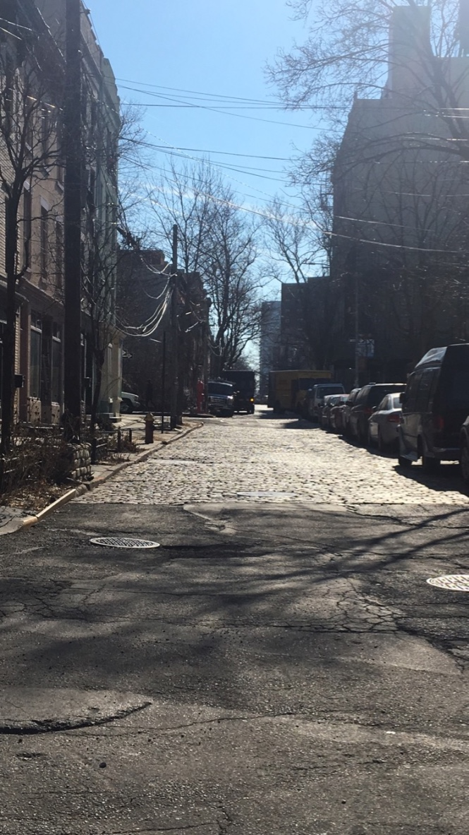

Deandra Anthony
Due 02-15-17

Introduction
In this site report I will be discussing our visit to vinegar Hill. Within Vinegar Hill we see different types of architecture through the buildings. Some of the buildings come together collectively and have the same height, style, and overall theme. Other buildings just stand out and disturb the history of Vinegar Hill. Throughout this report you will see pictures and drawings that will express these ideas.

Pre-Visit
I had never heard of Vinegar Hill prior to hearing my professors talk about it. It was weird to think that there was a place that existed right next to Dumbo that I have never heard or seen. Before going I looked at a few pictures of Vinegar Hill and the Farragut housing. They looked like they were in two totally different places but were walking distance from each other. This made me really interested to see the whole neighborhood and to scope out the differences.

Site Documentation (Photo/Sketches)

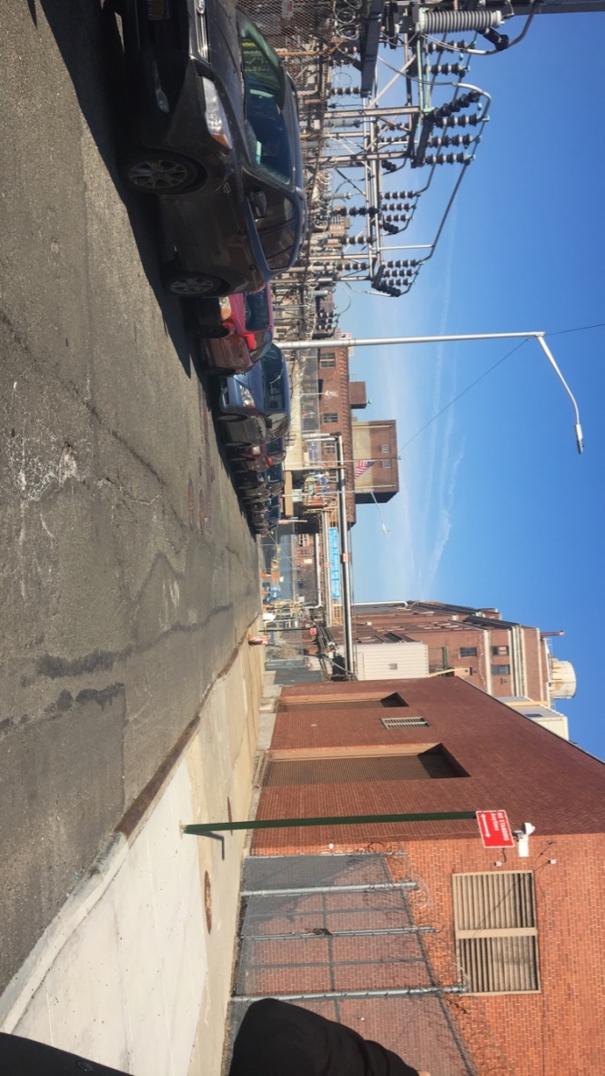

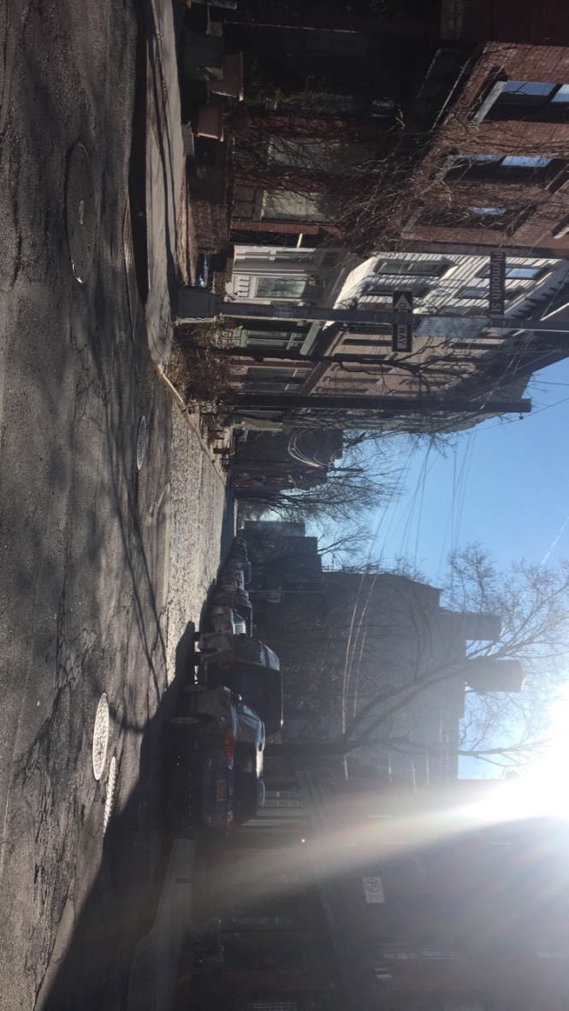
In the above picture you see a shot of the Con Edison power plant in Vinegar Hill. It’s right next to the water, tohe street is cement, and a sign that says welcome to Hudson Station. You can see the barb wire fencing and overall unappealing area. If you make a 180 turn you see this.

In this picture you can see the change, just by tuning around. The street changes from cement to Stone. You start to see homes that look a little deserted but also have an old feel to them. The street seems smaller and more close in a way. Architecture wise the leveling of buildings go from low, to a little higher, to a little higher. But the buildings are not tall like you see all over New York City. The transformation just on a street block is huge.

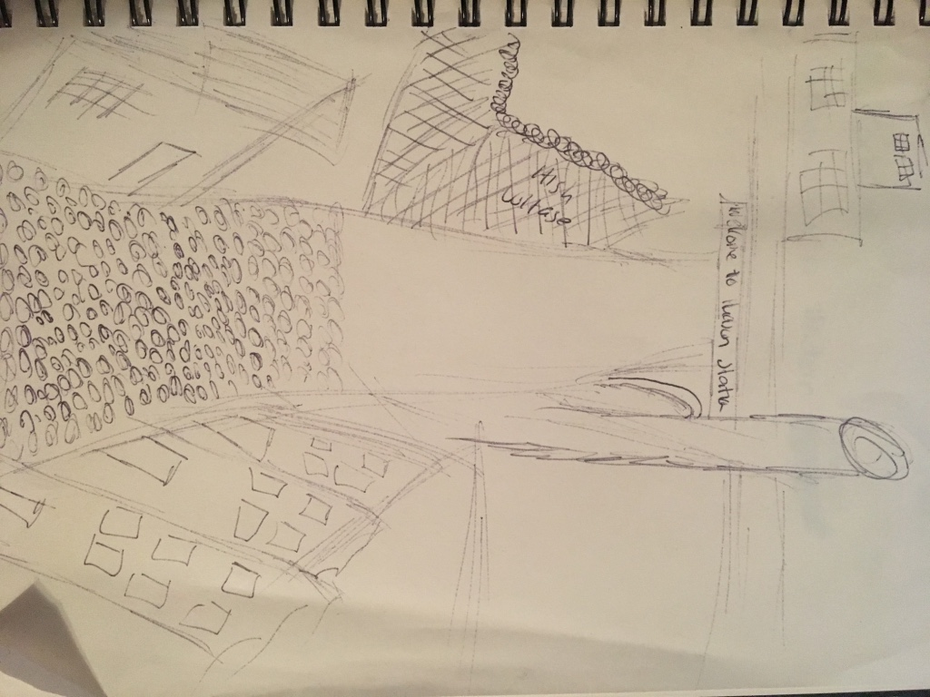

In the sketch above you can see my interpretation of the change on Plymouth and Hudson. You can see what I talked about before. The change in street, buildings, building heights and so on.

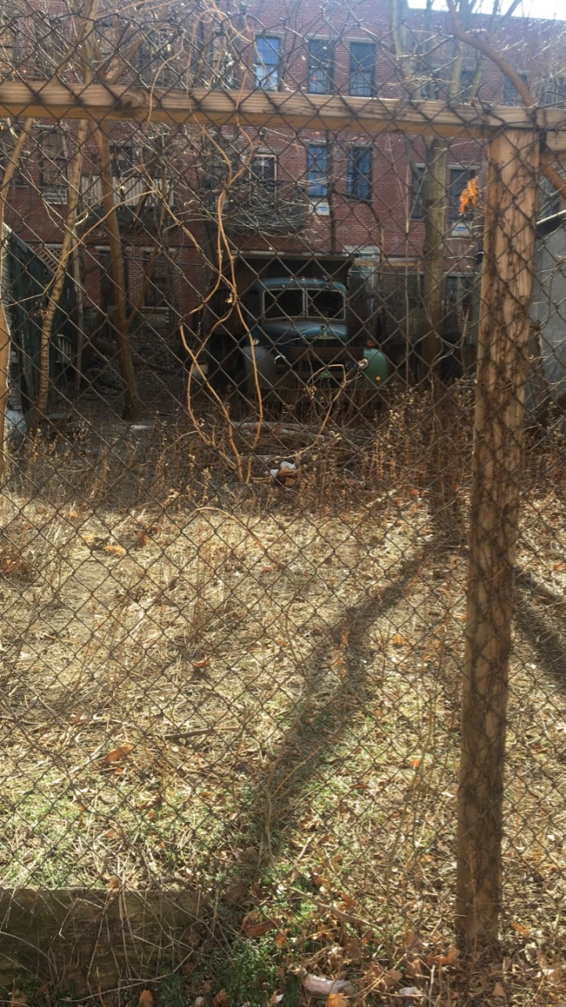

In this photo you can see the old in the neighborhood. There were a lot of old trucks and tractor trailers. Things that were just left and never cared for after.

Observations
- There was a mixture of the old and the new within this one neighborhood.
- In certain building the first floor was boarded and seemed empty but when you look upstairs you can see that people are living in the building.
- The change from block to block was big. From heights of buildings to old and new uses of those buildings now. Some building that use to be warehouses are now residential spaces.
- The separation by the BQE from one side to another.
- The remains of railroad tracks that building owners have made a part of the architecture of the building.

Quantitative Data
SUBJECT | DATA
Age Of Building | You can tell that certain buildings are way older and haven’t been touched in many years. Versus some buildings that blend in with a modern building in New York City. A lot of glass windows and odd shaped buildings. Even the buildings that have been converted you can tell that they have been modernized in a way.
Height Of Building | The height of the building also shows the modern versus the old. The newer buildings ten to be way taller that the older ones. They also interrupt the idea and view of New York City as a whole.
The amount of People | In the older part of Vinegar Hill you barely see people walking around. Even cars don’t really drive back there unless they are looking for parking. The closer you get to the Farragut housing area the busier it gets. It’s like going from the suburbs to the city.

Questions And Hypothesis

Questions
- Are the homes on Hudson street empty on the first floor?
- Can people buy it for commercial use and if so do they have to maintain the look of the community?
Hypothesis
- The area is going to get more modernized within the next couple of years.
- More people are going to try to move into that area. It has this antique feel which people like.
Summary
Overall, I had a great time learning about Vinegar Hill. I liked seeing the different areas within and learning about why things were put where they were and the reasoning behind the buildings. I would like to go again to get more research and pictures.

References To Explore Hypothesis
- Wikipedia
- Community Website -vinegarhillhouse.com/
- News Paper Articles

