Colin Grant

LIB2205ID – D938 Learning Places: Understanding the City – Interdisciplinary

Site Report 1- Vinegar Hill

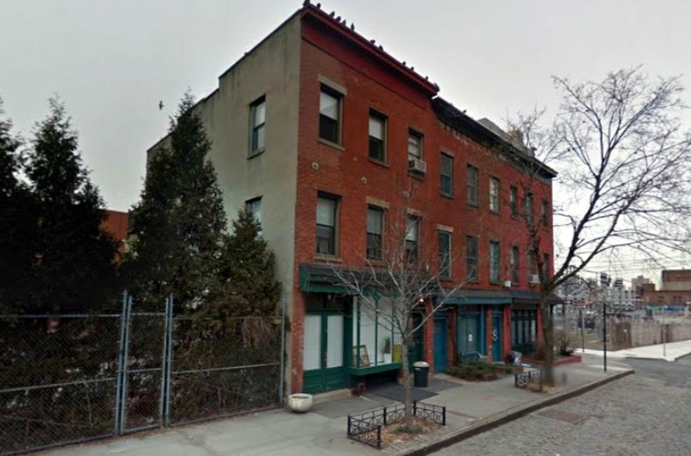

Introduction

For our first site report, the class visited an old gem of Brooklyn’s history called Vinegar Hill. I’ve been around Vinegar Hill prior to this visit, but I never noticed the new developments and construction surrounding this secluded area near the East River. I was able to gather information about past developments during our visit and new condos being made in this part of the community. I think the influence of the city and their neighbors in Dumbo are starting to make Vinegar Hill less historic with the creation of these new developments. But the rapid change is much needed to what seems like a contradicting area.
Pre-Visit Reflection

Before visiting Vinegar Hill, all I could remember is the water front and the Con Edison Industrial plant. I didn’t realize that it is a quiet part of Brooklyn compared to the congestion of Downtown. The fact that there are small amounts of brownstones in the area also sparked my curiosity of what this part of Brooklyn could have been like years ago. I was excited to get the chance to understand the historic value in not just the Belgium block design, but the overall architecture of what is was then and the future for this part of the city.

Site Documentation(Photos/Sketch)

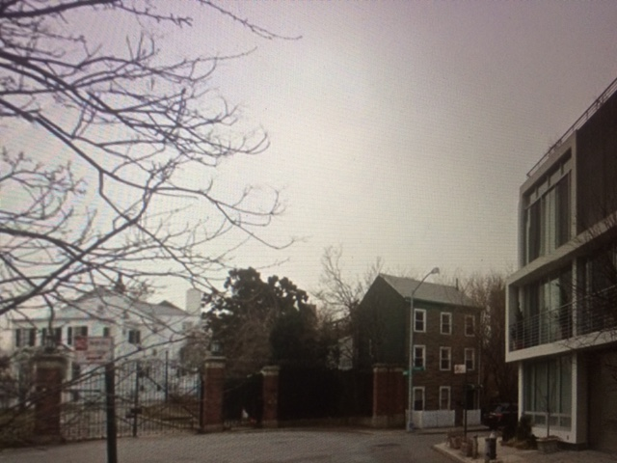

This was one of the photos I took that stood out because to me this represents the change being brought into the neighborhood of Vinegar hill. To me this can describe the change from old to modern design when it comes to the architecture of the loft building located on the right. Many people believe that change is good, but in a neighborhood where there are still gated housing and small 3 story homes we have to ask our self this. Is Vinegar Hill prepared for the rapid change like their Dumbo counter parts or will old property owners keep the potential of this place to themselves for a quiet neighborhood and a city view? Only time will tell.

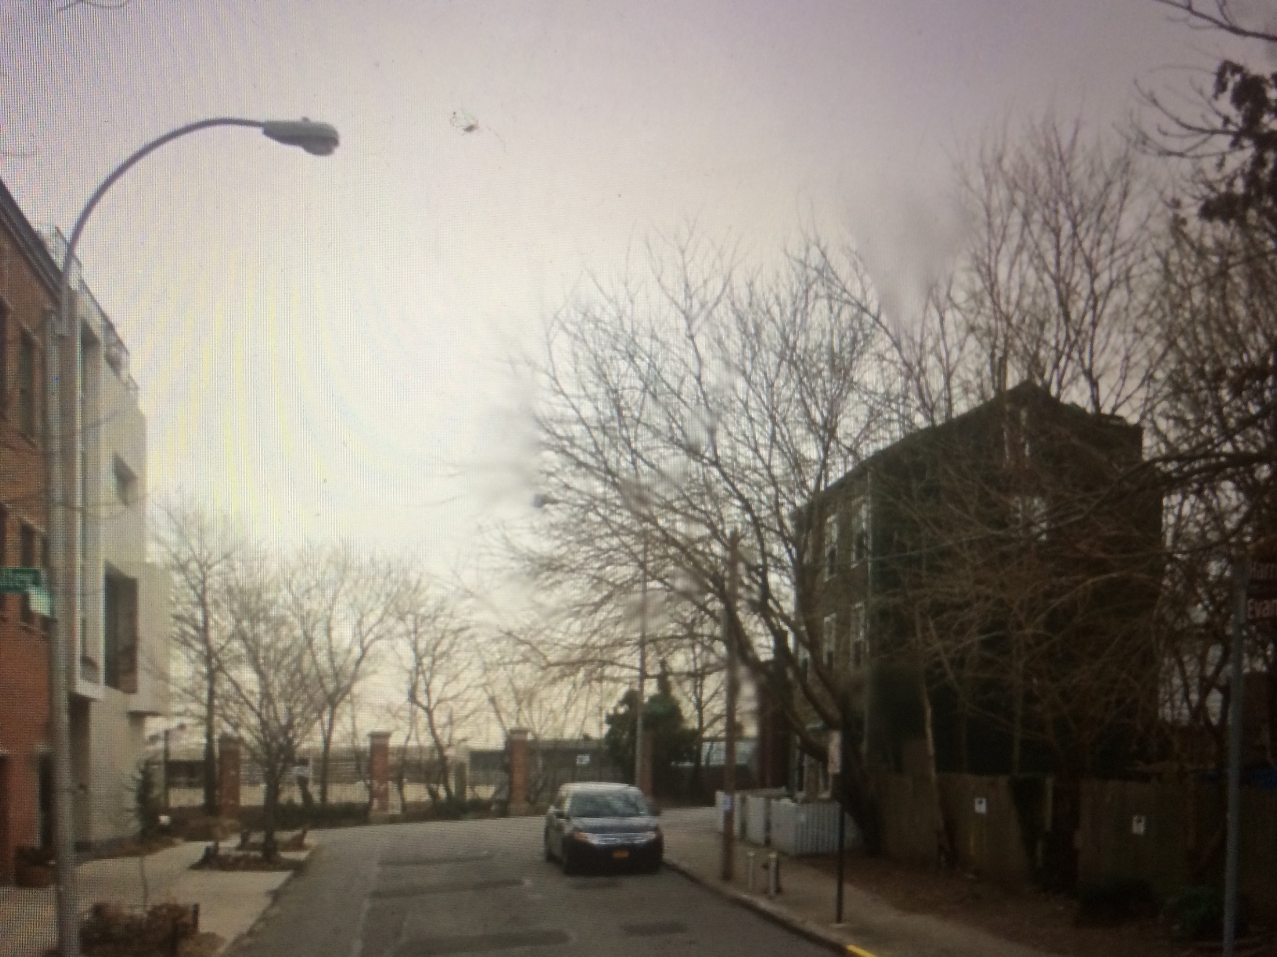

I feel like the older properties in Vinegar Hill is what brings the most attention to the area.(i.e. The Commandant's House) Yes, there is no way to stop the people who might want to change its appearance for financial benefit, but people must realize this would be the best for this neighborhood. This tension can be perceived by the photo above by showing the two contradicting life styles located at Harrison Alley and Evans St. The expensive city lifestyle is starting to look bigger than the small American dream that was made for these homes back then. And this must be hard for the people who have been living there all their life.
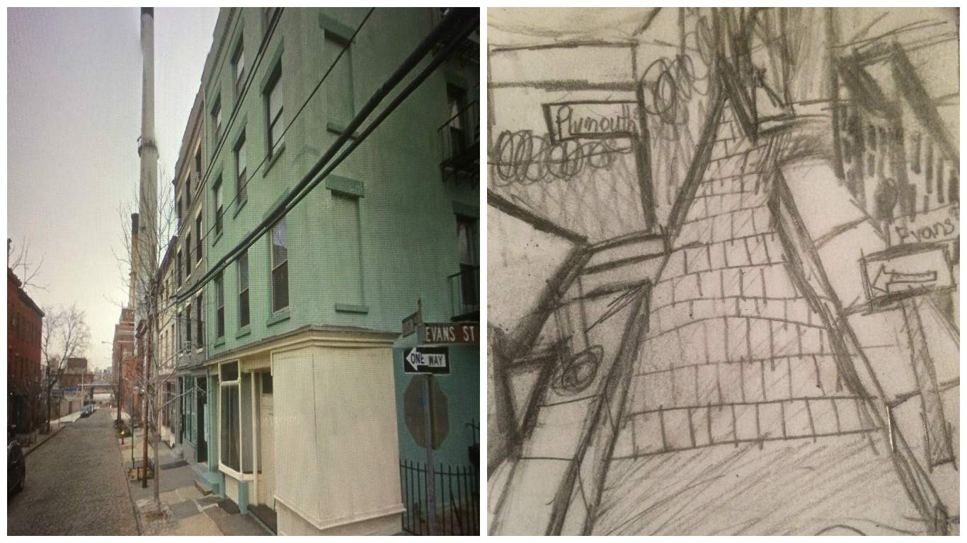

This was one of my sketches located on Hudson Avenue and Evans St. My focus was trying to capture the most important things such as the building and block street design. I tried to use vanishing points and horizon lines as learned in class to enhance my design and it really helped.

Observation

- Industrial influence on a classical way of living
- Fairly quiet for the location
- Less traffic and people
- Need for change architecturally
- Beautiful view

Quantitative Data

Subject | Data
Population | Not many people look like they live in the area. It’s mostly businesses in the area, but you would be surprised by the stores to see that not much is going on.
Business | You can notice that there is a lot of potential not just in housing but in a future of a mixed-use development around the area.
Transportation | If you’re in need of a workout you can sure get one trying to walk from a train to this part of the neighborhood. Many people were seen either riding bikes or driving during our siting.

Questions

- What will the future be for the remaining brownstone housing in the area?
- Who was involved during the design of the Con Edison plant and did that person think of the effect it would have on the neighborhood?
- How will the development of DUMBO real restate effect the outlook on the overall 3 story design of the neighboring Vinegar hill? Will it change due to popularity or will it try to keep its historic essence?

Hypothesis

- I feel like the people who have been holing out on these brownstone houses will be convinced eventually to help better the overall financial crisis that seems to be consuming that part of Downtown Brooklyn.
- Most likely the person who designed this couldn’t have considered the overall effect it would have on the look of Vinegar Hill. I feel like this can affect the way people view how it must be to live there. Yes, it may be quiet at times, but the constant sounds of construction and work are a constant reminder of what this place was meant for, business.
- Historically I feel like what Vinegar Hill is most known for is the Commandant’s House located at the end of the alley, but for the other surrounding properties will have a hard time not taking some of the offers that people will start to give in the upcoming years. This part of Brooklyn has the potential to be something that can help generate business instead of being known for historic artifacts such as the housing.

Summary/ Post Visit Reflection

I feel like the future of Vinegar Hill is important when it comes to the background surrounding the neighborhoods design. It gives a good look on how this part of Brooklyn was before the changes began on some of the other areas. It gives us a chance to learn more about how people lived but I still feel like change is needed. The amount of potential that this place has can be shown on the beauty and modern urbanization of DUMBO. It is not too far from Vinegar hill, but the concept of a mixed-use development in the eyes of such an historic area is hard to explain to people who have been living there for so long. Here is a picture of one of the future designs that may save the way Vinegar hill looks today with a new design for DUMBO.
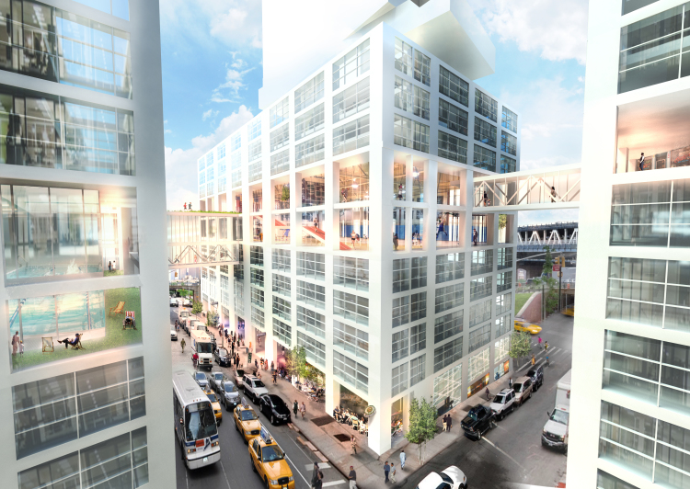

References

- "The Commandant's House is the sweetest landmark in Vinegar Hill." Brooklyn Daily Eagle. N.p., n.d. Web. 27 Feb. 2017.
http://www.brooklyneagle.com/articles/2014/12/10/commandants-house-sweetest-landmark-vinegar-hill

- https://www.6sqft.com/is-vinegar-hill-the-next-dumbo-this-storage-warehouse-owner-is-banking-on-it/
- https://www.brownstoner.com/tag/vinegar-hill-2/

