Learning Places Spring 2017
SITE REPORT
Vinegar hill
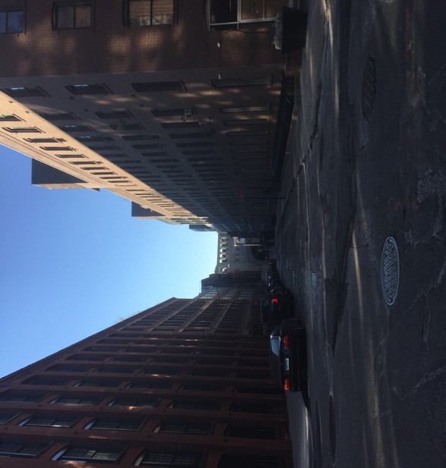

Mohammad Rasouly

2/14/2017

INTRODUCTION
Vinegar hill is a very historical neighborhood. It is very close to Dumbo. Vinegar hill is many historical places, such as old houses, garden, old buildings which are turned into office buildings. I have been to vinegar hill many times but this time going on a class trip, I observed many historical things. Vinegar hill had many old houses. there was in old garden which was serviced by the vinegar hill community. the train track under the building.

PRE-VISIT REFLECTION
Vinegar hill would be a very newly developed neighborhood. It would have many new places to visit. There would be parks, restaurants. I was even thinking that there would be many new buildings, and if you stand anywhere in vinegar hill, there would be a nice view of the city.
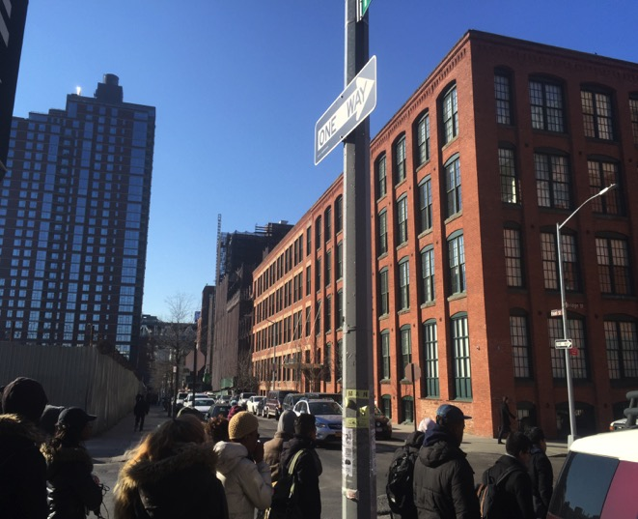
This is picture show about 20th century factory building. It is made out of concrete but decorated with bricks. This building is part of Dumbo. There were many wire house building, which have been changed to office buildings. The glass building is in Dumbo. It is newly build. Dumbo is a little more developed then Vinegar hill. This building is old building which looks like newly build.this office buildings are very modern, simple style.

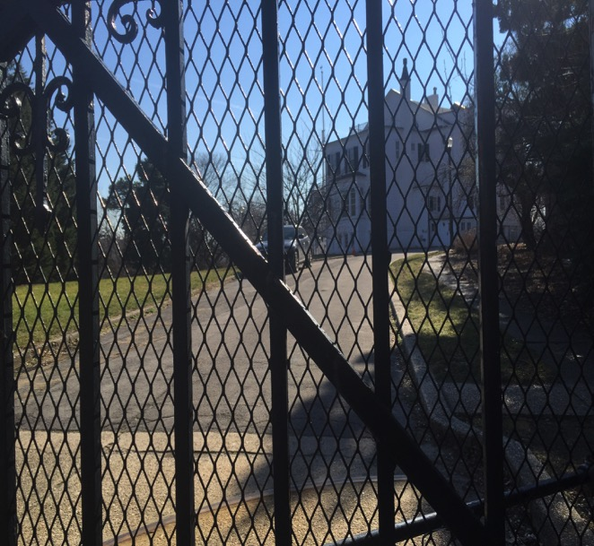
.This picture shows a big one family house which is in side the navy yard. It used to be for the commander of the navy. It is a beautiful house with open space. It is very private. The doors are locked. It has in open yard. This is the only house, I observed in vinegar hill with beautiful yard, drive way and a large yard around it. It show that not every one is aloud to go in to the house because it is a big gates. The house maybe had a security guard in the past. The house was it the end of Hudson street, which also made it very private.

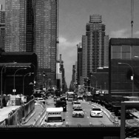
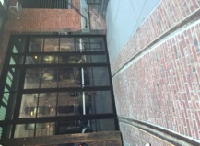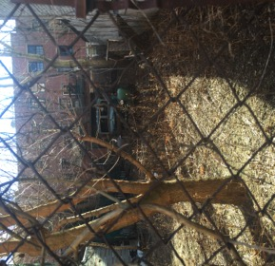

These pictures represent the history of Vinegar hill. The building on the left was a ware house building and they changed it to in office building. This building has a train track under it. It show that Vinegar hill is changing because many buildings like these have been changed to either office building or residential. The lot in the middle is next to a very old house. It has a very old truck standing in the lot. There were fences in front of the lot so I could not go very close but that truck looks like, it has been their for ever. These pictures represent the past and the future of Vinegar hill the picture on the left show how, It has been changed from having a train track and know, It is in office building. The lot shows the past which is the history of Vinegar hill. A truck standing their for years.

OBSERVATIONS
- People 4
- Cars 5
- Subway 1
- Restaurants 2
- Bars 1
- Parks 0
- Highway 1

QUANTITATIVE DATA
Subject | Data
Truck | Very old, all broken parked in old lot with a lot of Trees
House | A very big house in navy yard with big space
Tracks | A train tracks under the building

QUESTIONS AND HYPOTHESIS
QUESTIONS:
- why did they choice vinegar hill for the plaint?
- Why did they change the firehouse to in apartments?
- How does neighbors get to know each other since there was no activities?
HYPOTHESIS:
- That was the only open space.
- They did not needed, they need more apartments.
- By going to the same bar, or work in the same place.

SUMMARY / POST VISIT REFLECTION
Vinegar hill is very historical neighborhood. You can find many things that represent the history behind it. I learned a lot from visiting the neighborhood. The replacement of the buildings from warehouses to office building. The view you get from the historical places we saw. The peacefulness of the vinegar hill which is hard to find in the city. I learned how vinegar hill could be different from many neighborhoods in the city. Vinegar hill refreshed our memory about the history of how different neighborhood can have a piece of the past.

REFERENCES TO EXPLORE HYPOTHESIS
- John freeman gill “Brooklyn sleepy enclave”, NYT, 11 12,2014.
- Jeff Vandam “the little town that prices forgot”, NYT, 03 5,2000.
- Frank Bruni “out in about: Vinegar hill house”, NYT, Aug 12,2009

