Learning Places Spring 2017

SITE REPORT

COVER IMAGE: PLACE AN IMAGE PRODUCED BY YOU THAT BEST EXPRESSES THE IDEAS OF YOUR QUEST
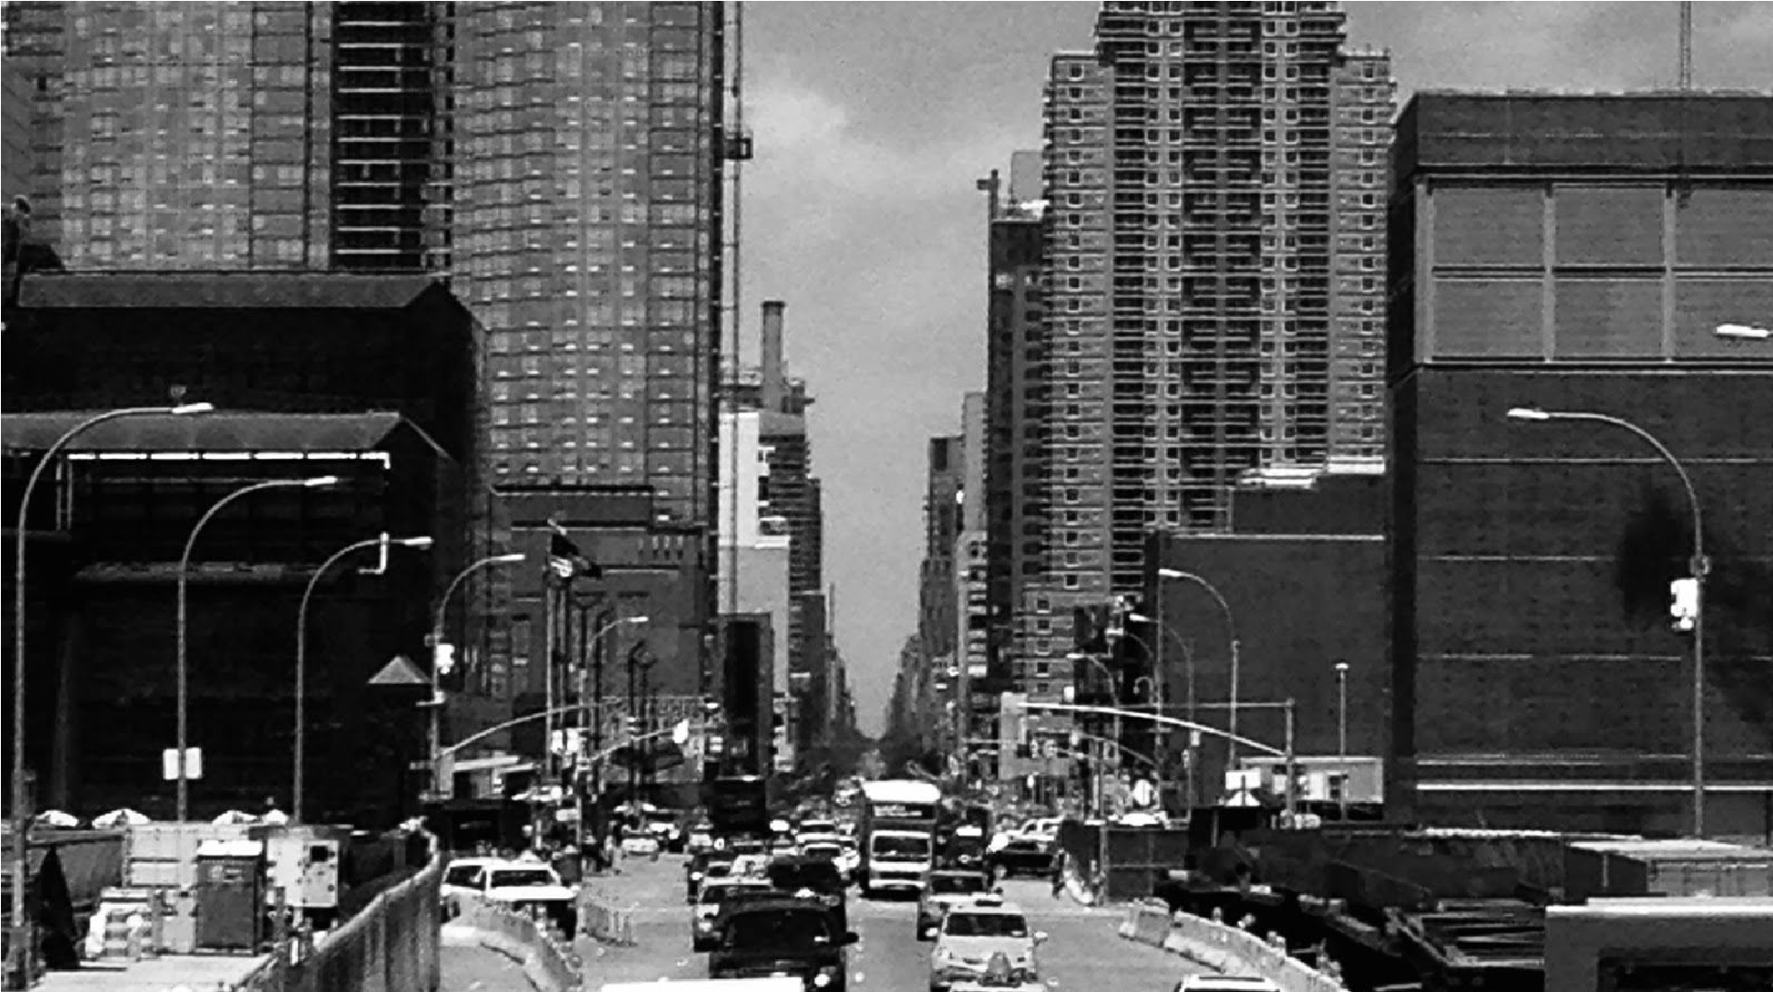

STUDENT NAME
00.00.2017 INTRODUCTION
Describe Scope of Activity
PRE-VISIT REFLECTION
PRIOR to site visit, reflect on what you anticipate learning or seeing during the visit given what you have learned so far from previous visit and your topic of interest

SITE DOCUMENTATION I: MAP OF AREA OF INVESTIGATION -- ON THE MAP CHART YOUR ROUTE AND MARK THE FOLLOWING: (a) significant stops; (b) Locations and directions of photos and sketches 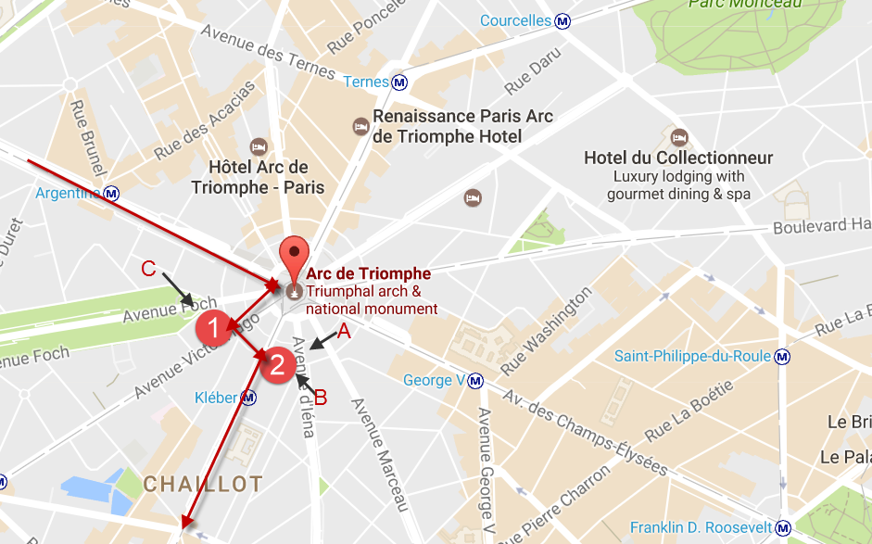

SITE DOCUMENTATION II: photos/sketches for 2-3 significant stops. Provide captions and explanations – why is the image shown significant for your topic of exploration
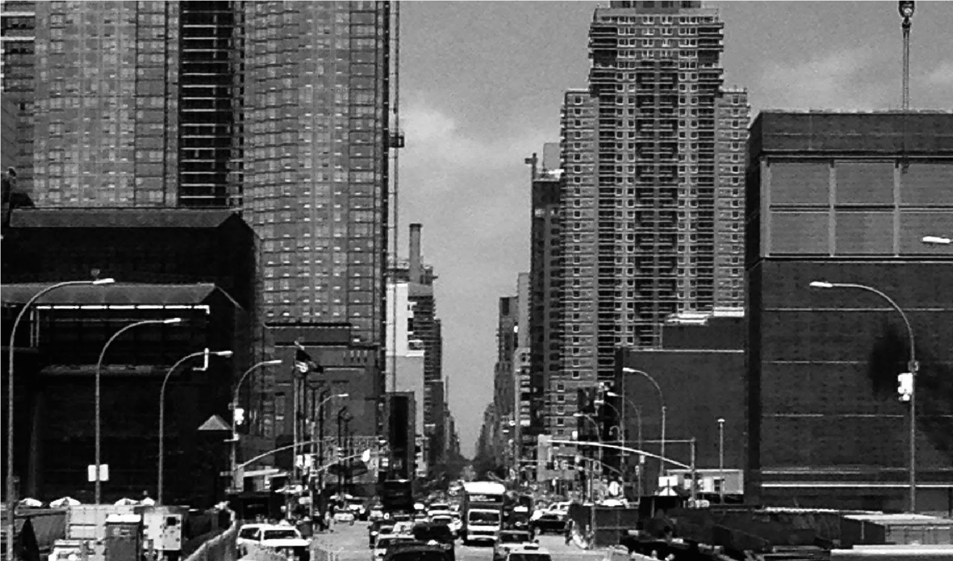
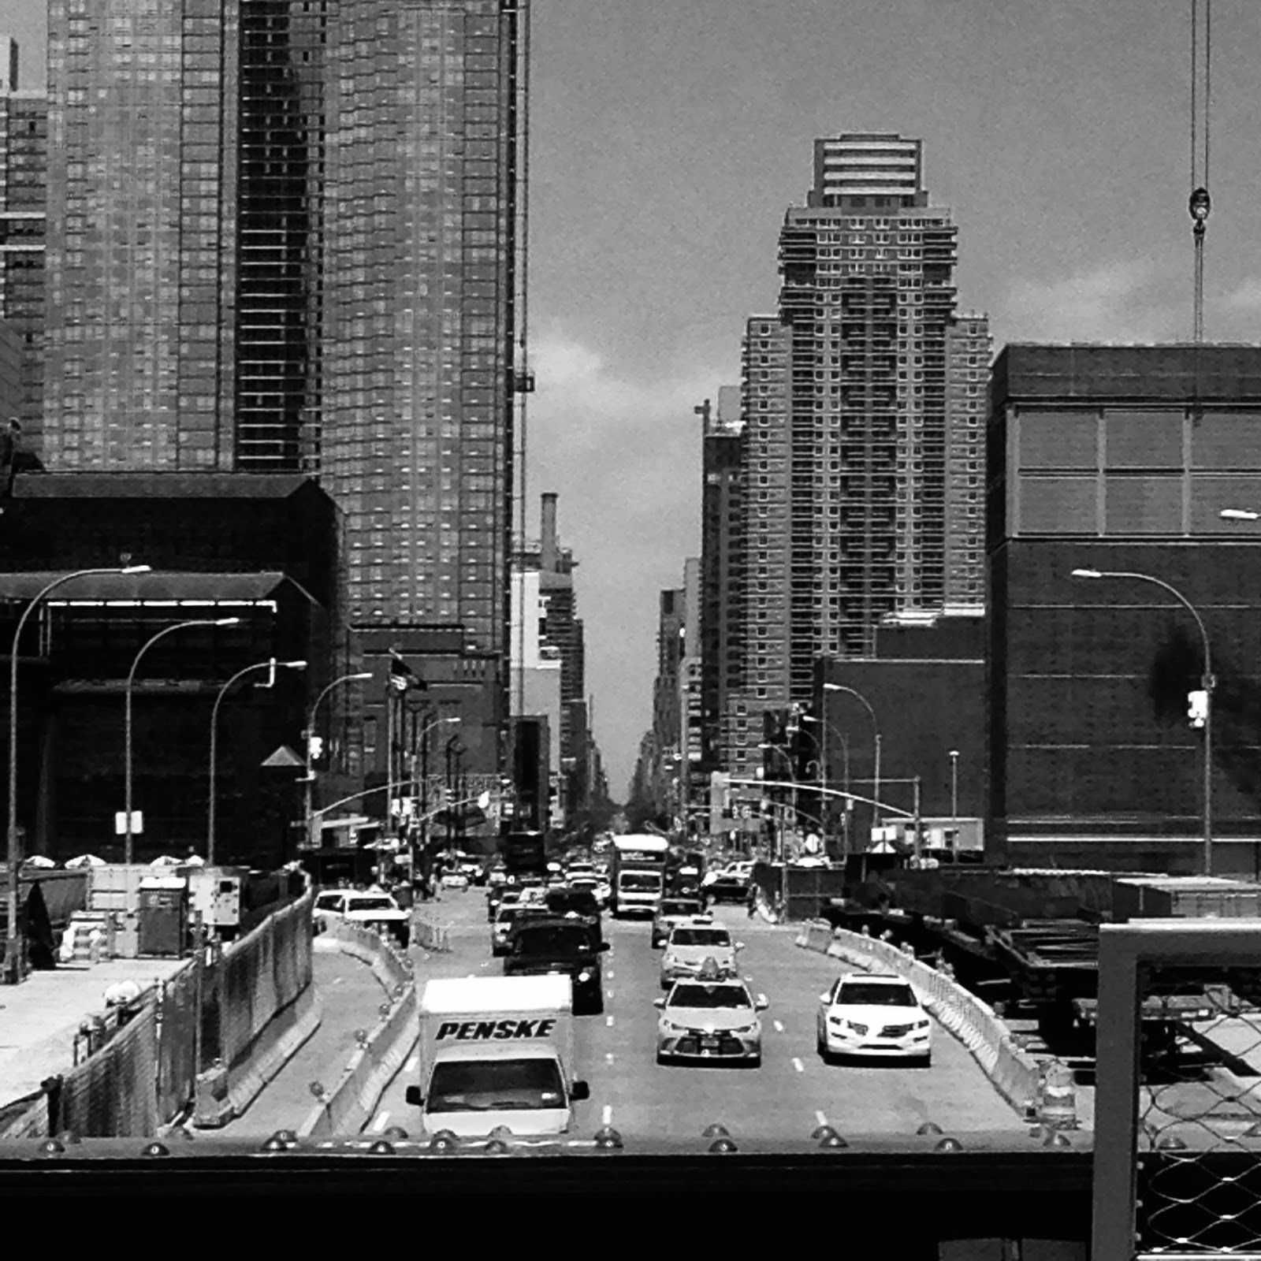
SITE OBSERVATIONS: Note conditions you found and explain how they relate to the topic of your investigation
- Lorem ipsum dolor sit amet
- Consectetuer adipiscing elit
- Sed diam nonummy nibh euismod
- xxx
- xxx
- xxx
- xxx
QUANTITATIVE DATA: under “subject” list the topic; Under “data” describe your findings and the quantity found
Subject | Data
Lorem ipsum
Lorem ipsum
Lorem ipsum

QUESTIONS AND HYPOTHESIS Consider the data found during your site visit and review the material you included so far in this report.
QUESTIONS:
- Lorem ipsum dolor sit amet
- Consectetuer adipiscing elit
- Sed diam nonummy nibh euismod
HYPOTHESIS: From the question you wrote above - select the most important question for your own research. Propose an explanation made on the basis of the limited evidence you have so far as a starting point for further investigation
- Lorem ipsum dolor sit amet
- Consectetuer adipiscing elit
- Sed diam nonummy nibh euismod
SUMMARY / POST VISIT REFLECTION / NEXT STEP? --
Lorem ipsum dolor sit amet, consectetuer adipiscing elit, sed diam nonummy nibh euismod tincidunt ut laoreet dolore magna aliquam erat volutpat. Ut wisi enim ad minim veniam, quis nostrud exerci tation ullamcorper suscipit lobortis nisl ut aliquip ex ea commodo consequat.
PRELIMINARY REFERENCES TO EXPLORE HYPOTHESES:
List articles, websites, public or government documents, or other information resources you have found that might help you explore your hypothesis. Try to find a variety of sources; 2 newspaper articles, 2 magazine articles, 2 websites, 2 public documents, etc.
- Lorem ipsum dolor sit amet
- Consectetuer adipiscing elit
- Sed diam nonummy nibh euismod
- magna aliquam erat volutpat
- Consectetuer adipiscing elit
- diam nonummy nibh euismod

