Learning Places Spring 2017
SITE REPORT
Vinegar Hill, Brooklyn

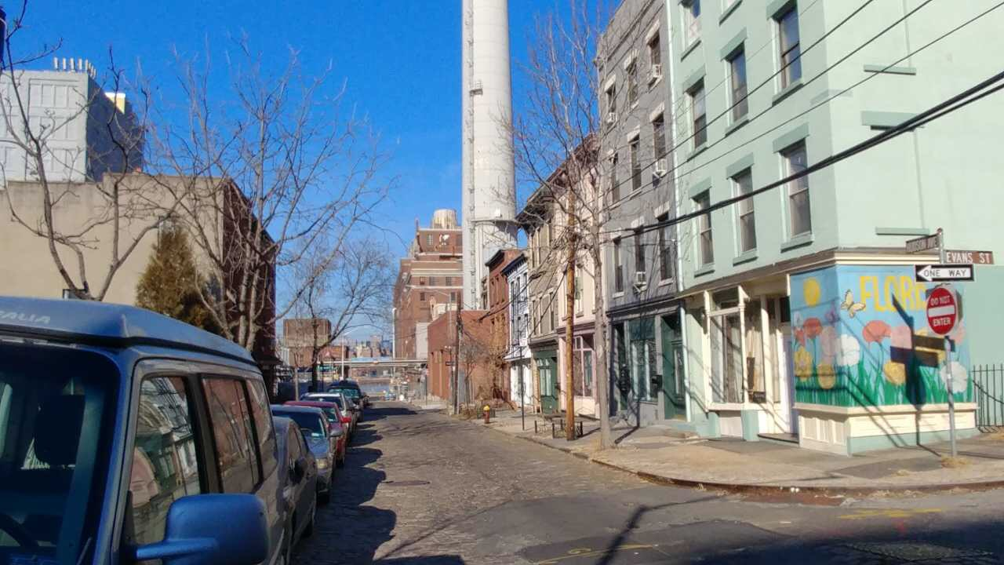

Pedro Torres
02.12.2017

INTRODUCTION
For our class we were assigned a site ( Vinegar Hill) which is in Brooklyn, New York. I personally had the chance to walk around before our site visit but didn’t analyze the neighborhood in depth compared to the class site visit on February 6, 2017. Vinegar Hill which is on the north side of Brooklyn may not be a popular place for tourist or NYC residents to gather when compared to other neighborhoods in NYC. Out of all the places that I have visited within the NYC Vinegar Hill has to be one of the neighborhood that is so rich in Architecture & American history.

PRE-VISIT REFLECTION
While I was walking from the Namm building on Jay St. & Tillary to Vinegar Hill I noticed a big difference. The Namm area was very commercial and had a lot of foot traffic. Once I got to York street after crossing under the Manhattan Bridge I started to notice that the vehicle traffic started to disappear and that marked a big difference in where I was at. The streets got narrower most likely to restrict the passage for commercial vehicles. I noticed a big change in building heights when comparing Vinegar Hill vs Downtown Brooklyn.

SITE DOCUMENTATION (photos/sketches)
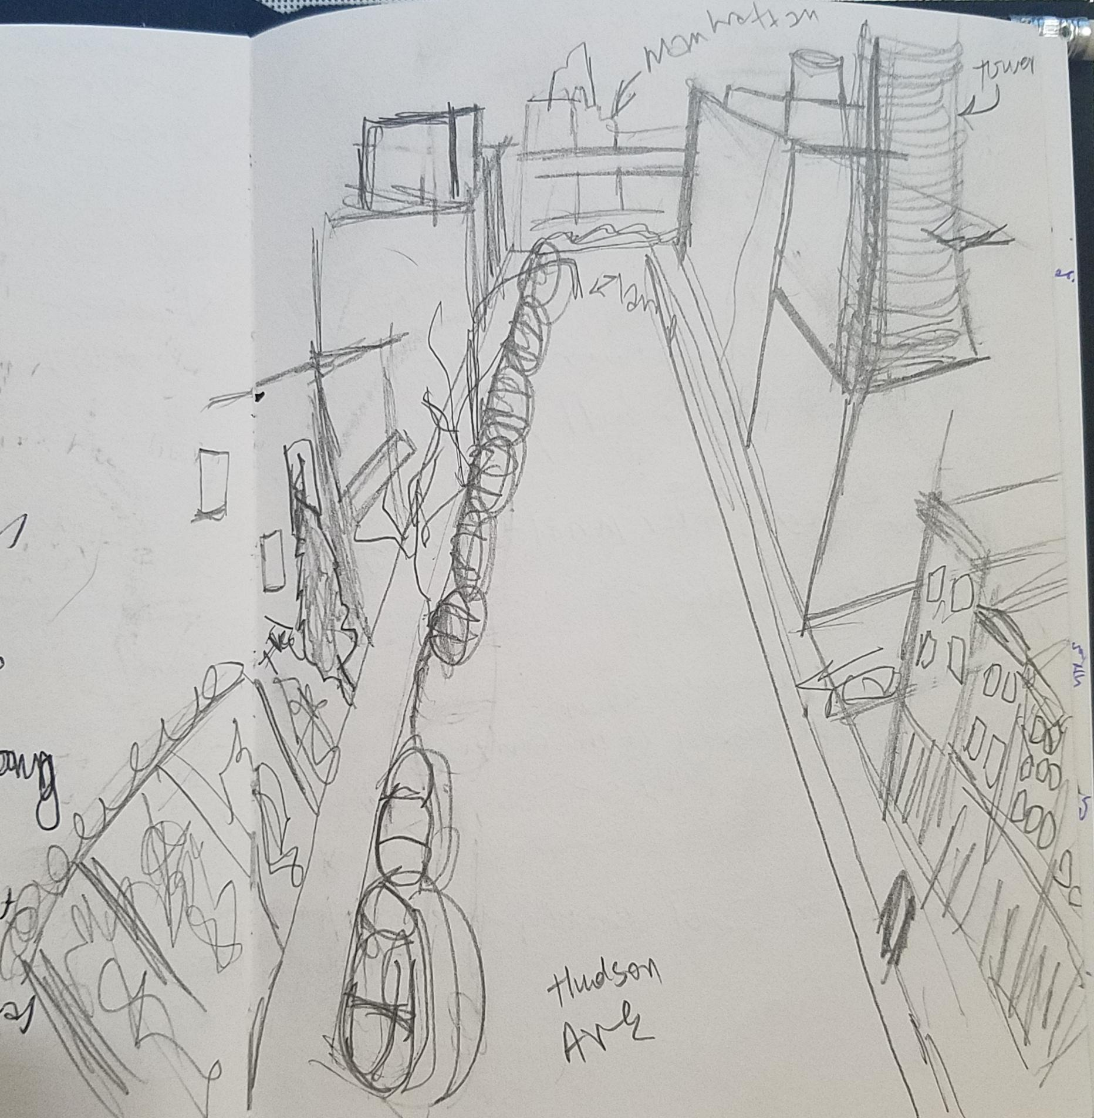

This sketch was taken on the corner of Hudson avenue looking down towards the Con Ed power plant on the waterfront. I wanted to show that the only have a 1 side parking which was something significant because in my pre visit reflection I saw that there wasn't a lot of foot / car traffic. The fact that there is only one side parking goes to show that there isn't a lot of cars in Vinegar Hill.

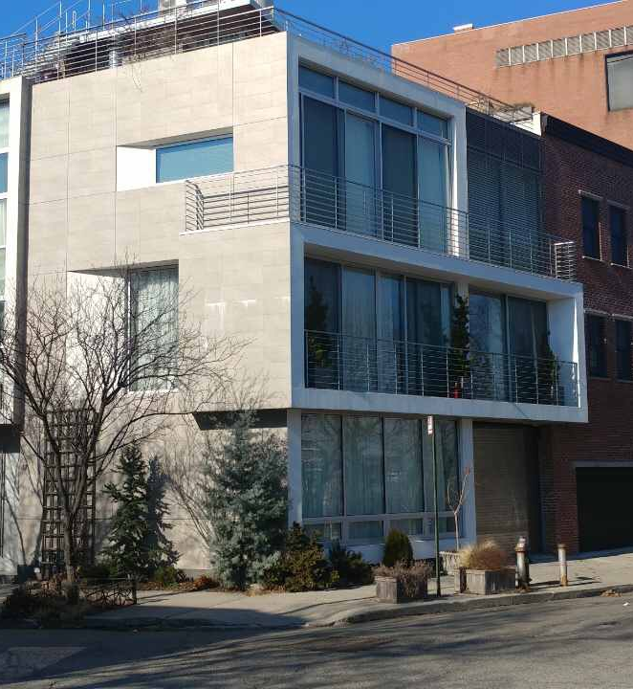

This house which was across the Commandant's House stood out to me out of most building in the neighborhood. It was very unique in the use of materials that were used in the facade. They used concrete and steel which is quite the opposite as to most other buildings in Vinegar Hill. It could be that it was used design that way to compete with the Commandant's House.

This decorative sidewalk was very unique. The company extended the sidewalk redo all the way into their building so you could see the red brick and metal rail road in their lobby. It represents the preservation and history of Vinegar Hill of what it used to be like in Vinegar hill in the early 1900’s to the mid 1900’s.

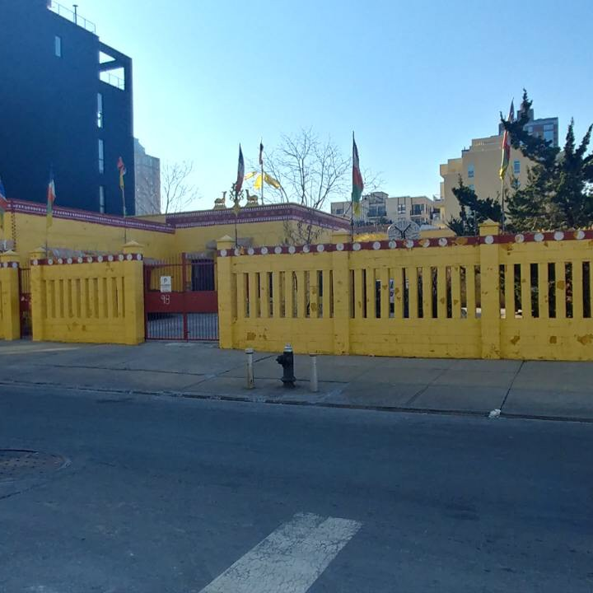

This Buddhist temple / center stood out to me. It surprised me see one here when I didn't really see any asian people. Although to be a buddhist it doesn't mean you have to be only be an asian person it made me wonder if the people here had converted to Buddhism. Could that be the reason why there is a Buddhist temple?

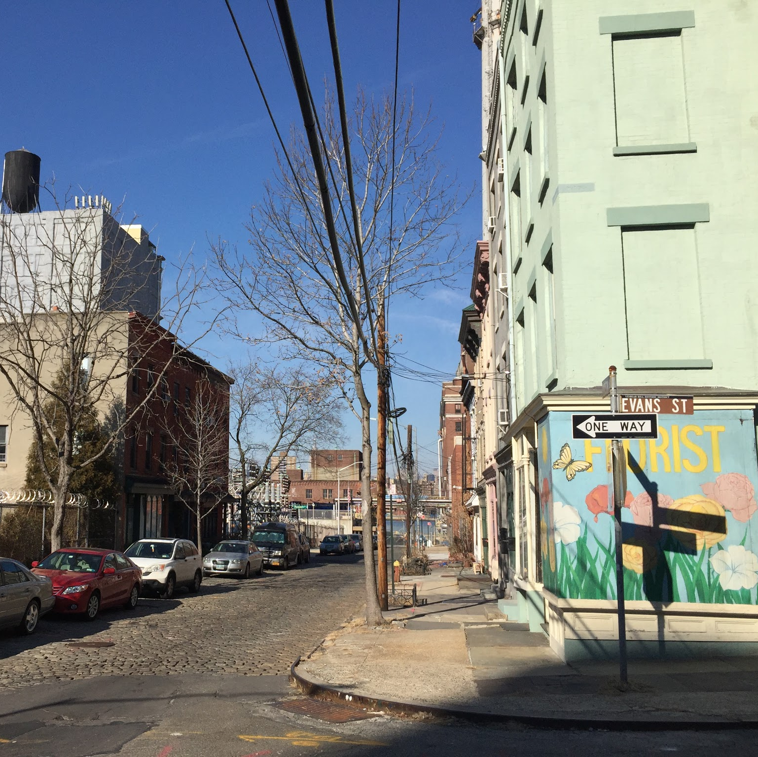

Although most of Vinegar Hill is practically identical the few times I saw art it stood out because it was a beautification to the neighborhood. Especially on Evans St. which seems to go through an identity crisis because on both corners they have something that stood out to me. On this corner it has some color on the mural as well on the building itself. At the top of the block both the concrete building & Commandant's House are located which is something significant. At the middle of this block there is the guarded alley which is quite the opposite of what I would expect when walking on that block when walking from both the corners

OBSERVATIONS
- Similar Zoning throughout the entire neighborhood mostly 3 story housing.
- Low Foot / Car traffic.
- Only about 2 coffee shop almost no interaction spots like Coffee, bars, or restaurants.
- I saw workers and resident in approximately their late 20s and early 30s.
- Some parts in Vinegar Hill belong to a Brooklyn Historic district.
- Only 1 train station nearby (York St Station)
- 1 Major Highway (BQE)- 2 Bridges (Brooklyn / Manhattan)

QUANTITATIVE DATA
Subject | Data
Crime | 4 broken car windows and 1 flat tire
Abandoned lots | Approximately 4
Transportation | Walking - 12 people, Cars - 7 cars, Bikes - 0 bikes

QUESTIONS AND HYPOTHESIS
QUESTIONS:
- Why does the neighborhood seemed abandoned?
- How can this neighborhood be improved to make it a touristic gathering point for the people of NYC and tourist?
- Who was the urban planner for Vinegar hill? Why did he plan Vinegar hill the way it was? More information on Sands.
HYPOTHESIS:
- I believe it has to do something with the NYCHA buildings. Having that in a neighborhood makes it less attractive.
- If there was new development that could make gather points for the people it would make the community more attractive. For example if a new park was proposed in the Con Ed location it would function really nice because it can take advantage of the views to manhattan.
- Most likely the man didn't envision Vinegar hill as a big city or he wanted it to be a peaceful residential place for all the Brooklyn Navy Yard Workers.

SUMMARY / POST VISIT REFLECTION
I was mostly surprised about the history itself to think that at one point in history this seemed to be a functioning community. I say that because it seems that most of the people were part of the brooklyn navy yard. Once the navy yard shutdown it seems that the neighborhood stopped functioning. One of the major problem that I believe Vinegar Hill has is that this doesn't feel like one community / neighborhood. To me it feels like it's a ghost town although there is people living in Vinegar Hill.
REFERENCES TO EXPLORE HYPOTHESIS
- Bortolot, Lana. "Why Vinegar Hill Is Brooklyn's Edgiest Enclave." New York Post. New York Post, 08 July 2015. Web. 12 Feb. 2017. <http://nypost.com/2015/07/08/why-vinegar-hill-is-brooklyns-edgiest-enclave/>.
- GILL, JOHN FREEMAN. "Brooklyn’s Sleepy Enclave, Vinegar Hill, Awakens." New York Post. New York Post, 12 Nov. 2014. Web. 12 Feb. 2017. <https://www.nytimes.com/2014/11/16/realestate/brooklyns-sleepy-enclave-vinegar-hill-awakens.html?_r=0>.
- Boyle, Lizzie. "Vinegar Hill: Step Into the Old World of Brooklyn." Atlas Obscura. Atlas Obscura, 13 May 2013. Web. 12 Feb. 2017. <http://www.atlasobscura.com/articles/vinegar-hill-in-brooklyn>.

