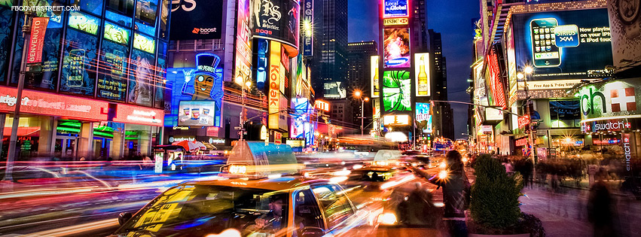
36 Hours in New York

By: Lisa Guerra, Amanda Torres, Jordan Chaux, and Shakira Majolie
Published: December 1, 2012

Is New York City really considered one of the most amazing cities not across the world? Well of course it is. There’s no other place to walk up and down the streets, observe the yellow taxis, hearing the noisy streets and walk into crowded stores. Every few blocks, one can see a food vender selling salted pretzels or a Sabrett Hotdog. With thousands of attractions such as Lincoln Center, Rockefeller Center, Broadway, to name a few, New York has become one of the most visited cities in the world.
Friday
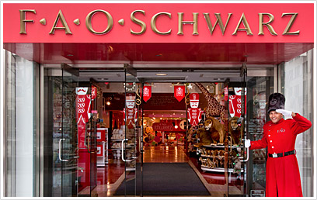
4 P.M.
1) 5th Avenue
Stroll your afternoon in 5th avenue where you will encounter some of New York’s best shopping stores. Fifth Avenue has been known as the blocks of wealth, privilege, and luxury. Walk pass FAO Schwarz (767 Fifth Ave. at 58th St., 212-644-9400) you’ll find a smattering of ultra-high- end goods and an array of stuffed animals, dolls, train sets, blocks, board games, and even candy. Saks Fifth Avenue (611 Fifth Ave. at 50th St., 212-753-4000) This top-end department store is filled with major American designers and plenty of Europeans, plus a complete collection of diffusion lines. Tiffany & Co. (727 Fifth Ave. at 57th St., 212-755-8000) The most democratic of the big jewelry houses, Tiffany’s welcomes shoppers who come by Town Cars, taxis, and tour buses and limousines. Snap up key rings, money clips and cuff links, or invest in beautifully- made men's watches, kitchenware, or their classic 6-prong diamond engagement ring\
Taken from Fao Schwartz http://www.fao.com/shop/index.jsp?categoryId=3810526

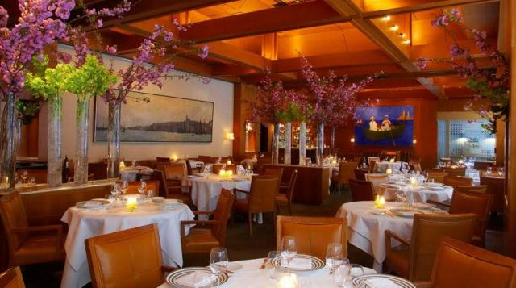
5:30 P.M.
2) Le Bernardin

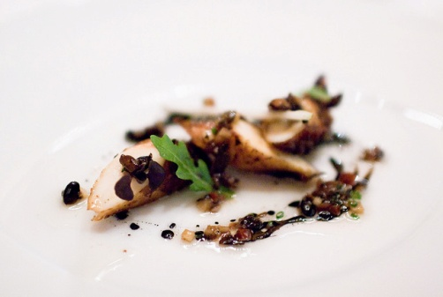
After having shopped at New York’s Finest stores take a limousine ride stop for an elegant dinner at Le Bernardin (155 West 51st Street, (212) 554-1100). This is the ultimate French restaurant – where the quality matches the hype. Not only did it win Zagat’s Best Food award for eight years, but non-food critics alike also sing the restaurant’s praises. Eric Ripert is the seafood genius. He has become particularly well known for the charred octopus with fermented black bean and pear sauce. For desert try the Chocolate-Peanut caramel tart with Meyer lemon puree and praline-citrus sorbet, and you may just reach nirvana.

Photo from http://le-bernardin.com/

8 P.M.
3) Lincoln Center
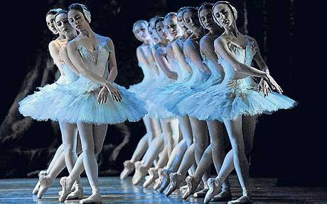
For a subtle evening, visit Lincoln Center (10 Lincoln Center Plaza, (212) 875-5456) It is a center for artistic talent but gives exceptional shows. It is home to the New York Philharmonic, the New York City Ballet, and the NYC Opera. Performances at the Lincoln Center are unmatched in quality and class in New York City. In season come view the Nut Cracker, Swan Lake, or Giselle. The sheer expression of human creativity and athleticism exudes beauty, grace and strength. Visit the Box Office at the Lincoln Center for discounted tickets to their frequent world-class performances.

Photo from Lincoln Center website: www.lincolncenter.org

Saturday
11 A.M
4)Books and Coffee
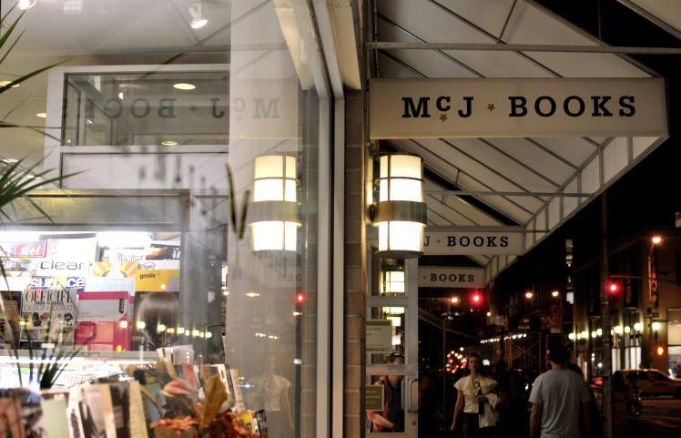
Photo Credit: Yvonne Brooks
Their name has nothing to do with what they sell, but McNally Jackson (52 Prince Street; 212-274-1160; http://mcnallyjackson.com) turns out to be a nicely owned independent bookstore. With two floors and a café you can enjoy a light breakfast, coffee ($1.75) and a muffin ($2.50), and walk around the bookstore. The book store arranges their books by nations, but with their engaged staff you won’t be getting lost looking for a book.

12:30 P.M
5) Anyone want Big Daddy’s?
Big Daddy’s Restaurant is located on 239 Park Avenue South. Built in 2005, a beacon of neon light started to shine on Park Avenue South to the delightment of hungry people all over Manhattan and beyond. Big Daddy’s Restaurant brings the 80’s to life with their bright colors, toys from that decade and hit music. Try their famous dish, Daddy-o burger ($14.50) with one of their many milkshakes ($7.00).

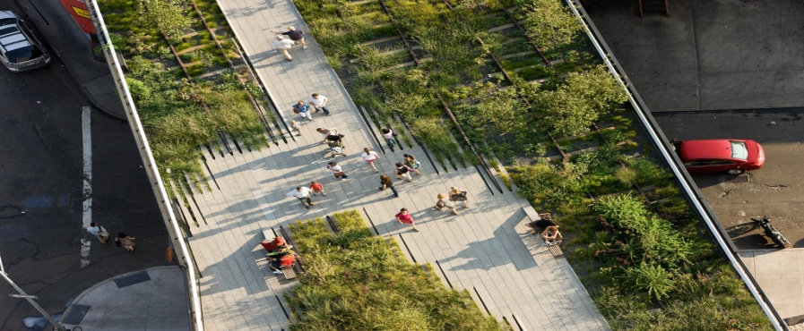
2:00 pm
6) Walk through History

Photo Credit: Iwan Baan
Walk on a historic freight rail line elevated above the streets on Manhattan’s West Side, known as The Highline. The Highline runs from Gansevoort Street in the Meatpacking District to West 34th Street, between 10th & 11th Avenues. In Section 2, guest can sit on the grass and enjoy the scenery the Highline as to offer.

4:00 P.M
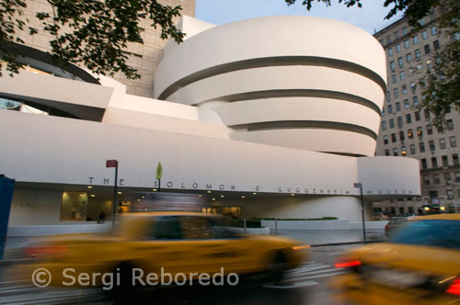
7) Make room for Picasso
By 4pm we made our way to the Guggenheim Museum on 5th avenue & 89th street. The museum currently has an exhibit on Picasso Black and White until January 23, 2013. This exhibit contains over 150 of Picasso's ability to use black and white only. This was a great experience since some of these paintings have yet to been see before.

6:30 P.M

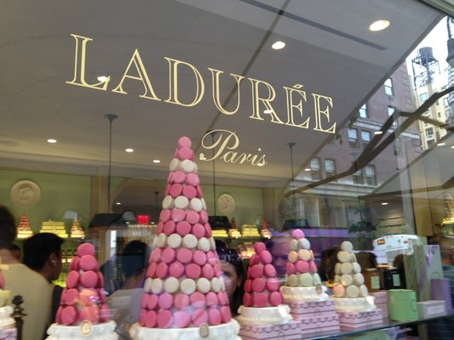
8) Dinner awaits us
Walking around the museum became tiring and hungry. Luckily we remembered we had made a reservation for a private room at the Jean Georges restaurant. It is located at Central Park West between 60th & 61st street. The restaurant offered a great selection of French cuisine with a feeling of the West 60s and a great wine list.
9:30 P.M

9) Can't forget about dessert
After dinner we decided to stick to the French theme we had going on and have dessert. So we went to Laduree which wouldn't be to far from where we already were. Laduree is located on 71th street and Madison Avenue. They are mainly known for their delicious macarons that are said to be made in France and brought over here.They offer over 15 different flavors and because of the holiday season they temporarily had a little more variety like Christmas flavors, chestnut, chocolate milk, coconut, blackcurrant violet and chocolate pure origin.
Laduree www.laduree.fr/en/maisons/monde

Sunday
11 A.M
11) Sunday Morning Brunch
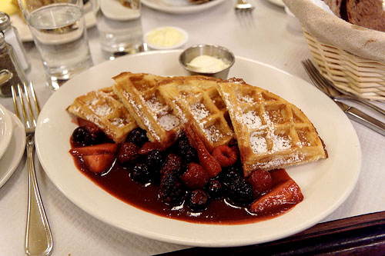
When looking for a great place to enjoy a morning brunch Balthazar (80 Spring St, Soho, New York 10012 212 965-1785) is the place to go. Located conveniently in Soho, next to the 6, N, R, and 4 trains you can get an affordable meal. This restaurant when you enter in it gives off a French Bistro feel but at the same time gives you a New York Loudness. There is no outdoor seating but with the ambiance inside who needs it. A wide variety of Brunch items are served with a very vegetarian friendly diet, and at 12 noon the fully stocked bar is opened.
Chelsea. Balthazar's French Toast. 2010. Photograph. 13 Dec. 2010. Web. 1 Dec. 2012.

1 P.M
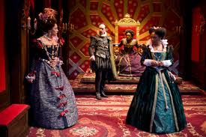
12) Broadway Shows Can be Expensive
Off Broadway shows can be just as good as Broadway shows but less expensive. The Soho repertory Theatre (46 Walker St New York, NY 10013 212 941-8632) is a small theatre that offers off Broadway shows at a special price on Sundays. Normal priced tickets there cost range from 30 to 65 dollars but on Sunday’s shows for under a dollar are offered! This is not only a steal but convenient. The experience is unlike any other in this small theatre of 73 seats. You are up close to the actors, and get to see the “development of unconventional” plays right before your eyes.
Davis, Blaine. Lear. N.d. Photograph. 17 Jan. 2010. Web. 1 Dec. 2012.

If You Go!
Want to Stay in the middle of the New York City Rush but still have a comfortable/ relaxing place to go back to, The Casablanca Hotel (147 West 43rd Street, New York City, NY 10036 212 869-1212) is the place to be. With convenient check in and checkout times, complimentary food bar services, and employees willing to meet your every need; this is an ideal place to stay. The rooms vary from 281 dollars and up for the night.
The Best Western Conventional Center (W 38th Street New York NY, 10018 212-405-1700) is always another option on great hotels to stay in. This hotel offers a continental breakfast and if you ask will also book restaurant reservations for you. By staying here it allows you to be in accessible distance from iconic sites such as Pen station, Rockefeller Center, Empire State Building, etc.
Although a bit more pricey if you want to stay on Park Avenue the Giraffe Hotel (365 Park Ave S, 26th Street, New York City, NY 10016 212-685-770). The rooms vary from 311 dollars and up for the night. The hotel is quiet and offers continental breakfast, wine/cheese reception (Monday-Saturday), 24 hour lobby, etc.

