Prof. Lovegreen
Luis Flores
ENG 3773 Bridge Manual
3/10/15

Intro –
This manual will instruct you on how to construct a souvenir bridge in which you can place anywhere in your home for decorative purposes. The process is not very lengthy; just about 14 minutes. The bridge is comprised of three foundations, a deck, and a tower. Let’s begin:

Tower –
- Take out a total of twelve 1x2 blocks and a 2x4 block.
- Place five of the 1x2 blocks on top of each other to make a wall.
- Repeat step 2
- Place both walls, parallel to each other and on both ends, underneath the 2x4 block.
- Place the two remaining 1x2 blocks, on opposite sides and parallel to each other, on top of the 2x4 block.

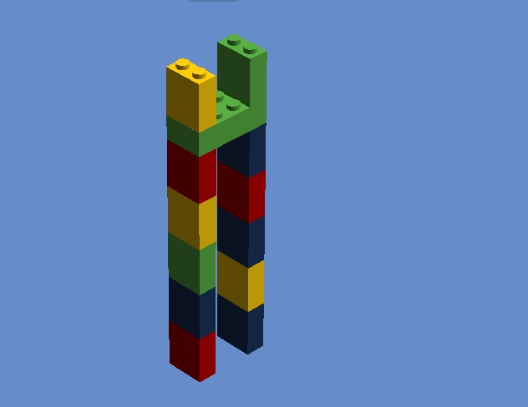

Building The Foundation –
- Left Foundation
- Take out two 1x2 blocks and eleven 2x2 blocks.
- Now, place four of the 2x2 blocks on top of each other to form a wall.
- Then, take another 2x2 block and place it underneath the wall in such a way that only two circles are visible from the 2x2 block..
- Repeat steps 2 and 3
- Afterwards, place a 2x2 block in the middle of the bottom blocks to connect both walls.
- Lastly, attach the remaining 1x2 blocks on opposite sides, parallel to each other, on the connected walls so that four circles are visible in the middle..
- Right Foundation
- Repeat everything from steps 1-6
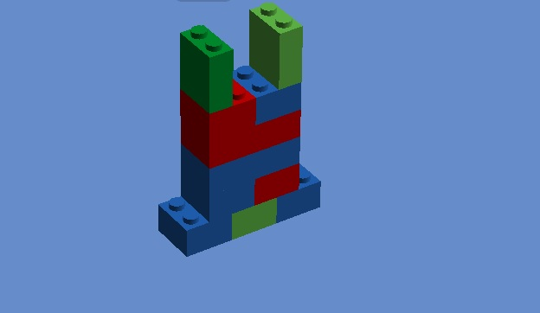
- Center Foundation
- Take out a 2x6 block, four 2x4 blocks, a 1x8 block and two 1x4 blocks.
- Place the four 2x4 blocks on top of each other to make a wall.
- Next, place the 1x8 block on top of the wall (be sure it is perpendicular to the wall) at one of the ends..
- Afterwards, place the 1x4 block on the other end of the wall (be sure it is perpendicular to the wall) in such way that it is connected to only one circle.
- Then, attach the final 1x4 block on the same end as the previous 1x4 block so that it also is connected to only one circle.
- Lastly, attach the 2x8 block on the wall such that it is between the two 1x4 blocks and the 1x8 block.
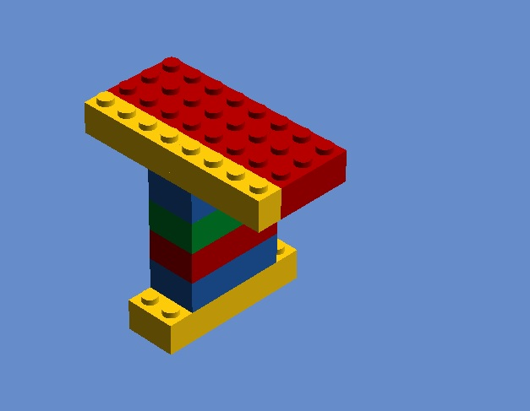

Deck –
The desk will be comprised of the remaining Lego blocks. The 2x8 block will act as the center of the bridge.
Left Side -
- First, place two 1x4 blocks on top of a 2x2 block in such a way that they are parallel to each other and each cover only one circle from the two-by-two block.
- Next, attach a 2x3 block underneath two 1x6 blocks in such a way that only two circles are visible from the 2x3 block.
- Then, attach a 2x3 block on top of the 2x3 block.
- Lastly, attach a 2x3 block underneath the two-by-four block.
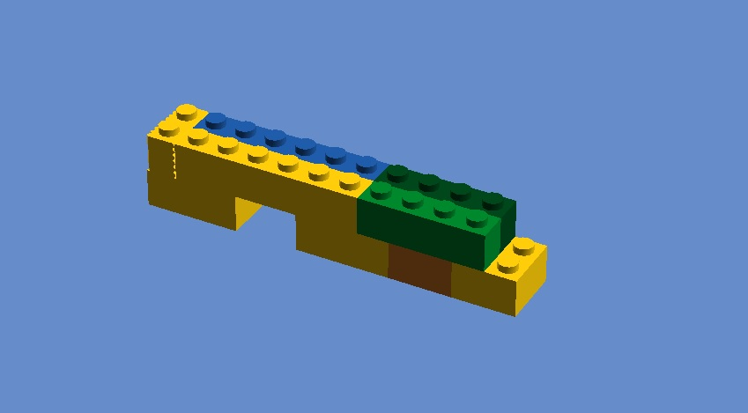
Right Side –
- Place a 2x4 block on top of a 2x3 block in such a way that it connects with two circles from the 2x3 block.
- Then, attach the 2x3 block to two circles underneath the 2x4 block.
- Afterwards, place two 1x4 blocks on top of the 2x3 block so that it connects to the remaining circles of the 2x3 block.
- Now, place a 2x3 block underneath the two 1x4 blocks in such a way that two circles are visible from the 2x3 block.
- Finally, place a 2x2 block on top of the 2x3 block.
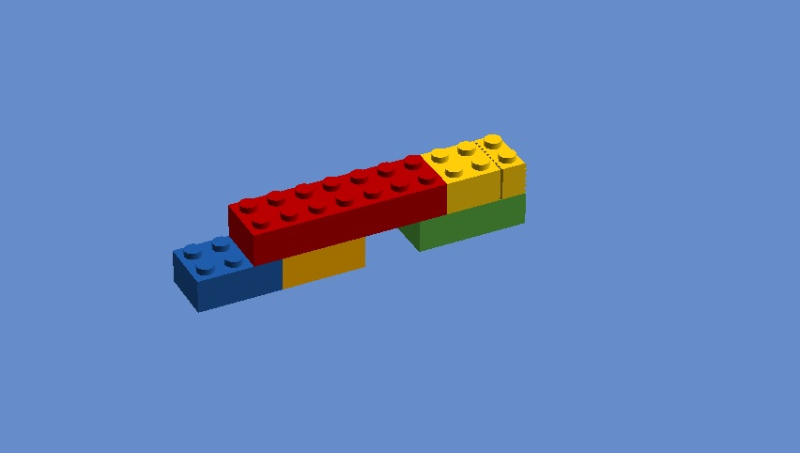
Now, the only thing left for you to do is combine all of the parts, so that it forms a whole.