Prof. Lovegreen
Luis Flores
ENG 3773 Peer-Review
3/10/15
1) The images enhance the visual appeal of your technical document but it feels as if the document is relied solely on the images. I feel you should decrease the total number of images used in the document.
2) Try Implementing a few changes in your wording and phrasing of directional queues.
a) Step 15 is worded awkwardly
b) Step 19: “…on either side with the short side facing you.”
Other than that, your technical document is looking very good.

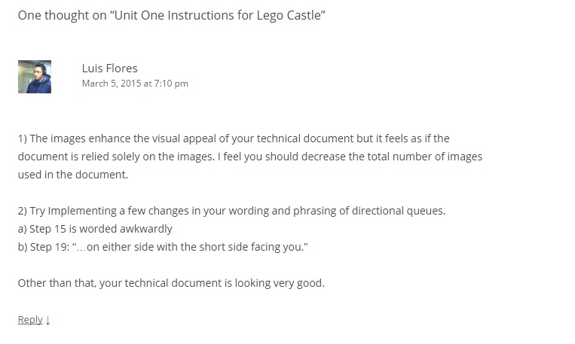
Google Drive Peer-Review
- Not sure what “outside spaces” means. Maybe if I had the Legos in front of me I may understand but just based on the wording, it confused me.
- Your comments look good; the technical language confuses me because I don't have the Legos in front of me. It looks good, though.
