Department of Architectural Technology

ARCH 1231 BUILDING TECHNOLOGY I

Exterior Wall Assembly + Performance Analysis Assignment

Description: Interior space requires a level of control over the quality and condition of the environment including temperature, humidity, moisture, air quality, airflow, lighting, and acoustic properties. The control of the interior environment starts with the building envelope. The building envelope is a system of assembled elements and spaces that work together to regulate the relationship between the interior environment and the exterior environment. The performance of the building envelope can be studied and measured to ensure it is providing the designed regulation of environmental elements.
This assignment focuses on the design of the exterior wall assembly for the case study building, utilizing masonry as the primary material. Each student will develop a system for the exterior wall, document it in two and three dimensions, annotate its components and their role in the assembly, and then analyze the performance of the system.
Assignment Context: This assignment introduces building assemblies and performance analysis that will be developed and enhanced in the Building Technology courses that continue the sequence.

Prerequisites: Understanding of three-dimensional projection and material properties and modules, completion of the required readings.

Recommended Text:

Ching, Francis. Architecture Graphics. John Wiley and Sons, 2009.

Suggested Reference: See the City Tech Openlab for additional reference materials.
Plagiarism: Student work submitted must be original and developed individually. Tracing is not acceptable. All construction lines and notations during drawing construction are to remain visible at final submission. Drawings without construction lines (guidelines) will be downgrading significantly.

Assignment Specific Learning Outcomes / Assessment Method
Learning Outcomes | Assessment Methods
Upon successful completion of this assignment the student shall be able to: | To evaluate the students’ achievement of the learning objectives, the professor will do the following:
Develop coordinated, accurate, and consistent set of two and three-dimensional drawings documenting the exterior wall assembly. | Review student drawing set for consistency, orthographic projection and coordination between drawings, and dimensional accuracy.
Understand some of the basic principles used in the appropriate selection of interior and exterior construction materials, finishes, products, components, and assemblies based on their inherent performance, including environmental impact and reuse. | Review student notebooks and drawing set submission for proper application of material properties, rules of thumb, and performance analysis.
Understand and apply basic principles of performance analysis. | Review student performance analysis diagram for application of conventions and accuracy of analysis.

Grading Rubric Student Name:

 | Approaching  Benchmark | Benchmark | Approaching Capstone | Capstone
Lineweight  Distinguishing elements especially cut lines (poche), grid lines, transparent elements, finishes | Lines are consistent thickness and quality, in the correct alignment | In addition, two line weights are distinguishable, including cut line | In addition, three or more line weights are distinguishable, including some finish textures | In addition, transparency is clear, centerlines, grid lines, dimension lines are shown w/ correct line type and line weight.
Drawing Organization and Accuracy  Setting out of grid and the relationship of elements to the grid is accurate | Structural Grid is established | In addition, structural grid is dimensioned accurately and labeled correctly | In addition, major elements (walls, columns) are accurately placed in relation to the structural grid | In addition, all drawing elements are carefully located in relationship to centerlines and the structural grid
Construction / Guidelines  Guidelines and constructions were utilized in the careful construction of each drawing | Guidelines are used for overall geometry of drawings | In addition, guidelines indicate orthographic projection for 3-d vignette construction. | In addition, guidelines indicate geometric center of spaces, perimeters of spaces, and grid locations of key elements | In addition, guidelines are accurate, working off of grid lines and centerlines to each major element and guiding alignments.
Envelope System  The exterior envelope system is developed based on principles of exterior wall assembly. | General configuration of exterior wall and assembly is depicted | In addition,  masonry modules and coursing is accurate | In addition, insulation and vapor barriers are correctly positioned | In addition, all elements of the assembly are properly labeled and annotated
Performance Analysis | Performance Analysis diagram is depicted | In addition,  Thermal and Moisture Resistance is diagrammed correctly | In addition, unit and total R values for each element are listed and calculated based on thickness with reference provided | In addition,  Total R value is calculated accurately and dew point is diagrammed correctly.
Drawing Conventions + Coordination  Standard methods of drawing and documentation of key data and elements are utilized and coordinated | Drawings are properly scaled and provided with a title including course #, student name, professor name, semester + year | In addition, detail drawings are referenced to each other using cut lines and tags | In addition, drawings are organized on sheet to ensure proper projection from plan to elevation to section detail | In addition, drawings are consistent and coordinated and indicate clear understanding of drawing types and layers of information
Assignment Schedule: See syllabus
Deliverables:
- Plan Detail Sheet Size: 22”x 34” Scale: 3/4”=1’-0”
- Section Detail Sheet Size: 22”x 34” Scale: 3/4”=1’-0”
- Elevation Detail Sheet Size: 22”x 34” Scale: 3/4”=1’-0”
- Axon Detail Sheet Size: 22”x 34” Scale: 3/4”=1’-0”
- Performance Analysis Sheet Size: 22”x 34” Scale: 1 ½”=1’-0” or larger
Extra Credit:
- Annotated Digital Model of Axon Sheet Size: 22”x 34” Scale: 1”=1’-0” 20 points
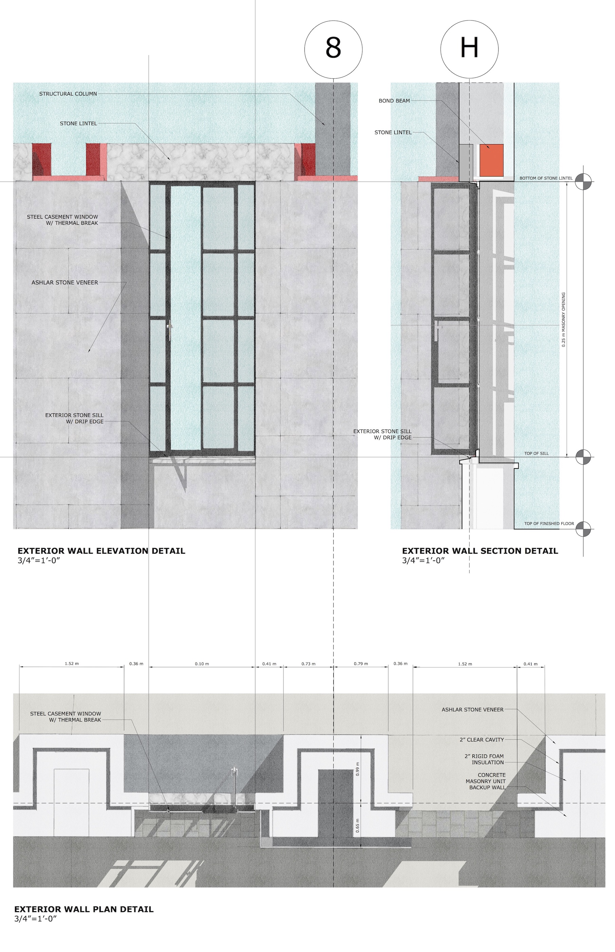
Mockup of Exterior Wall Detailed Plan, Elevation, and Section

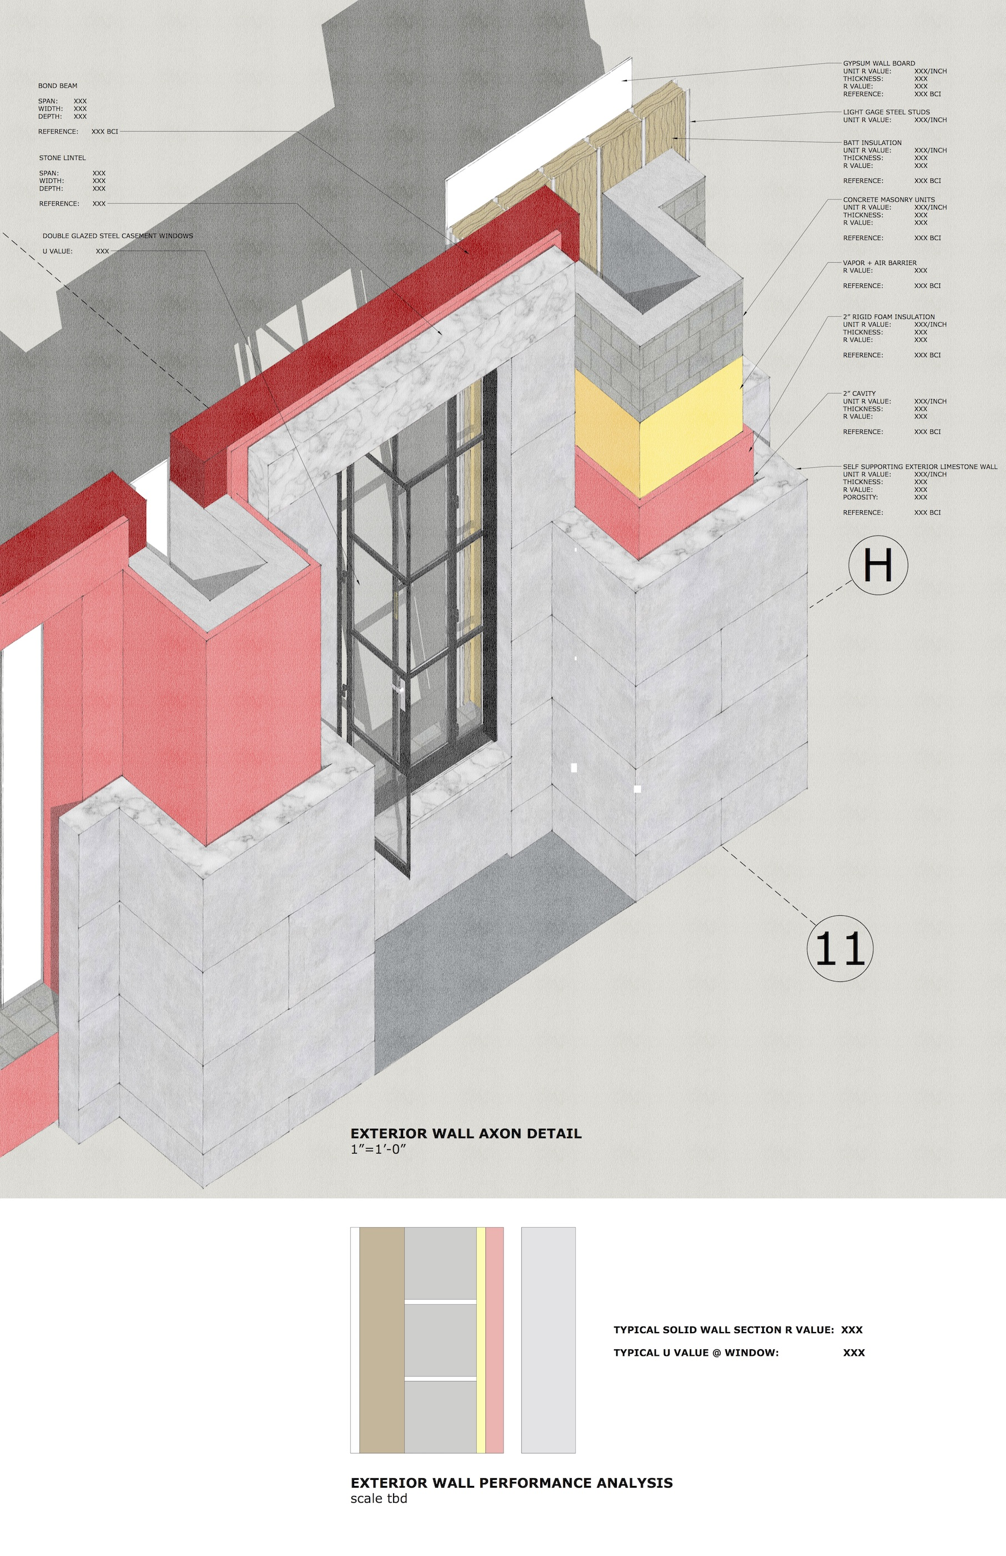

Mockup of Exterior Wall Axon w/ Performance Analysis

