Learning Places Fall 2015
SITE REPORT
New York Public Library Visit
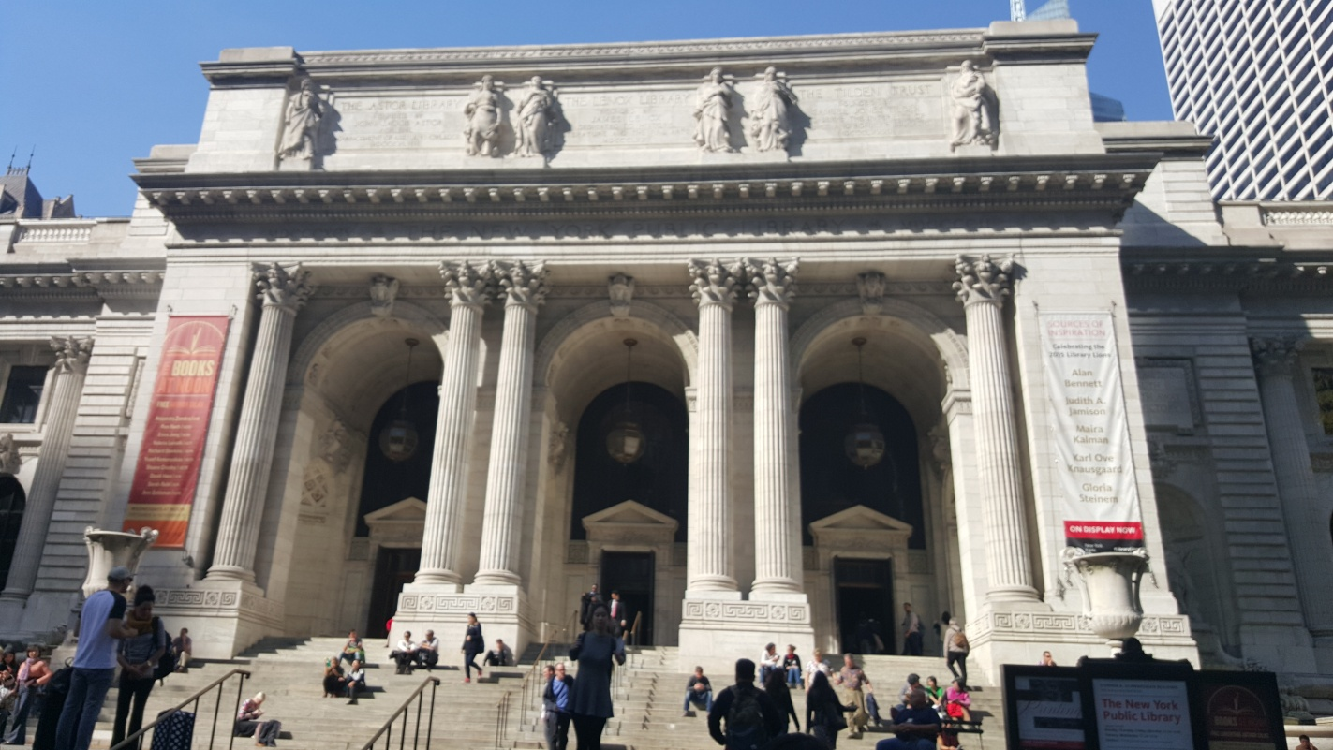

Litz Jean
10.28.2015

INTRODUCTION
For this site visit, we came to the New York Public Library, to try to gather information for our respective topics. In this case we focused mostly on old maps of Brooklyn to try to give us insight into the areas past in the hopes of discovering relevant information and drawing conclusions based on evidence found.

PRE-VISIT REFLECTION
Based on some of the other posts I read I’m not the only one that hasn’t been to the library in a while, and not just to use the bathroom but to actually research something. I think this should be a good visit, although we’ve visited the site and collected data on it, one of the best ways to find out the “why” of something is to look at its history. If we can see the conditions of the land or what was there before, we may be able to draw conclusions on the thought processes of those who decided to be rid of a “slum” to make way for this construction. I think this information should be beneficial to all groups.

SITE DOCUMENTATION (photos/sketches)
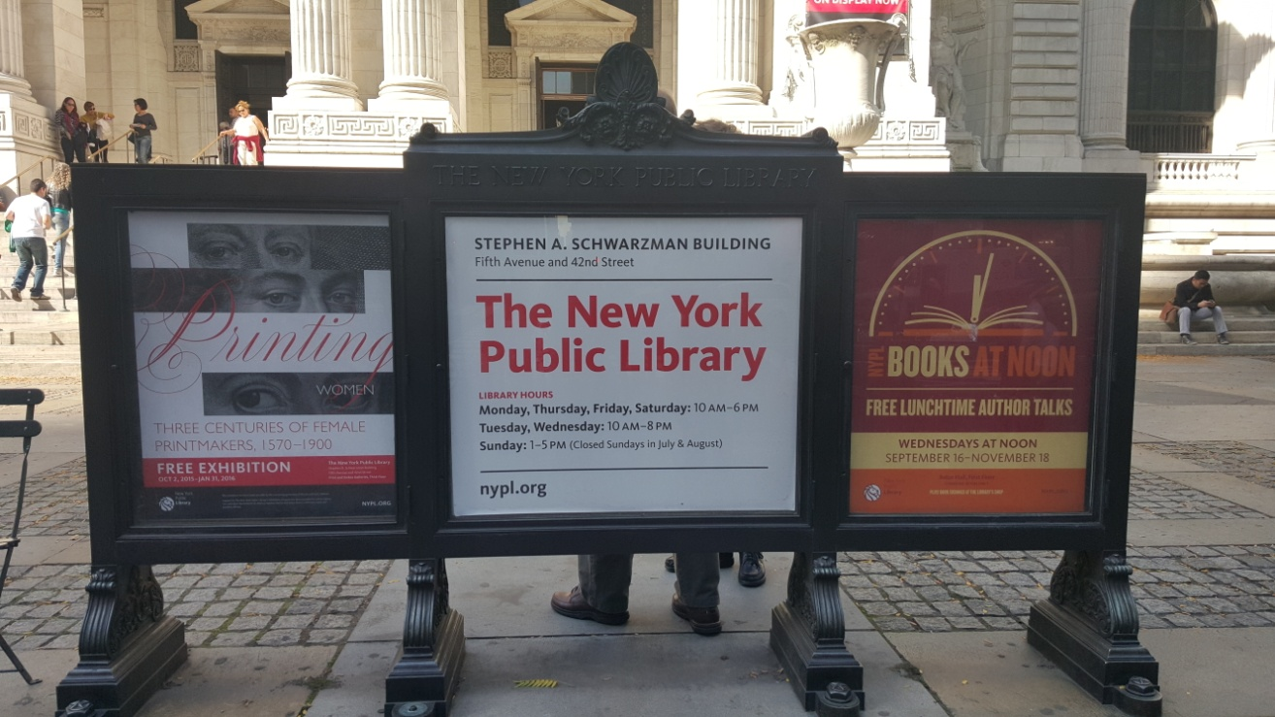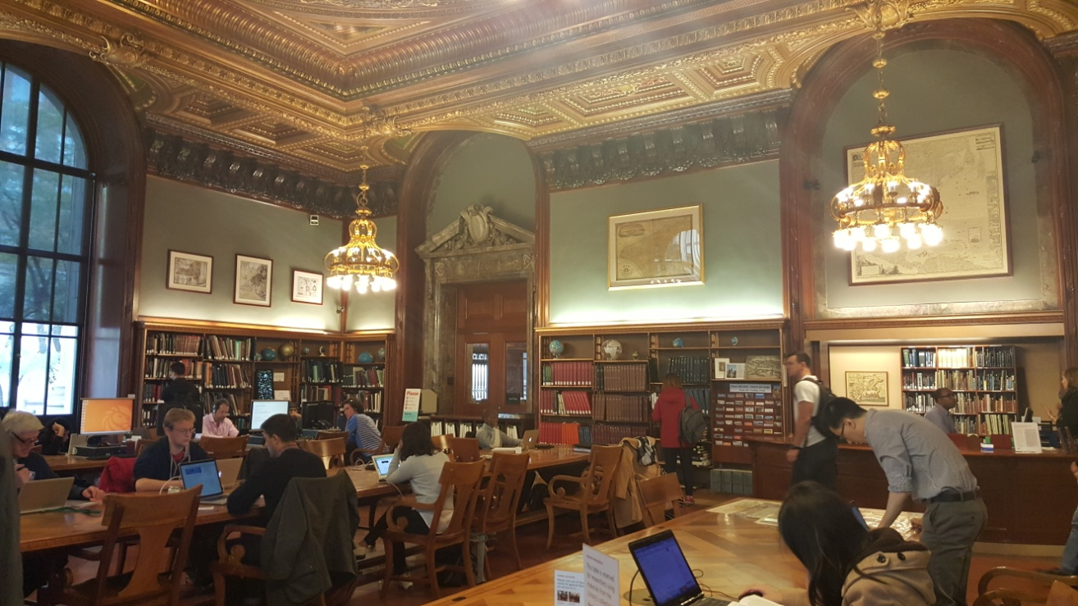
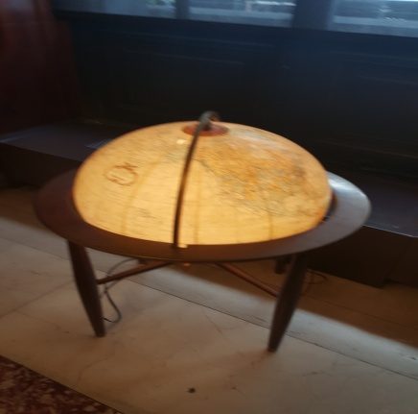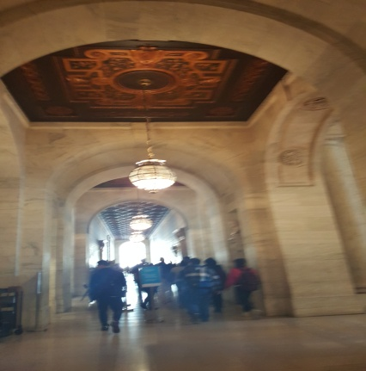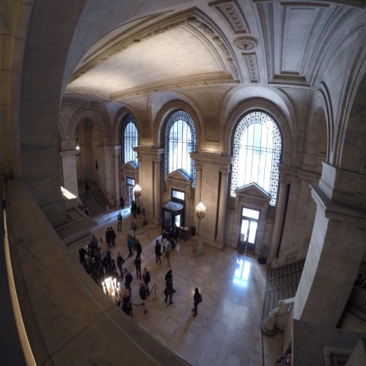
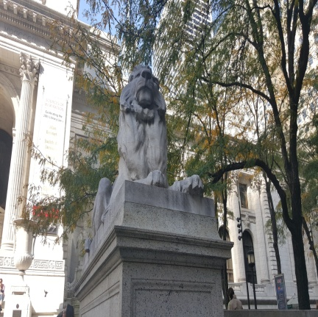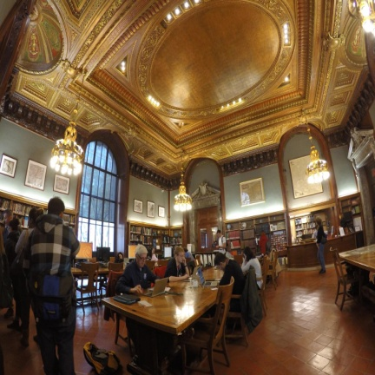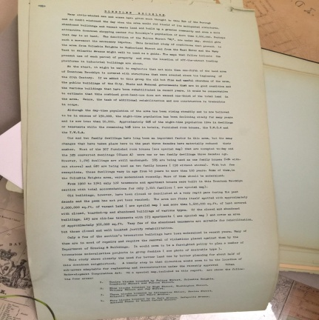

SITE OBSERVATIONS
- There are two lion statues perched outside
- There were a lot of tourists
- It is a very large building with many rooms with different information
- There was a book reading in the lobby.
- The maps we looked at varied between old books and laminated papers.
- The building itself is supported by a lot of arching architecture.

QUANTITATIVE DATA
Subject | Data
Amount of years of construction | 12 years
Amount of Opening day visitors | 50,000
Cubic feet of marble used | 530,000
Size of library Lions | 11 feet

QUESTIONS AND HYPOTHESIS
QUESTIONS:
- Why did they choose that location to build the Farragut houses?
- How much did the construction of the building cost?
- How did crime affect the area?
HYPOTHESIS:
- Some maps showed buildings in the area to be really old; perhaps they were trying to address a safety issue.
- I assume it wasn’t cheap, counting both the building price and the land.
- The abandoned buildings may suggest a crime riddled area, as it is an ideal place for criminals to strike as opposed to a populated area.

SUMMARY / POST VISIT REFLECTION
This was a very interesting visit. Before that day I never actually stepped foot in the library though I’ve passed it many times. It was cool to see how massive the building looked both inside and out. Though I arrived a bit late due to train problems, my visit was still just as beneficial. The maps that were laid before us ranged from general overviews to as specific as zoning and street level maps that told us the age of the buildings. Though it may not have been easy to find maps directly related to me safety & crime topic, my group was able to look indirectly at some maps and draw conclusions based on them. Froe example, a building map showing the ages, though it didn’t directly show safety information we may be able to assume a lack in the buildings integrity making it not the safest building to be in. It was good to get some information through these maps that I may not have gotten otherwise.

REFERENCES TO EXPLORE HYPOTHESIS
- http://www.nypl.org/blog/2014/03/28/open-access-maps
- http://www.nypl.org/about/locations/schwarzman/facts
- http://exhibitions.nypl.org/100/learn/fun_facts

