Learning Places Fall 2015
SITE REPORT
New York Public Library
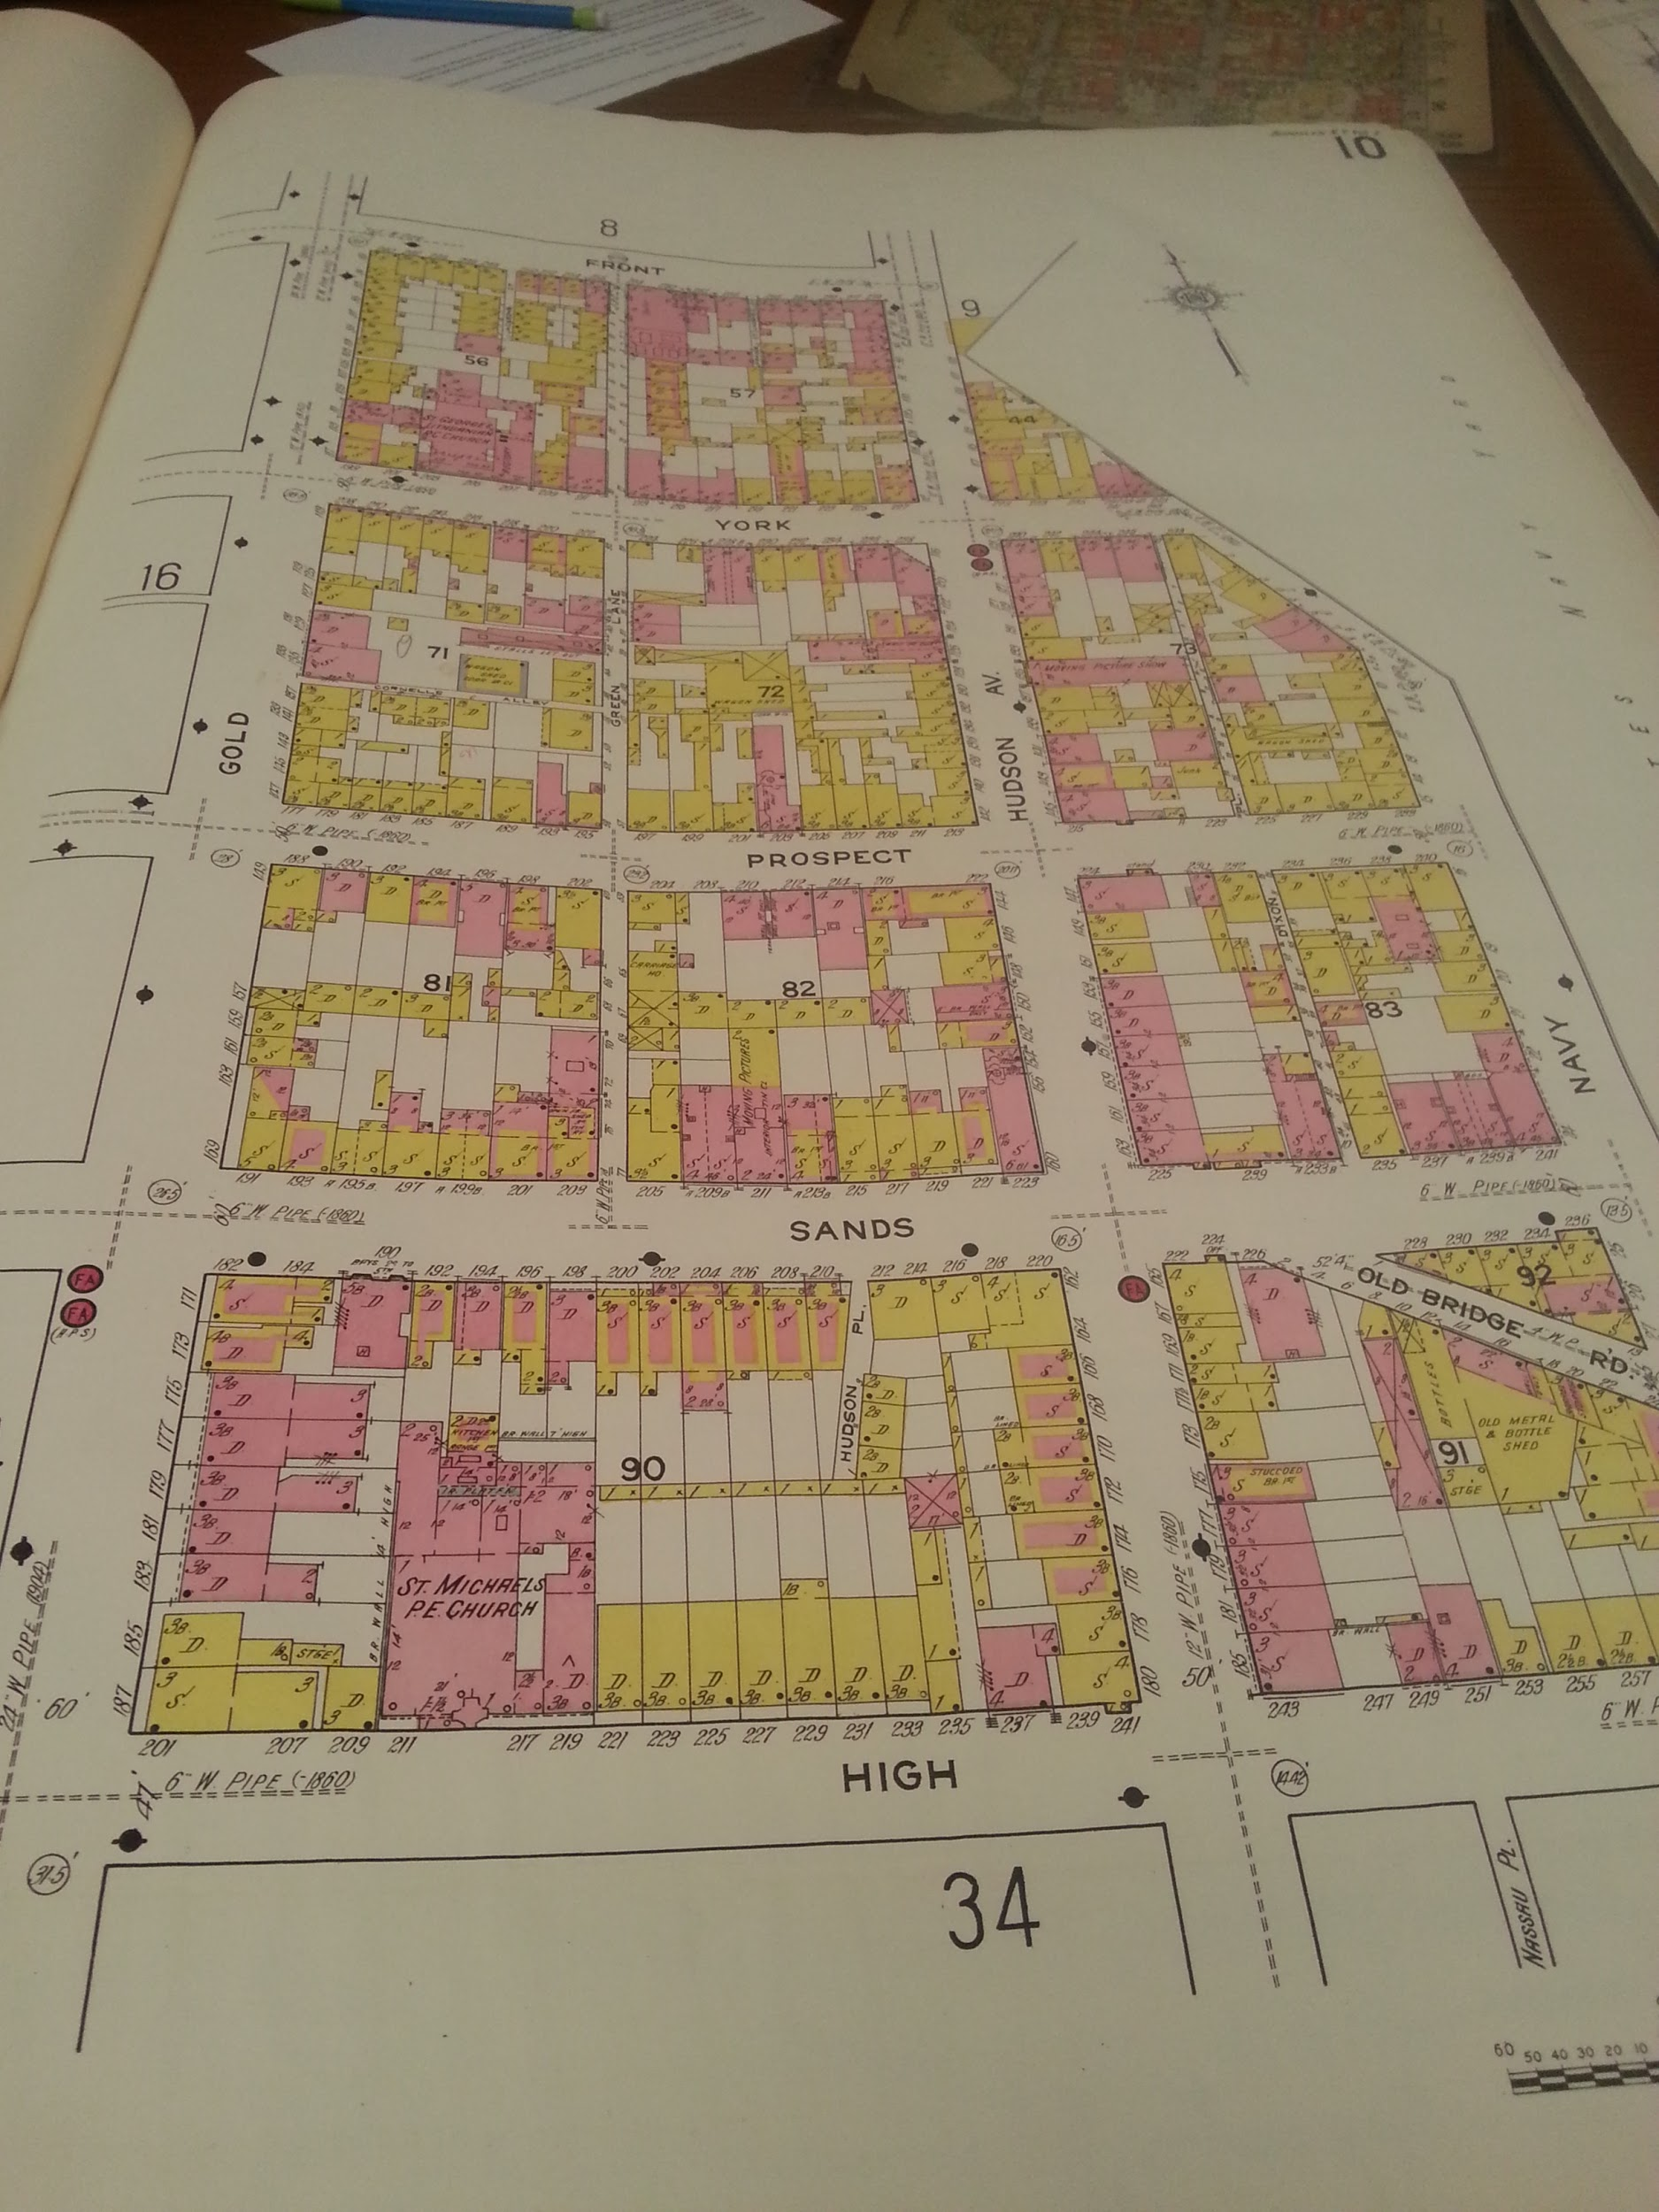

STUDENT NAME
William Tom

INTRODUCTION
On October 21,2015 we went to the main branch of the New York Public Library in bryant park. There we observed many historical maps of New York City dating back from 1800s. We primarily looked at maps of the neighborhood of the Farragut houses, Vinegar Hill, and the Navy Yards in Brooklyn. With this research and information of the layout of the land through history, we will have a better understanding of the history of the neighborhood.

PRE-VISIT REFLECTION
On October 21, 2015 the class will meet in the New York public library in Bryant park to go to the map room. I am excited to go on this visit, I have passed by the library many times but I have never been inside. I am particularly excited to observe the historical maps. It will be amazing to observe the physical history on the topography of New York city throughout history. I expect this visit will be vital with our gathering of information for the Farragut houses and the neighborhood of Vinegar Hill for the Wikipedia page.

SITE DOCUMENTATION (photos/sketches)
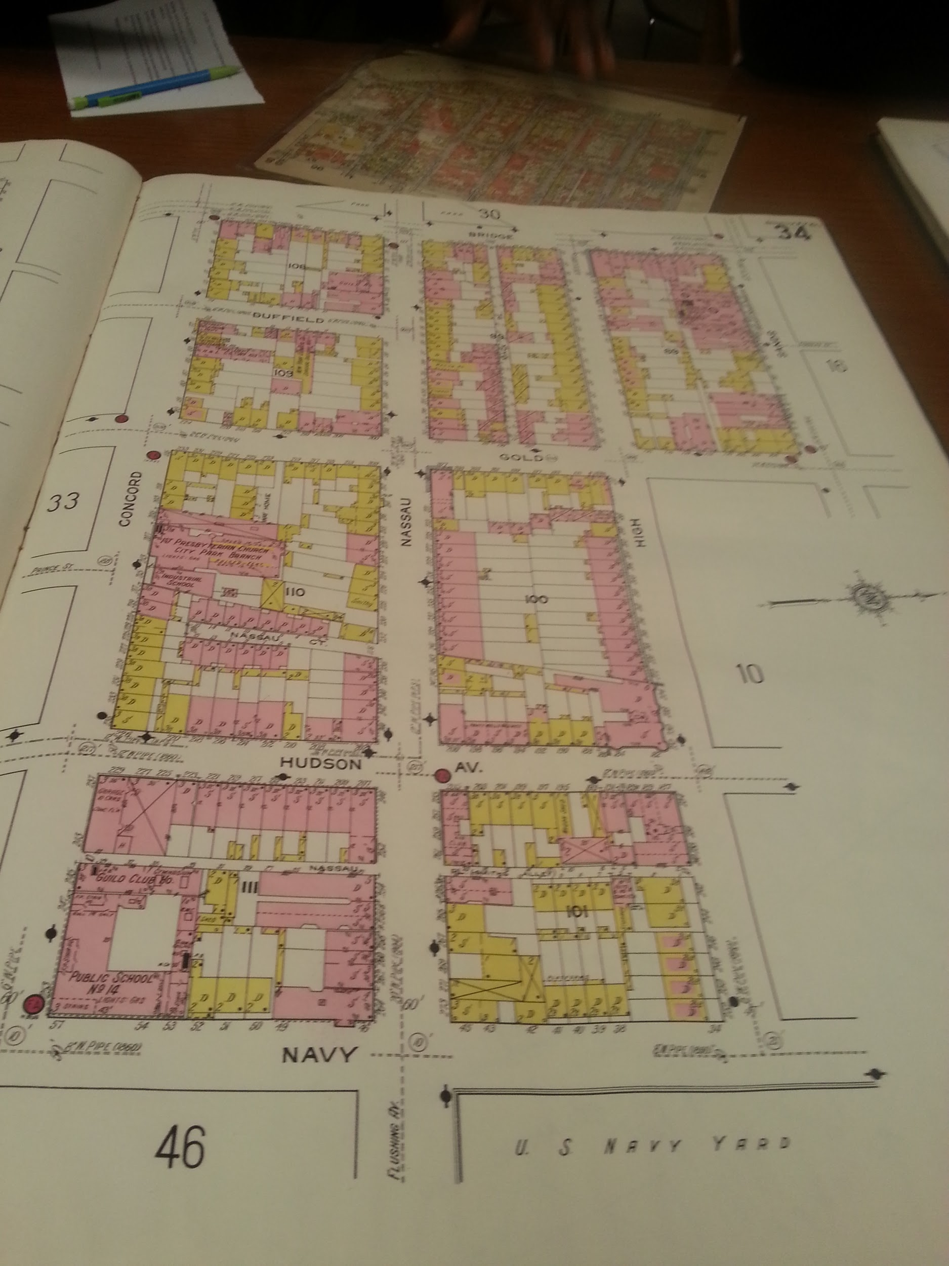

SITE OBSERVATIONS
- The building was massive with amazing architecture
- The library has a large collection of historical maps of many places all around the world
- The maps of New york city range from 1800s to modern times
- Despite age the maps were in relatively good condition but they are far from pristine.

QUANTITATIVE DATA
Subject | Data
Total maps collected data | 10
Number of sources | 3
pictures of maps | 2

QUESTIONS AND HYPOTHESIS
QUESTIONS:
- How many maps has the library acquired and is the public allowed to see all of the maps?
HYPOTHESIS:
- The library has over 20,000 maps in its collection and is is open to the public upon request or can be accessed online because the library has digitally scanned these maps in high resolution .

SUMMARY / POST VISIT REFLECTION
The site visit to the New York Public Library was an interesting experience. I have never went into the main branch of the library before. The architecture and design of the building was stunning. But was was just as stunning was the maps that they provided us for our research. Prior to the visit I thought these maps were kept in vaults and were only accessible in pictures in textbooks and the internet. To be able to examine the actual historical maps by hand was a privilege.

REFERENCES TO EXPLORE HYPOTHESIS
- http://www.nypl.org/blog/2014/03/28/open-access-maps

