Learning Places Fall 2015
Farragut Houses and Gold St
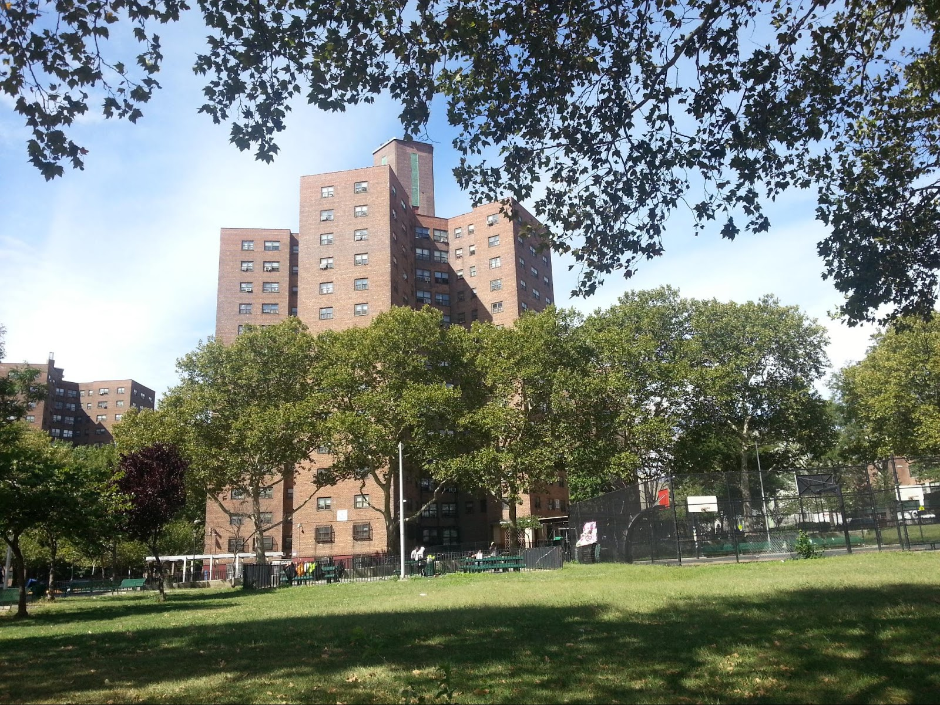

STUDENT NAME
William Tom

INTRODUCTION
In our revisit to the farragut houses we reexamined the neighborhood to gain more knowledge about the area. We took more pictures and surveyed the area. Also sketched the building because in our previous visit we did not because of weather conditions. Also we split into groups to go to seperate blocks and examining the ares. My partner Stephon and I went on Gold st, there we looked at buildings and storefronts.

PRE-VISIT REFLECTION
Prior to this site visit I anticipated to be the same experience we had on the previous visit. But since the weather was clearer I expected to see more activity in the neighborhood so we can see how the community behaves.

SITE DOCUMENTATION (photos/sketches)
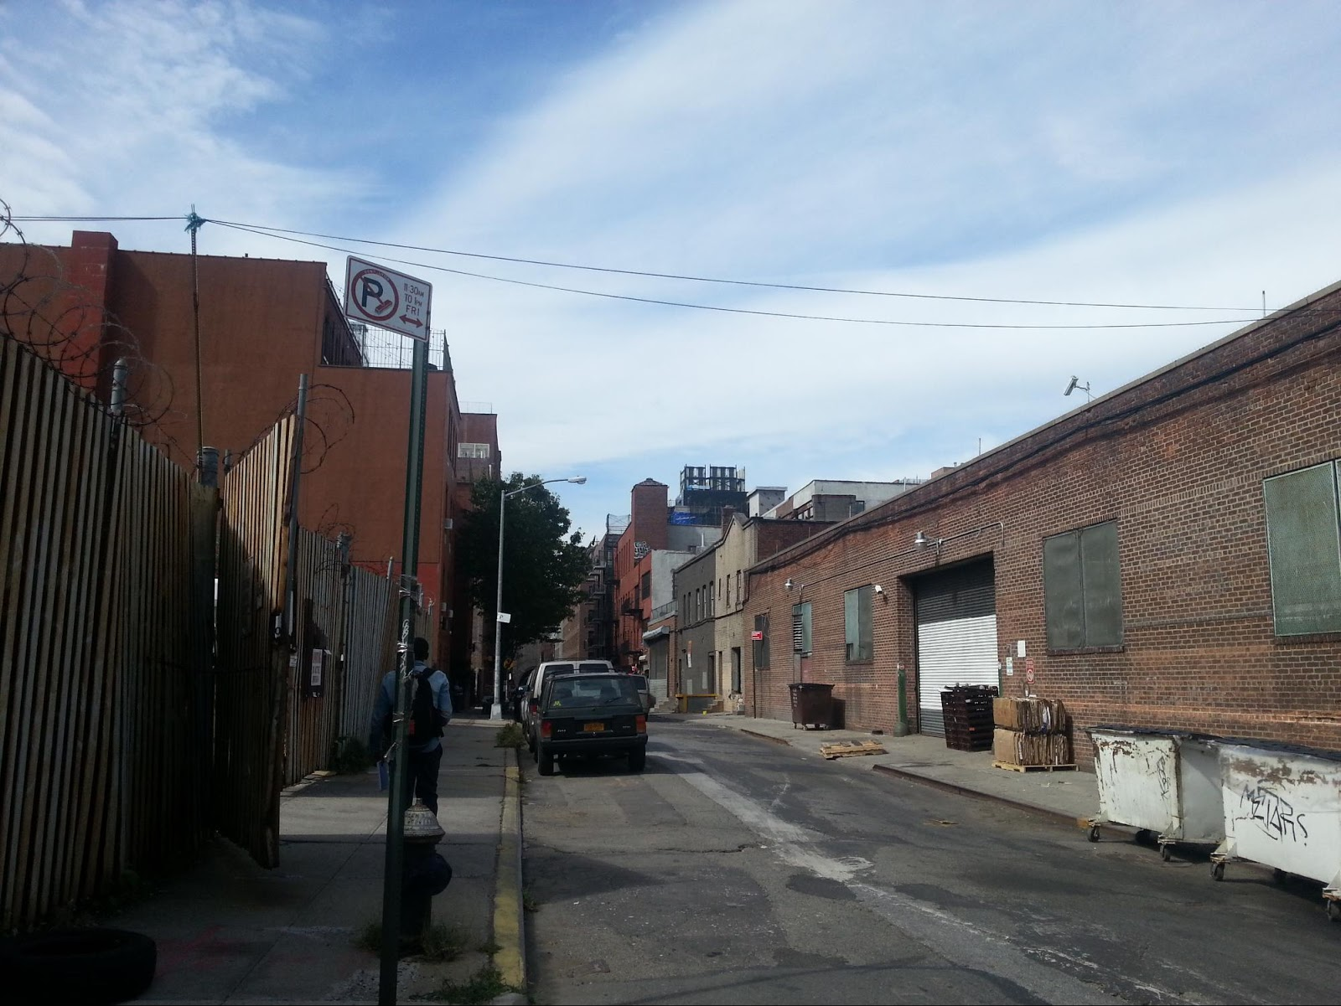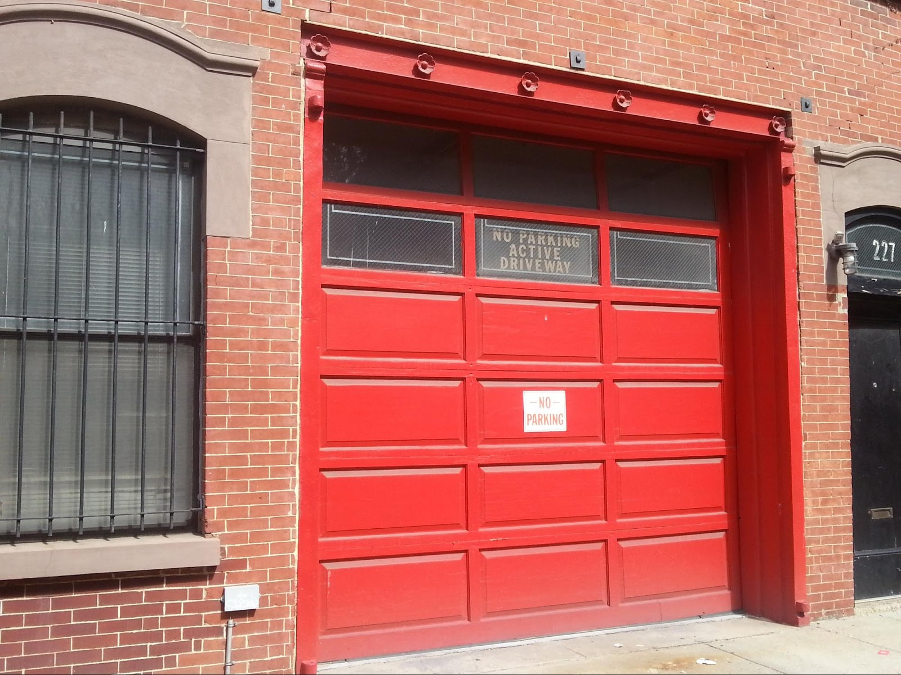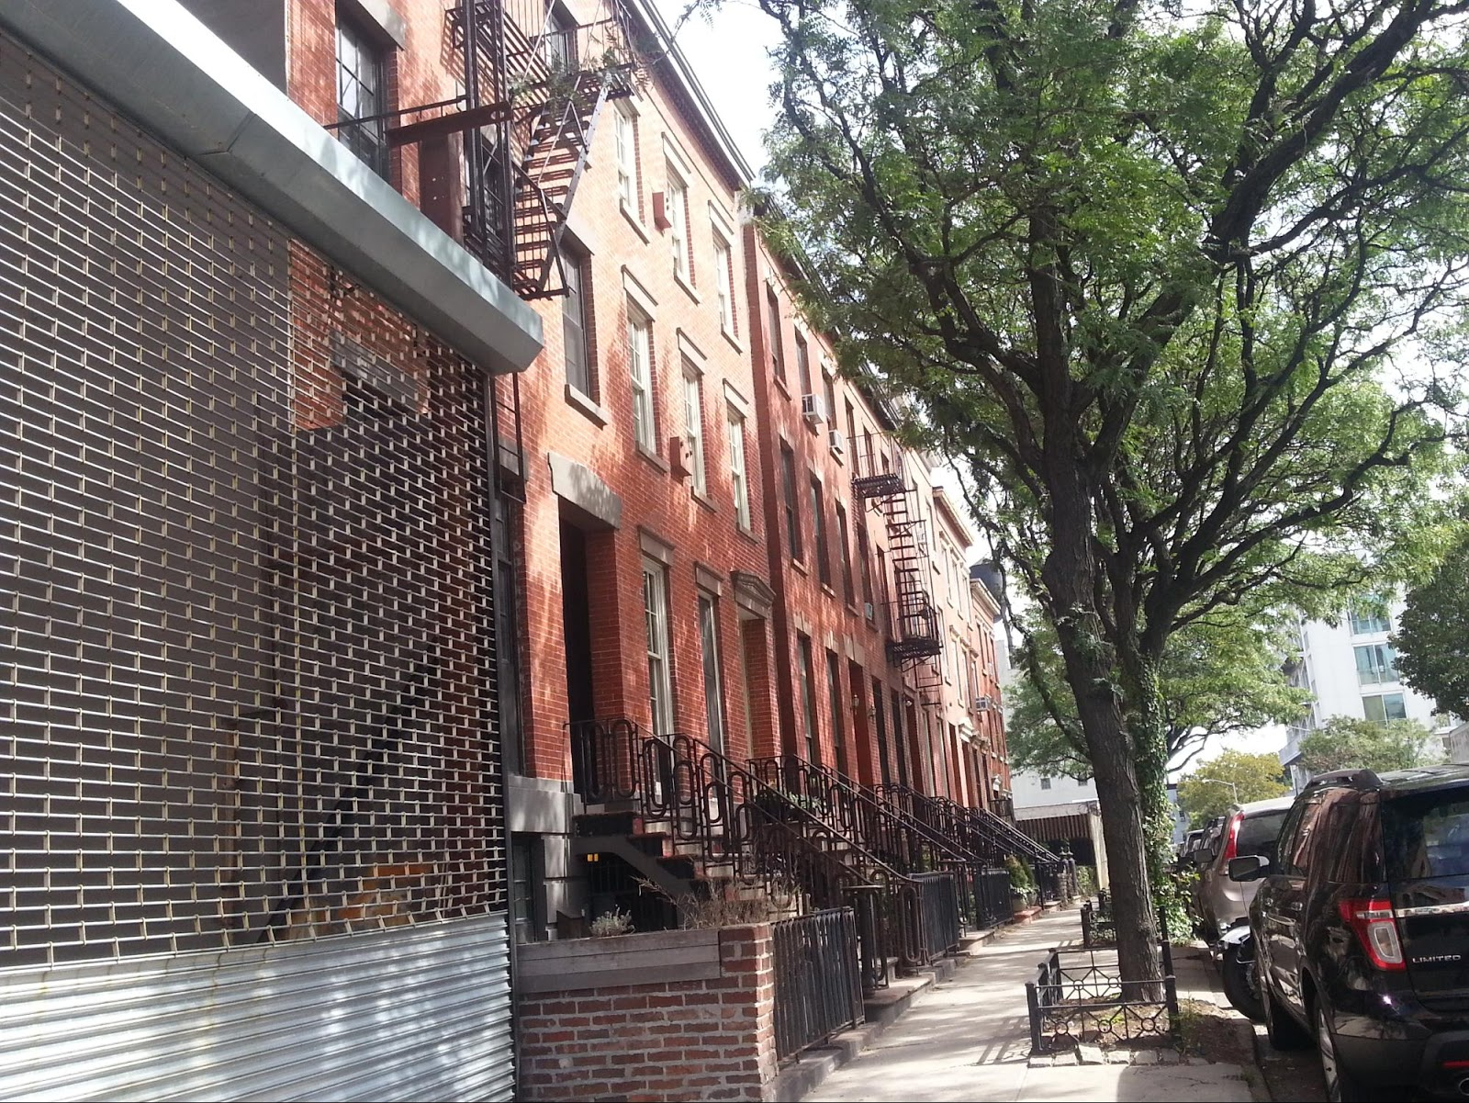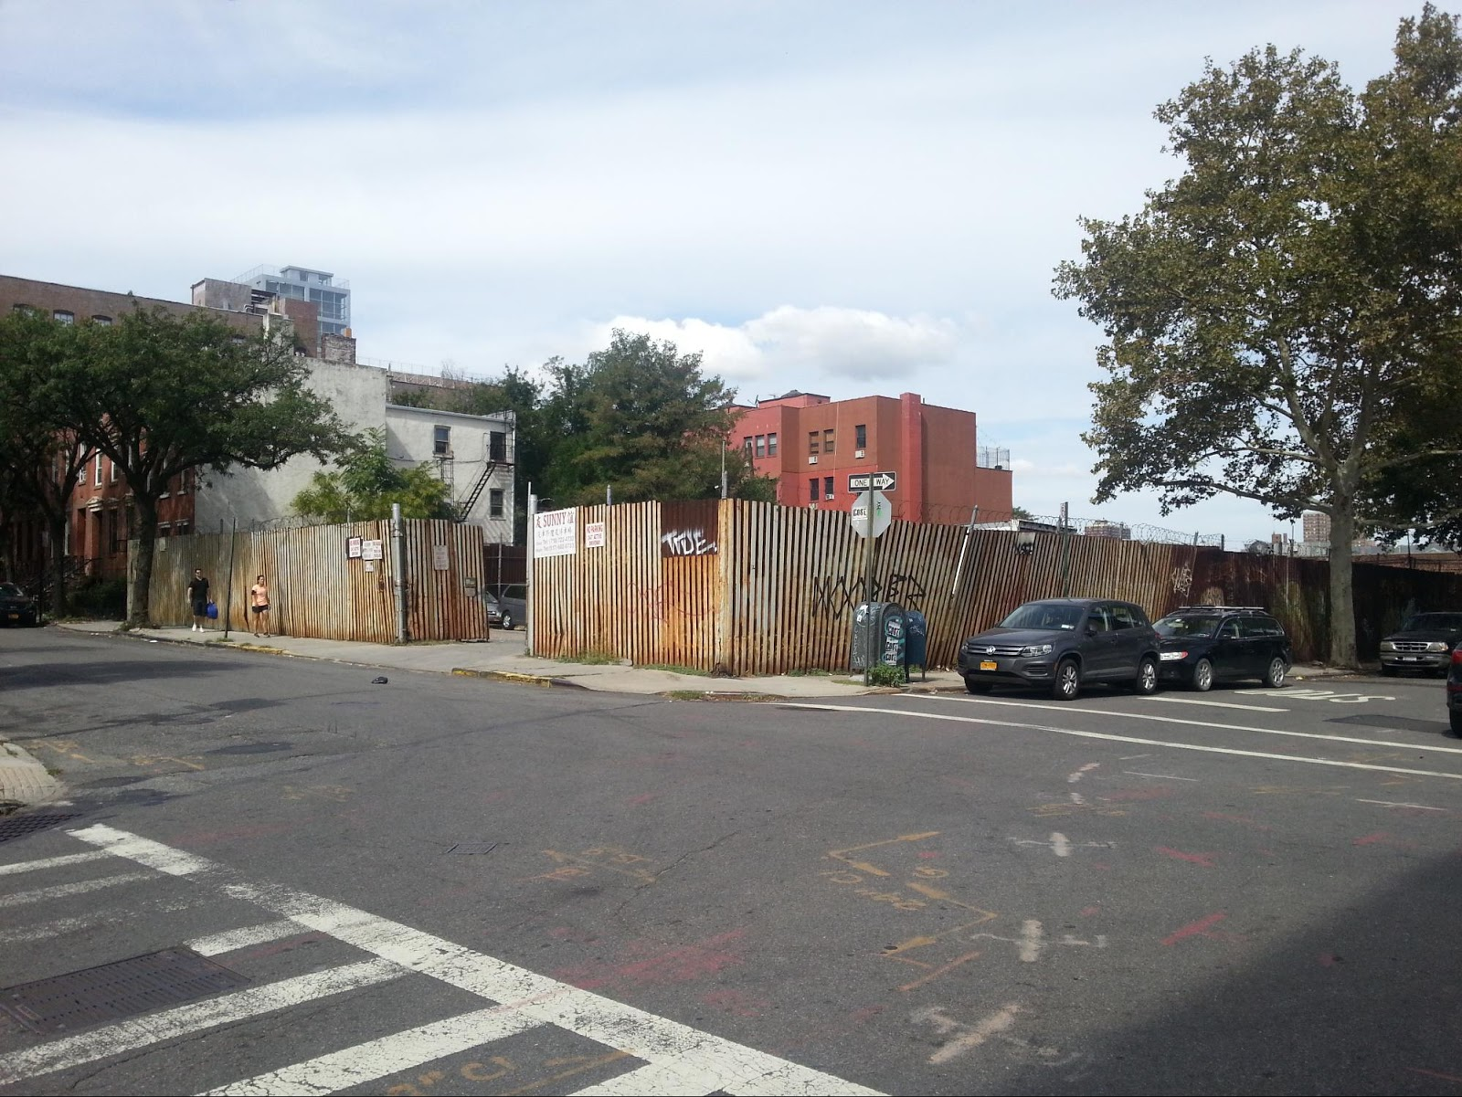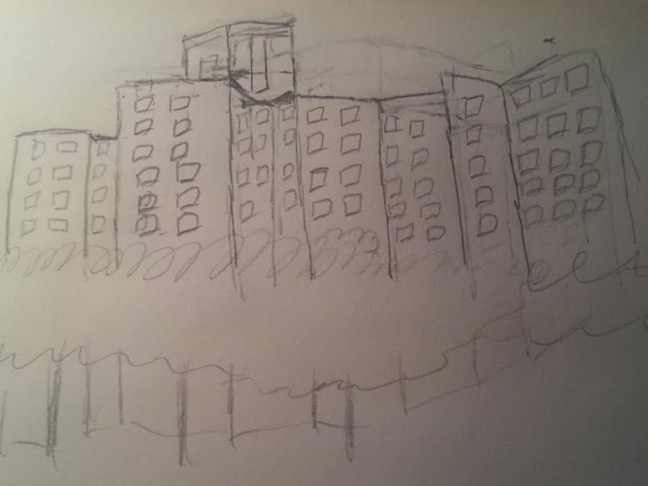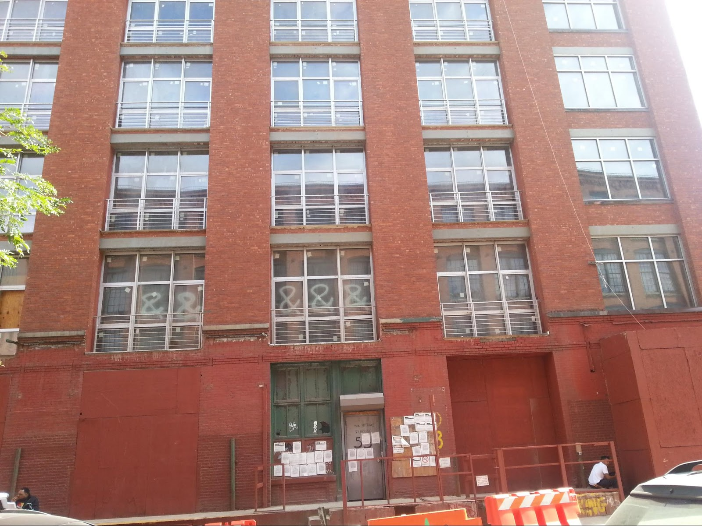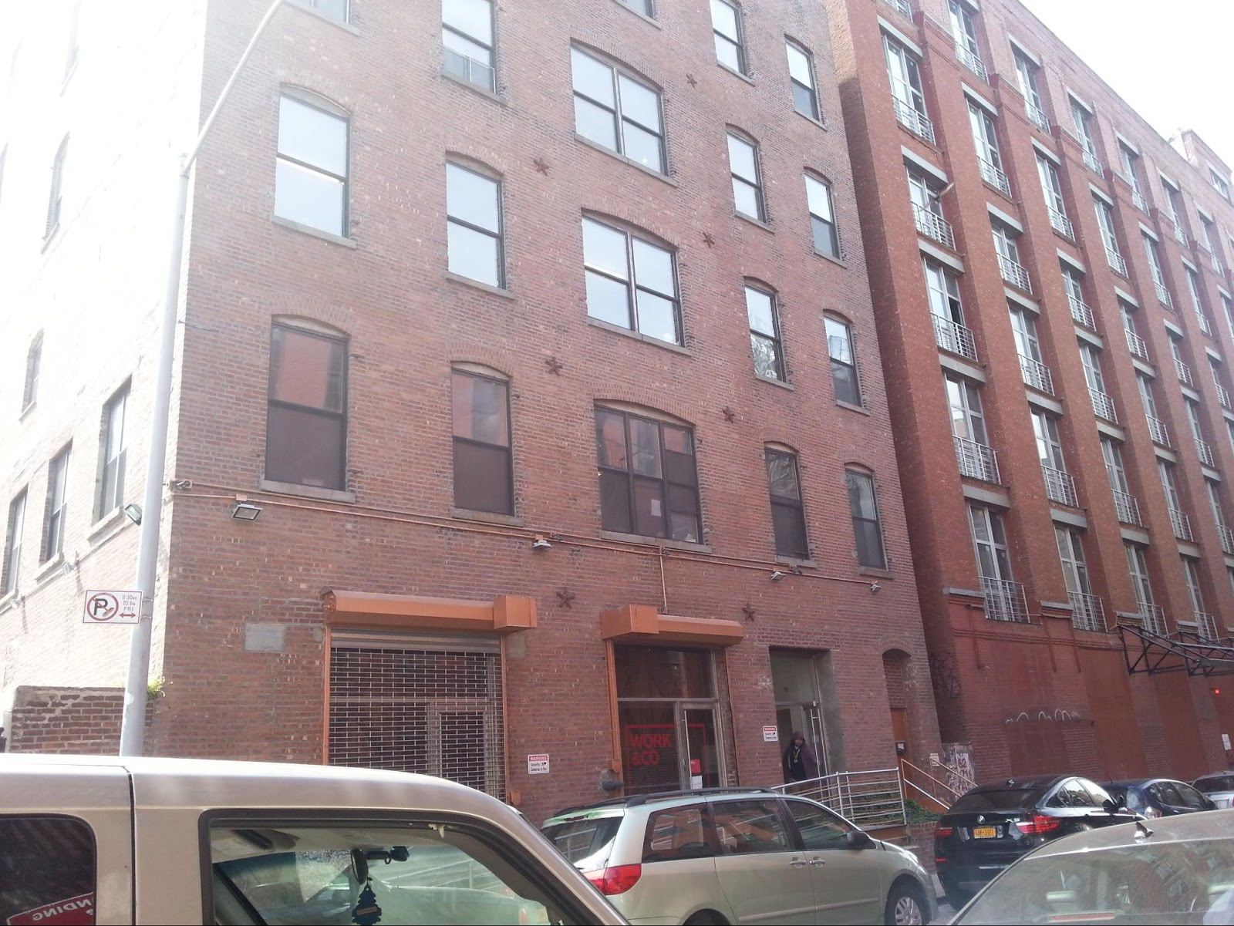

SITE OBSERVATIONS
- The Farragut houses are shaped very uniquely, it is arranged in a star formation but geometrically complex
- Gold st is mostly construction and parking lot area
- The buildings seem very old and repurposed for business and residential apartments.
- There is a building that seem like a old fire house
- alot of private parking spaces
- very few of the block is for residence

QUANTITATIVE DATA
Subject | Data
227 front st | It is residential apartment
year buildings were designed | 1870
Street pave | cobblestone

QUESTIONS AND HYPOTHESIS
QUESTIONS:
- What was building 227 originally?
- why are the some of the buildings empty?
- Are there any businesses nearby
HYPOTHESIS:
- Building 227 was originally a fire house. It was the constitution engine company 7 volunteer fire department, then it was engine number 8. It was built in 1870.
- The buildings are undergoing renovation
- There is a buisness called Work&Co which is a digital product and development company.

SUMMARY / POST VISIT REFLECTION
Sketching the Farragut houses was truly a challenge, the design is deceptively simple but it is a complex architect design. The farragut buildings and the history of the neighborhood is very interesting, learning about the changes of the neighborhood and what the people experienced in the neighborhood was a very informative. In the neighborhood my partner and I examined, most of the space in the block is taken up by private parking and construction. Very little of the area is business and residential. It was interesting learning about the old fire house and how a firehouse is now home to families. It was also interesting learning about the business in the block, Work & Co, and learning about what the company does which it designs digital product.

REFERENCES TO EXPLORE HYPOTHESIS
- http://www.brownstoner.com/blog/2013/01/building-of-the-day-227-front-street/
- http://work.co/

