Learning Places Fall 2015  
**SITE REPORT**

Farragut Houses and Vinegar Hill

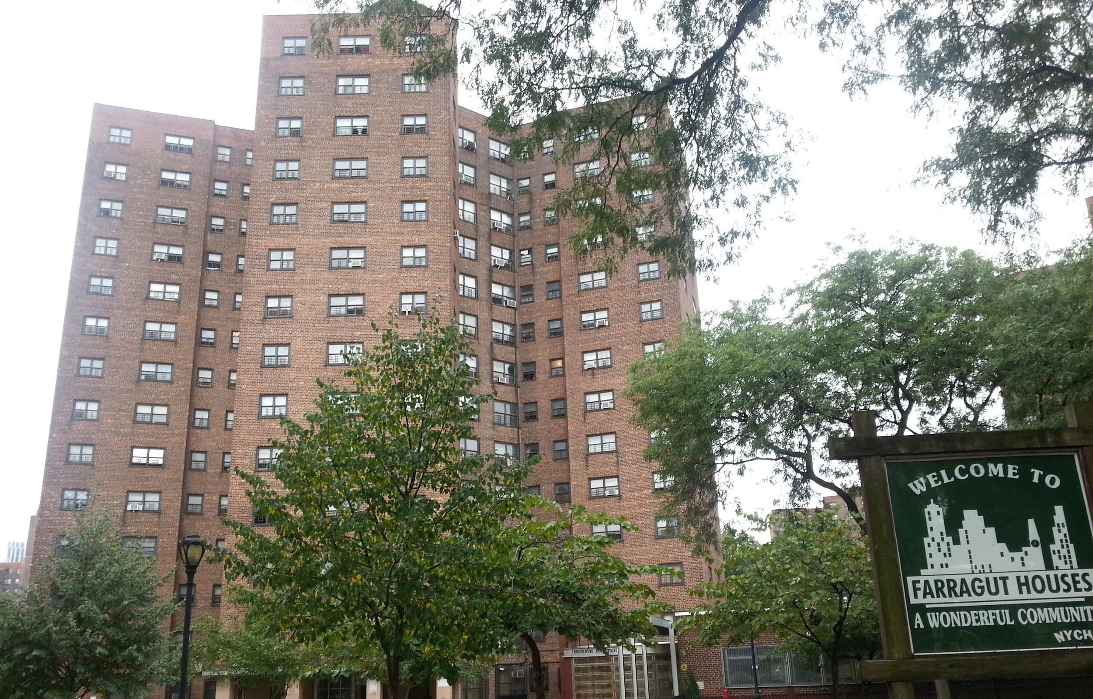

# STUDENT NAME

WIlliam Tom

INTRODUCTION

In this site visit we began in vinegar hill on the corner of Hudson avenue and Plymouth street. We began with observing the architect of the houses and discussed about how buildings were built at the time and the history of the neighborhood. Then moving on to the Farragut Houses and also discusses what makes the area and the building unique.

PRE-VISIT REFLECTION

On September 10 we will be going to the Farragut housing in Brooklyn. I have never heard about the Farragut houses neither have I seen them before. Mainly because I am not from Brooklyn and I don’t explore Brooklyn enough as much as I want to. The architectural design of the building looks intriguing yet simple. I am excited to observe these buildings and getting the opportunity to explore more of Brooklyn but I am nervous about my drawing/sketching abilities. I am not an artist and I do not usually draw often, I am intimidated about drawing the buildings onto a sketchbook. Drawing with a pencil seems more difficult to me than using a computer program to draw machine parts.

# 

# SITE DOCUMENTATION

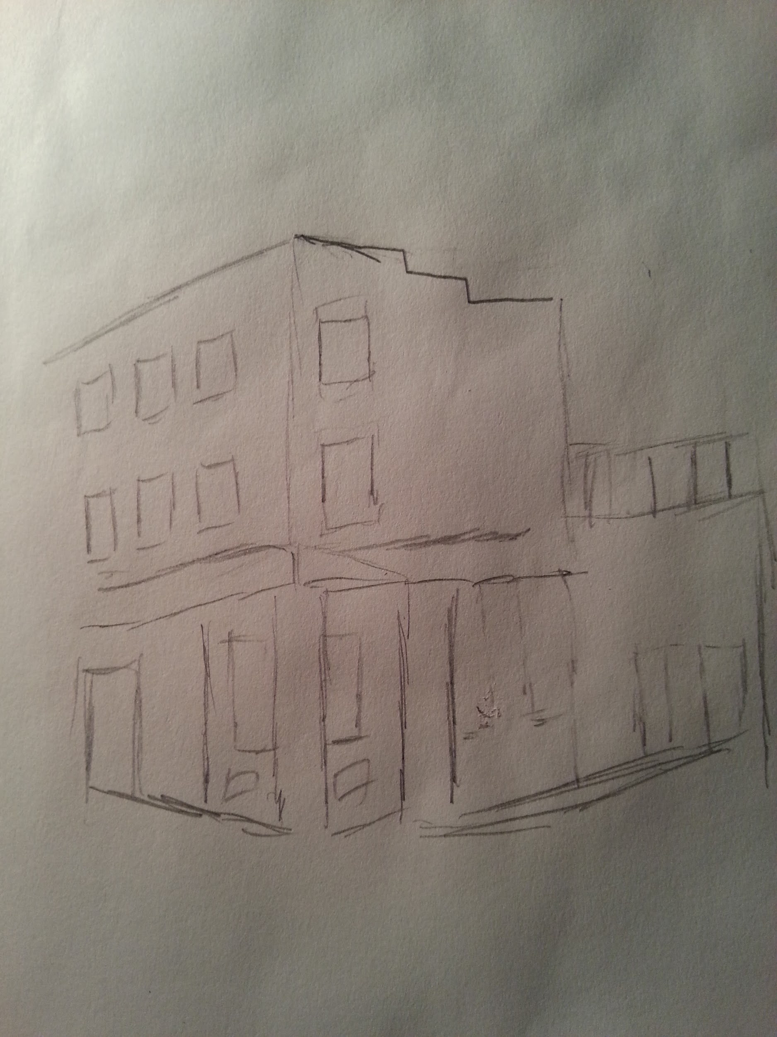

# 

# 

# 

# 

# SITE OBSERVATIONS

1. Evidence of the history lingers in the area such as cobblestone streets
2. Near a highway (BQE)
3. Parks and a school nearby
4. Small windows
5. Small shops/Bodegas
6. Buildings are all identical

# QUANTITATIVE DATA

|  |  |
| --- | --- |
| Subject | Data |
| Height | 14 Stories Tall |
| Property size | 16.61 acres |
| Number of apartments | 1,390 |

# QUESTIONS AND HYPOTHESIS

QUESTIONS:

1. Who were the buildings named after?
2. Who was the architect that designed the building?
3. What is the crime rate?

HYPOTHESIS:

1. The buildings were named after David Glasgow Farragut, The first admiral of the U.S Navy
2. The architects who designed the Farragut houses were hired by NYCHA
3. The neighborhood of the Farragut houses have a bad crime rate of primarily drugs and gangs.

# 

# SUMMARY / POST VISIT REFLECTION

After visiting the Farragut Houses I have a better idea of the layout of the neighborhood and what the area is really like. Not only observing and sketching but observing the people who live there, what personalities do they have and how is the community there overall. Though the building itself was nothing special the neighborhood has interesting history about the development of the area over the past few decades.

# REFERENCES TO EXPLORE HYPOTHESIS

1. <http://www.nyc.gov/html/nycha/html/developments/bklynfarragut.shtml>
2. <http://www.dnainfo.com/new-york/20150126/vinegar-hill/brazen-drug-dealers-used-farragut-houses-as-headquarters-officials-say>
3. http://www.nydailynews.com/new-york/nyc-crime/nycha-residents-live-fear-major-crimes-public-housing-soar-article-1.1747195