Dear spring 2022 MAT 1272 student,

Welcome to the start of your lifelong statistical voyage to collect, analyze, display, and infer from data. We will be using Wiley Plus for some graded aspects of the course, including homework. In addition, you will access many of the course materials such as the textbook and videos through Wiley Plus. Below you will find how to set up an account. On the reverse, there are details regarding payment, including the use of a code that gives you a $29 discount for 2 options. To set up an account go to https://education.wiley.com/ngonboard/index.html#/signup
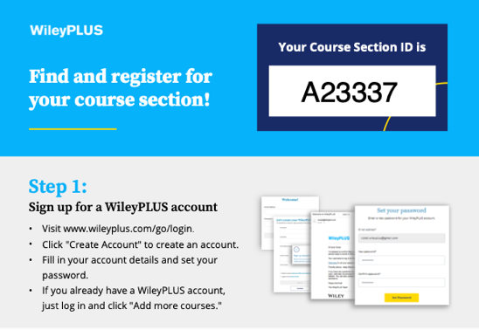

A12345

When choosing the school, you can start typing
CUNY COLLEGE OF TECHNOLOGY-BROOKLYN
there is pattern recognition and it will become visible
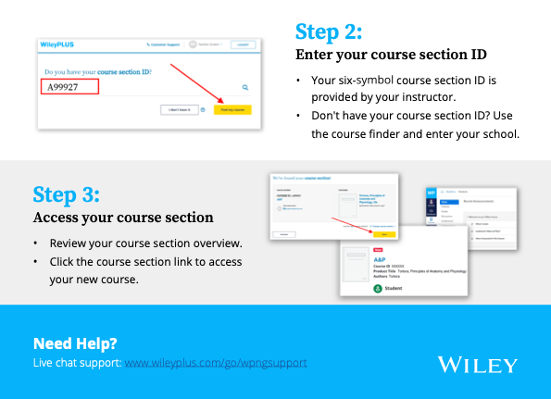
in a dropdown menu after typing just the first 3 characters.
When you get to this page:
- If you use financial aid to pay for books, you should get a registration code from bookstore which you enter here.
- For those paying out of pocket, leave this field blank: you will get an opportunity to pay via credit card later.
In either case you should be sure to click on single term (our course is only a single term; if you do not pass the course, you can ask for a free extension of your subscription for the next semester). Only the two choices shown here (the first and the last) will be discounted upon checkout (the bottom option allows you to get a printed version of the text).
If you selected version without the paper copy, then after the promotion CTC06 has been entered, it should look like this:
If you selected version with the added paper copy, then after the promotion has been entered, it should look like this:
First Day of Class video providing an overview of how students use New WileyPLUS is here.
Please let me know if you have any difficulty getting set up,
Your instructor: Prof. Victor Lee, vilee@citytech.cuny.edu

