Antonin Lesov
Prof. Lange
COMD 3504 -D240
Assignment 1
May 21, 2020
Works citied

Aphex Twin - Collapse Vinyl EP SILVER SLEEVE
2018

This is album cover for the latest EP of an English musician Richard David James , best known by his stage name Aphex Twin. For this project designers Weirdcode and Daniel Mason created series of visuals. From mind meltin videos to foil engraved record sleeves.
To achieve collapse effect designer Weirdcore drew inspiration from works of art of Victor Vasarely. Designers Republic-era Warp sleeves, Cornish cottages, Blade Runner, and a series of imagined android hallucinations. Daniel Mason, tasked with researching and delivering the limited edition record sleeve, the instructions were even more diffuse. He talks about being given a “series of co-ordinates or part of an equation”. In the case of Collapse, this began with a hunt for an obsolete foil-engraving technique used on ’60s electronic avant garde label Prospective 21e Siècle.
The silver version of limited-edition album was inspired by original 60s avant-garde music vinyl sleeves. Siècle was a record label of Philips. Siècle and some other labels thhrough the 60s and going through the 70s a number of releses were ptroduced using metalic process which is combination of printing and engraving foiling and lamination on a particular receptive type of board . The process created by Handy Bendy Wendy.
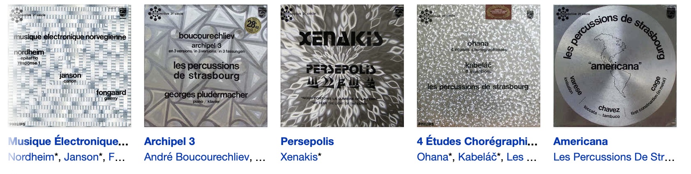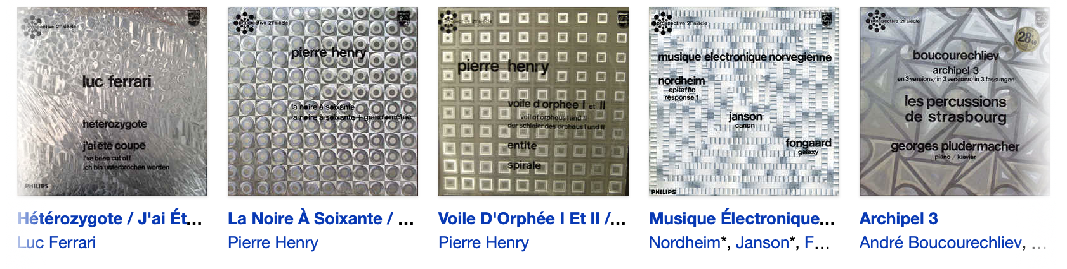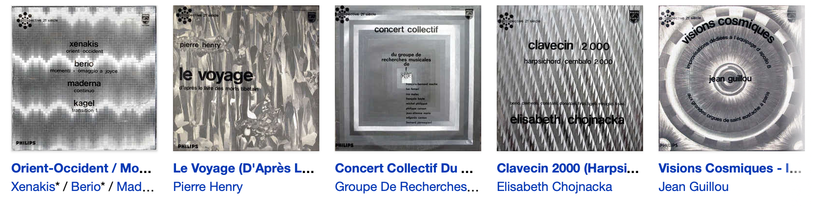
As a result the sleeve cover has movement and dynamism to it.
Daniel Mason describe the cover as a “…relic from the future created by somebody in the past, trying to imagine what future would look like… it is very unique at the moment”.
Unlike Futurist that that didn’t admire work created in the past and saw museums as “cemeteries of wasted effort” and way to “waste the best part of your strength in a useless admiration of the past, from which you will emerge exhausted, diminished, trampled on” (Marinetti, Filippo Marinetti. ​The Futurism Manifesto​. 1909.) Mason and Weirdcode created their version of the future based on design created in the past.
The album cover sleeve features the logo of the artist . On the little sticker on the corner we see name of the musician and title of the album. Judging by very limited information provided on the cover we can suggest that target audience for this product is limited and require familiarity with this artist and his logo. The image is combination of horizontal lines and sequences of angled structural lines and shapes pointed toward the center. These carefully positioned elements create a radial structure, they direct out eyes toward the center, create an illusion of depth and connected to the name of the album “Collapse”. The colorway of the image is limited – variety of shades of silver grey, achieved by reflection of light of silver plate. Organic shape of the logo create contrast with rectilinear shapes and horizontal lines.

References
1) Marinetti, Filippo Marinetti. ​The Futurism Manifesto​. 1909.

