Antonin Lesov
Prof. Lange
COMD 3504 -D240
Assignment 2
May 21, 2020

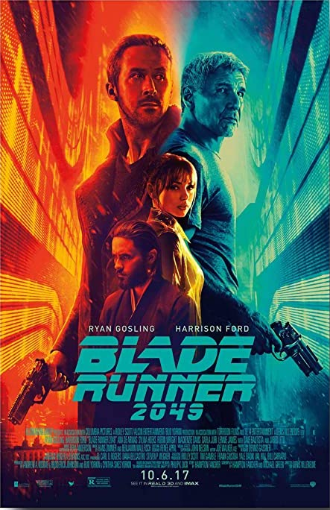

The advertisement I decided to write about is the Blade Runner 2049 movie poster.
The first what we notice about this poster is its bright complimentary colors – orange and blue. Combination of complimentary colors are typical for cyberpunk genre. Also these colors in the movie provide additional information. Orange color usually associated with happiness and joy, in the movie symbolize danger. The more orange we see on the screen, the more dangerous situation. So I suggest colors on the poster is part of coded information connected to the narrative of the movie.
Sequence of lines created by buildings in perspective on background radiate towards the center of the poster. They don’t just surround the figures, they direct our eyes toward the center and create strong focal point. Also, we notice contrast of value. Dark elements in the center placed against more light background.
The composition displays kind of sense of symmetry. Buildings on left and right mirrored, the only difference is color. Also 2 main actors mirroring each other. The poster features 4 people. 1 woman and 3 man all of the actors are Caucasian.

Variation in size create hierarchy. Ryan Gosling is the largest figure on the poster. Without even knowing the movie we can suggest he is the main character. The next 3 figures, each smaller than the figure it placed over, create controlled visual rhythm that lead the viewers eye from actors to the title of the movie.
The linguistics message of this poster is the name of actors, title of the movie BLADE RUNNER 2049 , the year 2049 provide information that the movie is about the future. Information bellow is hard to read. The typography is very dense and chosen bluish-green color create very low contrast with the background. We can suggest this information is not as important as the rest information on the poster. Below is the date of release of the movie written in sans serif font. The color is white on very dark blue background. The information standout.
Symbolic message is reflection in pose of the 2 main actors. The poster is separated by 2 colors orange and blue in half. One actor is on the orange side, the other one is on the blue side. If I didn’t know the movie I would think they are enemies. Maybe it was created intentionally to confuse people that would watch the movie. The font of the name of the movie has futuristic and brutalist feel to it. The top 1/3 of the font horizontally cut. It is connected to the word BLADE. Alo it is the same font used in the original Blade Runner from 1982. The viewer that familiar with the movie will recognize the font. It could also awake sense of nostalgia. Each of the 2 main figures on the poster hold a gun. It creates sense of danger. Also face expression of the actors and high saturation of colors help to create intense image.
The linguistic message on the poster – names of actors, title of the movie “Blade Runner 2049”, The fact is – Blade runner 2049 is the name of the movie. All text information require knowledge of English language for understanding.
The Iconic Non-coded messages: image of people, buildings, guns, colors, gender, ethnicity, clothes … everything that literally means what it is “We need no other knowledge than what is involved in our perception.”
The symbolic (coded) message : the chosen font for BLADE RUNNER 2049 chosen font will be recognized by people familiar with the original movie, words Blade and Runner can provide further association and interpretation , we can suggest that the action in the movie happen in 2049 but we don’t know for sure. Also cut of the font, meaning behind chosen colors on the poster (interpretation depends on viewers background and culture), characters played by the actors ( familiar with the movie people would know at least one), Guns can suggest that movie has elements of violence and not for young children.
\References
1) Barthes, Roland. ​Rhetoric of the Image​. 1977.

