Andy Cuevas
Communication Design Theory
Professor Lange

Adverts usually use ads that convince customers to get interested in the product after which they end up buying the product. The Audi Automobile Industry had made a photograph of the new model of cars that the industry is manufacturing. The picture was tailored to create public awareness of the luxurious new model of cars that are aimed to change the automobile industry as a whole. The advertisement (Hoffman, 2020). The Audi Automobile Industry was founded by August Horch in 1910 and has its main office at Ingolstadt in Germany. Although it was a sole proprietorship, the firm has now been integrated to incorporate four members and thus the four rings that represent its logo. The advertisement is contained in a rectangle with a picture of the Audi car which is occupying more than half of the space in the rectangle in a horizontal position that enables the viewers to have a 3-D view of the photograph. Contained in the photograph are the words that represent the slogan of the company, two happy couples, the Audi car, its logo as well as the great varsity that the Audi car sits on.

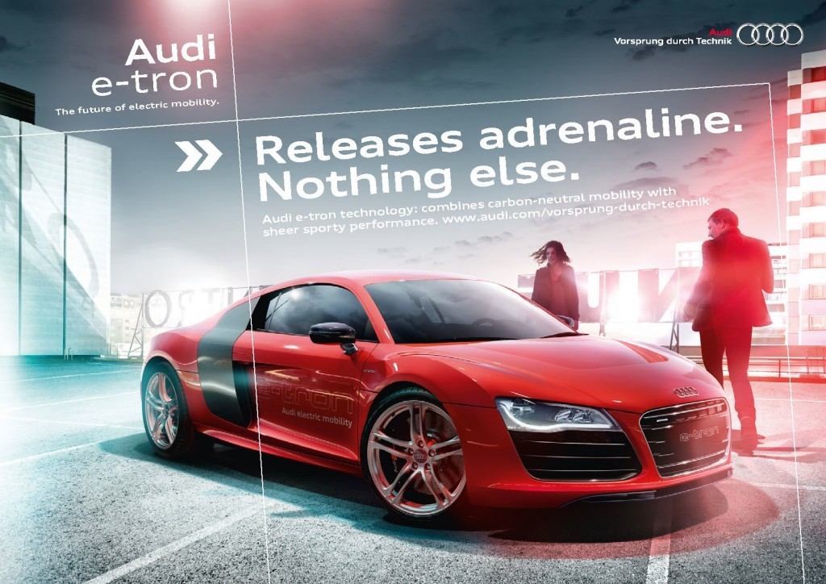

According to Barthes’ ‘Rhetoric of the Image,’ that articulates the three messages that an image contains, the linguistic message in the ad is the logo, the caption as well as the labels. In this case, the linguistic messages present in the photo include: ‘Audi-electron,’ signifying the high technology that the car has been made with, ‘the future of electric mobility,’ which is a caption that makes the viewers that the car is the best suitable when it comes to electric mobilities, ‘Vorsprung durch Technik, ’ which is the slogan of the Audi Industry that means that the industry is always ahead in term of technology, ‘Release Adrenaline. Nothing else,’ which is a caption that shows how compatibility the car is to the users (Lambert, 2020). There is also another caption that states, ‘Audi e-Tron technology: combines carbon-neutral mobility with sheer sporty performance’ which is tailored to signify the specialty of the car in make. In terms of anchorage, a relay has been applied in this advertisement since texts have been accompanied by a photo that makes the viewer to clearly understand the message behind the advert.
There is also articulate use of colours to spice the advertisement. The Audi car is painted in red hence representing the passion, the desire as well as the love that people can have for the car (Hoffman, 2020). Moreover, the rear door and the windscreen are painted black which shows the elegance and the strength that the car has. The font contained in both the slogan, caption, and the log is big enough to see by the viewer making them easily readable.
The second message contained in the photo is the coded icons which make the viewers get the meaning of the ad with ease. The coded icons include the car, a man, a woman and the pleasant varsity that hosts the car (Lambert, 2020). For instance, the couples are representative of the happy moments that the car can bring to the client’s life while the pleasant varsity represents the environmentally friendliness of the car when it is in use. This makes the viewer get the message of the advert, synthesize it, create interest in the Audi car and plans to buy it hence helping to convert a prospect to a loyal client.
The literal message in the photo can be gotten through the use of denoted icons (Lambert, 2020). Through the use of denoted icons as put forward by Barthes, the images have signified as well as signifiers that have the same meaning in the eyes of the viewers. In this case, the initial degree of intelligence is usually applied to enable the viewer to understand the image more comprehensively (Lambert, 2020). In the ad, the Audi image is a representative of the Audi car, the varsity image is representative of the varsity grounds, the image of the women is represented of a woman while the image of the man is a representative of the man.
In summary, the Barthes approach has been widely used in many f the ads as it has been seen to convey messages more clearly and concisely.

References:
Hoffman, C. (2020). Just So You Know, the Audi in That Super Bowl Ad Is the Electric e-tron Sportback. Car And Driver. Retrieved from https://www.caranddriver.com/news/a30717547/audi-e-tron-super-bowl-ad/
Lambert, F. (2020). Audi launches new electric car ad campaign featuring Game of Thrones’ Maisie Williams. Electrek. Retrieved from https://electrek.co/2020/01/29/aud-electric-car-ad-campaign-feature-game-of-thrones-maisie-williams/

