  - Julian Townsend-Taylor
  - Communication Design Theory
  - 11/15/2020

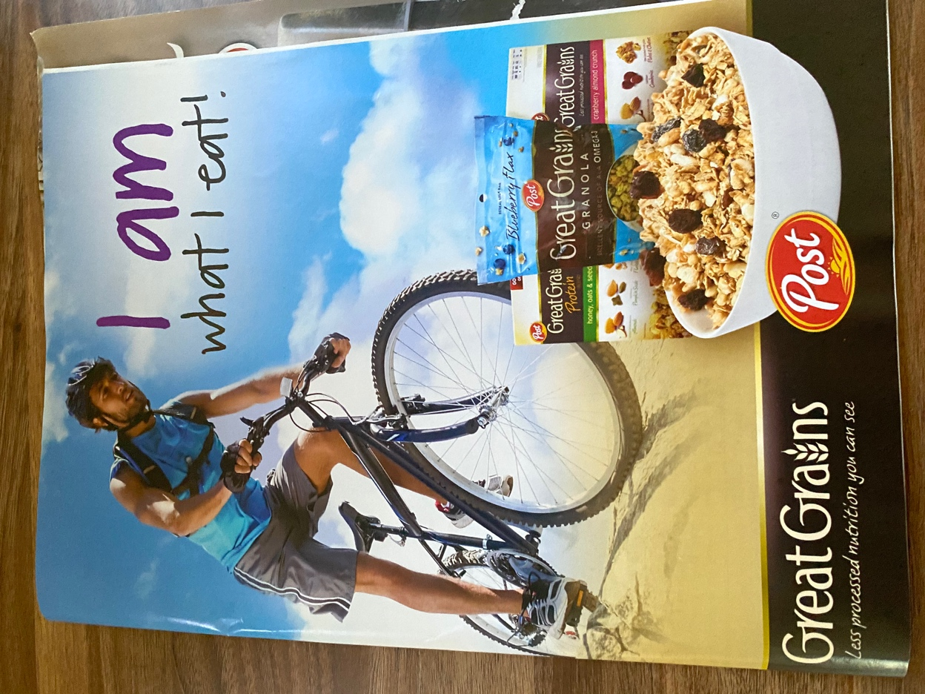
What is the first word that comes to mind when you look at this Advertisement from Great Grain? Is it health? Fitness? If those are the words that come to your mind when you look at this Ad then Great Grains is doing a good job at keep their brand identity within this Ad. Great Grain is a Cereal brand that promotes a healthy breakfast to start your day and sometimes even fitness, because fitness and health goes hand to hand. As you can see in the Ad, there is a photograph of a man riding his bike sweating, wearing workout gear, what seems to be the being of the day because of how blue and bright the sky is. You can also notice the handwritten type on the upper right hand corner saying “I am what I eat” imply that the guy is saying it out loud or to himself, but at the same time letting the viewer know if you eat great grain cereal you will not only be eating healthy you will be healthy, because you have to eat healthy to be healthy. Lastly, Of course you have to place the product on the ad, you will see 3 different type cereals that is suitable to your taste buds.
This Ad has a lot of element to it that the average eye will not know or matter a fact notice. All the details and information is right in front of you but there is a reason why the design team specifically wanted the photographer to depict this scene to support the identity of the cereal in this ad. First is the Linguistic message behind this photo, which is the literal description that identifies the elements of the scene, which is like I example previously the elements in the photo being the man, the bike, the bright sun, the man working out on the bike, the man sweating and how the typographic is linked to the scene depicted as well. “I am what I eat” equal to I am healthy I eat healthy, which ties in with another element, the Coded iconic message. What make great grain healthy? Why is this the photo they use to depict the message of the Ad? Grains itself is healthy because it provides nutrients, fiber and vitamin B that are important to a person health along with keeping the body in shape. Grains reduces the chances of people getting chronic diseases, lower the risk of heart diseases and provides the body the necessary about of iron that the body needs. That is why they used this photo to present great grain because they are comparing and linking the importance of grains and exercising. Exercising provides nutrients to your body just like grains. Just to go back to the typography, “I am what I eat” is a saying that have been around for decades and the it is now used to help identify the subject matter of the denoted description of the image. The average person know exercising is health, so the cereal must be healthy but the average person before probably doesn’t know why grains are healthy but they will now associate grain and/or grain great to being healthy.
But it is the quote necessary? some might say no because the symbolism of the man exercising people will still automatically associate eating great grain must be healthy because it shows the man working out, the denoted message is clear. On the other hand the quote “I am what I eat” bring an connoted message to the Ad, people have an connection to quotes and words in general, because certain quotes and words brings an emotional (negative or positive) association to them, you want people to really connect not only to the cereal but the brand. People are more liable to buy a product when they feel like they can connect with it and all the elements in this ad even the typography connected with someone in some way. It’s targeted audience would be people that exercises frequently, people who watch what they eat and people that wants to change the way they eat and as a brand you have to welcome all the new customer and wants to feel as connected to the brand just like someone who’s always been eating grain greats. To me all Ad should imbody both the linguistic message and the symbolic message of the photo to the brand, they all play a role when people view the Ad.

