Kami Roberts
CityTech
11/15/2021
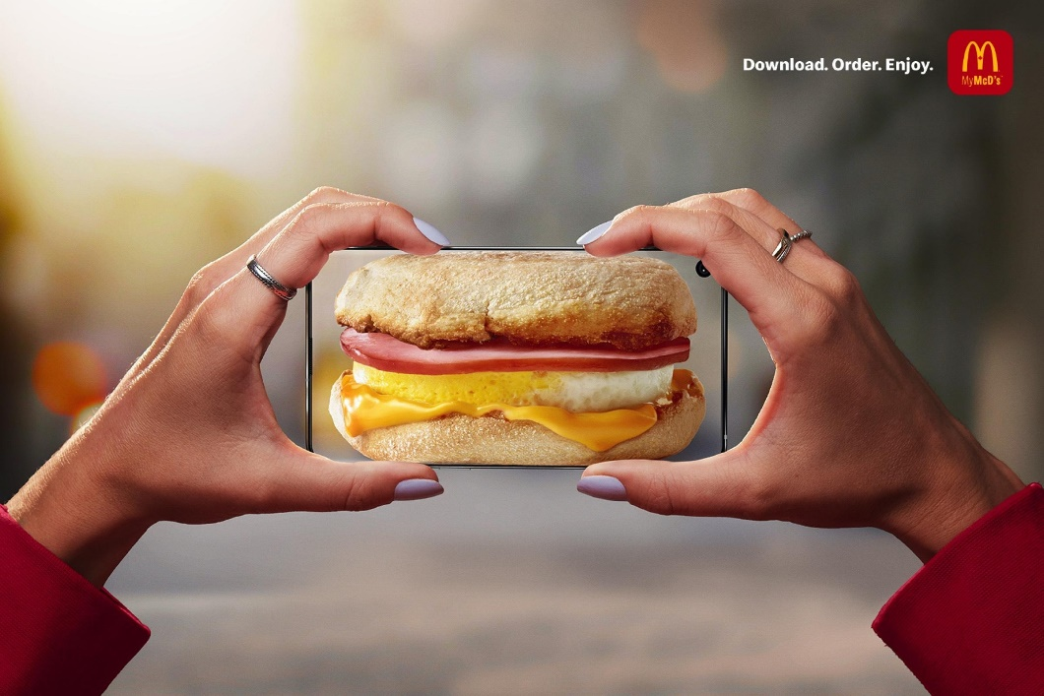
COMD Theory-Assignment 10a

I couldn’t find any recent magazines, so I ended up looking on the internet and settled on this McDonald’s ad. The ad is advertising its breakfast sandwich along with the company’s newest app. The main message of the ad is to get people to download the app to get their food faster which is why the sandwich is shown through the phone and not on a table. Furthermore, It appears that the woman is taking the picture outside emphasizing the app’s functionality to order your food from anywhere, despite the background being blurred to emphasize the phone. The text in the upper right-hand corner, “Download. Order. Enjoy.”, along with the app’s icon serves to further emphasize the conveniency of it. While this one shows a breakfast sandwich, they made another one with a hamburger on the phone which would imply that you can order anything on the app.
Similarly, to the Roland Barthes picture, it has very few words, letting the picture do the talking. In fact, the Roland Barthes picture only has text on the cans of tomato sauce in the picture. The creators of these two pieces made visuals that did not require the use of a lot of text. Instead, they used the picture to their advantage by creating it in such a way that it was almost obvious that there was a message behind it all. According to the reading, “If the image contains signs, we can be sure that in advertising these signs are full, formed with a view to the optimum reading: the advertising image is frank, or at least emphatic.” Certain aspects of an ad can emphasize different ideas. The phone showing the food as I mentioned earlier is a good example of that or the fact that the woman is doing all of this outside as well.

