Jamir Campbell
Matthew Lange
COMD 3504
11/14/21
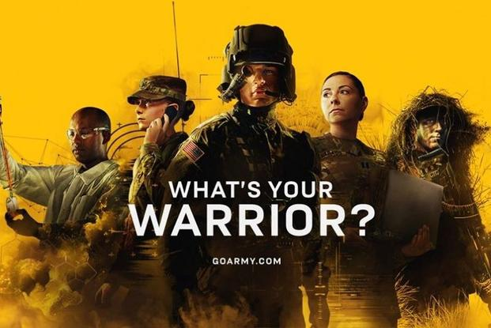
Go Army Ad
The ad I chose do was a Go Army ad, I find it interesting how they have remodeled their whole campaign style to connect with Gen Z and millennials. I would say their doing a good job using social media ads to connect with a younger audience. This poster is very eye catching, when looking at the poster you see five different people in different uniforms. On top of everything theirs a phrase that says, “What’s your Warrior?” in a San serif white font and under it is “GOARMY.COM” which is also in San serif white font. This poster reminds me of gaming posters. This poster is memorable because of the strong photos being used and the bright color used on it. It’s interesting and just like gaming posters this poster is telling a story about the army through the poster. Another thing that’s like gaming posters is this poster has a template with certain standards to follow like some of the more popular games, so you can make a series of different poster that look unified. The linguistic message in this ad is a new phrase they been using for a little while now which is What’s your Warrior? this phrase was used by the army as a way of showcasing the depth of opportunities and inspires a new generation of youth to discover their inner warriors and serve as part of America’s greatest team. The army used different soldier stories to persuade youths to enlist. The Coded Iconic Message is the five people standing with different uniforms on. What’s your Warrior offers a deeper look at army careers, newest installment of Army marketing campaign shows the diverse careers of 12 soldiers to communicate there is a role for everyone as part of the Nations most formidable force. By looking at the people you get a feeling that the Army is becoming a very diverse and big community and more people are joining every day. Some might look at the text on the poster and could simply think it means finding your inner fighter, they can think of it as a gaming ad, but once you see the go army, I think you can get a good understanding of what the army is promoting. When going into deeper things like Non coded Iconic Message this poster express how Out of more than 200 career options currently available in the Army, they chose to put those people on the poster to show 12 specific careers to raise awareness of surprising army roles and promote some of the more in-demand fields. From my experience army posters weren’t as visual and intriguing as this one. With the strong visuals and graphics, I believe that it’s a lot more effective and eye catching to the younger audience their trying to get. I do feel this poster might be slightly misleading, I read comments on the campaign, and it sounds like some people are out of touch with the reality of the war and that it’s a very serious commitment once you decide to go down that route. This might be because of the poster and how there’s not much type on it and its left up to the audience to depict what’s being said in the ad, it also doesn’t help that it looks like a Call of Duty gaming Poster. Some people also think that everyone participates in combat, which isn’t true, there are jobs where you don’t participate in a combat like Clinical laboratory scientist, Communication specialist, & Intelligence analyst. On the “The Soldiers Project” website it stated “You will not necessarily be seeing combat even if you are an infantry soldier. 40% of service members do not see combat and of the remaining 60% only 10% to 20% are deployed into the combat premise” (Brain Bartell, July 31, 2021). I would say that the poster could be more informative but at the same time It says the website on the poster so it could be on purpose and to get people on the website and see what they have to offer. I believe theirs a use of pathos in this document, their playing on the emotions of Gen Z and millennials especially the gaming community because of the poster and how it set up like a gaming poster. As someone who is a gamer, I know that people play games for numerous reasons, but one of the biggest reasons is that it’s a sense of relief and a mental break from the real world. This was purposely done because they were trying to obtain a younger audience and felt this would work. Targeting teens and young adults seemed odd to me because in a Teen Vogue article it stated, “71 percent of young Americans between 17 and 24 are ineligible to serve in the United States military” (Thomas Spoehr, February 13, 2018). The reason they’re not qualified is because lack of Education and physical problems. When doing research to see the reason for the push on young people I didn’t find much, I did see comments that said the reason the army does this is because they need a large population and the sooner young people join, the more likely they are to stay and build a career in the army. When it comes to the target audience and the goal of this army ad, they obtain their goal which was to get the interest of a younger audience. This poster can be a little misleading but could have been done to make the audience curious and want to dig deeper and figure out what the poster was about it. Overall, I think this was a good idea and they will get the young audience their looking for if they continue with this series.

Work Citied
Thomas Spoehr, February 13, 2018, (Young Americans unable to serve)
https://www.heritage.org/defense/report/the-looming-national-security-crisis-young-americans-unable-serve-the-military
Brain Bartell, July 31, 2021 (What Percentage of the Military Sees Combat?)
https://www.thesoldiersproject.org/what-percentage-of-the-military-sees-combat/#:~:text=Unlike%20what%20the%20military%20gives%20off%20as%20an,such%20as%20the%20military%20branch%20you%20are%20in.

