Comparison of a Visual Display to an Art Piece
Kelly Valladares
New York City College of Technology

Creativity can be found through many places in the world. Some people use their creativity in their jobs, others use it in their everyday routines. This may become crucial in some jobs such as visual merchandising. Visual merchandisers are considered to be artists. They coordinate trend-right fashion looks effortlessly, set up attractive displays without seeming to think about what they’re doing, and arrange effective department layouts with precision and speed (Bell, Ternus, 2015). Visual merchandisers use the same concepts as other artists do. These concepts will be demonstrated through a comparison of a window display in New York City's department store Bergdorf Goodman by fifth avenue and a painting in the Metropolitan museum of Art by Irene Rice Pereira called "White Rectangles, Number 3". The author will explain how these artists have incorporated the design elements as well as the principles of design into their display and painting.
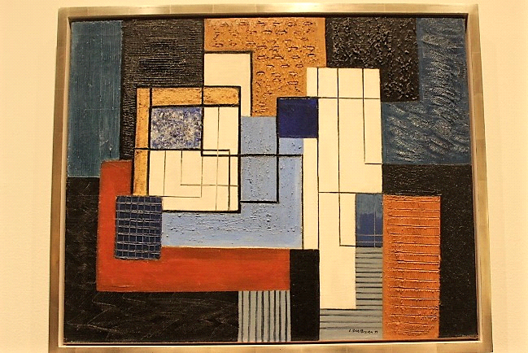
Figure 1. White Rectangles, Number 3

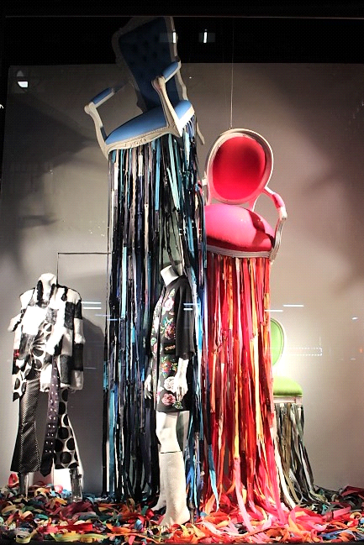
Figure 2. Bergdorf Goodman window display

One of the most important element of design is color. The colors that are used in the Bergdorf Goodman's display consists of primary and tertiary colors combined with black and white. The chairs that are hanging in the display with zippers are red and blue which are the primary colors. The third chair that is nearest to the floor is yellow-green which is a tertiary color. These colors bring much attention to consumers as they are vibrant colors. The first mannequin on the left is wearing all black and white, however the second mannequin is wearing is a more colorful print on the jacket with colorful blue and red flowers and green leaves. This display is composed of complementary schemes which consists of two colors that are directly opposite of each other on the color wheel (Bell, Ternus, 2015). These complementary schemes are shown in the props which have red, yellow-green, and blue-green colors. Some of the colors that are shown are tinted to appear lighter such as the blues and reds in the zippers.
The colors that are shown in Irene Rice Pereira's painting are a combination of primary colors and earth tones. The primary colors that are used in this painting are blue and red which is the same as Bergdorf Goodman’s display. The earth tones consist of navy blue, and rust colors. These colors have also been incorporated with black and white in the painting. Most of these colors were created by tinting and shading. For example, the addition of white to blue was used to create the sky blue color. Black was added to the blue as well to create the navy blue color.
Texture is one of ingredients that can be manipulated to make art and design more innovative and interesting (Gong, Shin, 2013). The appearance of the texture on the display is sheen. This sheen texture is shown on the fur coat and on the chairs. The soft texture of the fur coat is juxtaposed against the pants which has a rougher appearance. This contrast is also shown on the zippers which also have a rougher texture than the chairs. The juxtaposition of texture is shown throughout the entire display which catches the consumers eye.
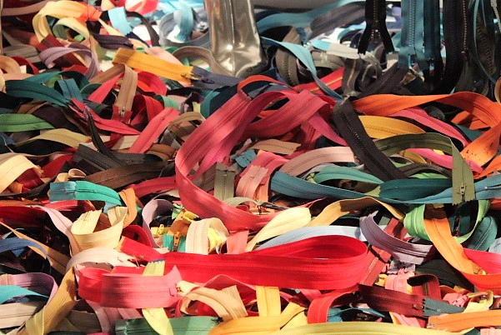
Figure 3. Texture and zippers
The texture on the Pereira painting appears to be rough on some parts and smooth on other parts. The texture on the darker colors appear to be rougher. Pereira used a number of different tools including, possible, the blunt end of the brush to carve into the paint surface to create troughs that enhance the paints physicality (Fund, 1983). The darker parts of the painting are juxtaposed against the smooth white parts of the painting. One can see the different types of textures given through this painting on canvas.
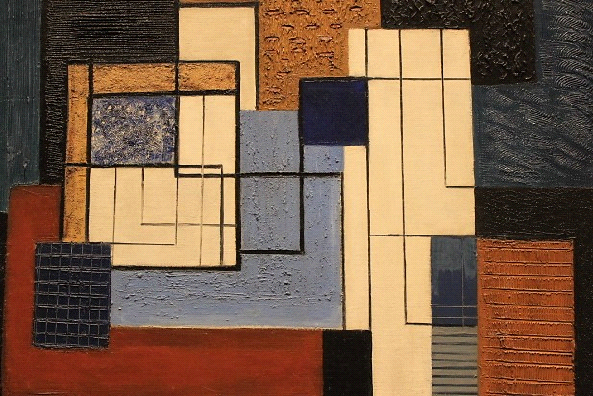
Figure 4. Texture on canvas

The Bergdorf Goodman's display shows vertical line formations. These lines are shown from the mannequins standing and the zippers hanging vertically from the chairs. Vertical lines send a message of dignity, strength, and height (Bell, Ternus, 2015). These lines would attract consumer’s attention and give the same message of vertical lines through the clothes. The vertical lines also give direction which guides the consumer’s eyes from the chairs to the merchandise on the mannequins. This display also shows an informal balance. The hanging chairs and the mannequins appear to have the same weight because of their location in the display.
There are both vertical and horizontal line formations in Pereira's painting. Some lines are defined with strong black outlines while others are more thin. These lines form a repetition of geometric shapes. The lines in this painting are much more visible than the lines in the Bergdorf Goodman's display. Some of the horizontal lines are shown through the strokes of the paint. Different types of lines represent different moods. These lines in the painting represent a mood of stability and strength. The thicker black lines represent power.
The display from Bergdorf Goodman is an example of how art influences life. Many people become inspired by paintings or any kind of art work and try to incorporate these ideas to their own work. Art requires creativity which many visual merchandisers use for creating displays. Like artists, visual merchandisers have to carefully choose the colors and the concept of the display. Some displays can be labeled as abstract just like paintings. The Bergdorf Goodman's display has a very unique concept with the chairs and the zippers. Art helps people think differently and come up with new ideas that will attract attention as portrayed through this display.
After analyzing both the painting and the display, one can see the importance of color and texture and how they are carefully used. Color has many different meanings and if it is not being used correctly, it may receive negative response. Some colors attract more attention than others. Red is a great example of this as people seem to instantly notice this color before others. Colors also evoke feelings which is why it is important to use the right colors. Texture is also an important aspect and may also give a certain mood. Texture on fabric is very significant for different seasons. The texture of fur is soft and conveys warmth which is perfect for winter. The texture in the painting gives a certain mood. A smooth surface tends to look more delicate than paintings that have a rougher surface. Textures are created through different techniques that artists use.
This comparison has proven how very similar art and visual displays are. Creativity and knowledge of the design elements are required to come up with ideas that will attract attention. Artists have to be careful when choosing the colors, texture and proportion for paintings and visual displays. This comparison teaches how visual merchandisers use these elements to create a certain mood and attract consumers as well as artists do in paintings. A display that consists of these elements will lead to consumers inside the store and buy the products that are shown.

References
Bell, J., & Ternus, K. (2015). Silent Selling. New York, NY: Bloomsbury Publishing Inc.
Figure 1. White Rectangles, Number 3 (2017). Retrieved at The Metropolitan Museum of Art on
1000 5th Ave, New York, NY 10028.
Figure 2. Bergdorf Goodman window display (2017). Retrieved at 754 5th Ave, New York, NY
10019.
Figure 3. Texture and zippers (2017). Retrieved at 754 5th Ave, New York, NY 10019.
Figure 4. Texture on canvas (2017). Retrieved at The Metropolitan Museum of Art on
1000 5th Ave, New York, NY 10028.
Fund, E. K., (1983). White Rectangles, Number 3. Retrieved at The Metropolitan Museum of Art
on 1000 5th Ave, New York, NY 10028.
Gong, S. (2013). The Innovative Application of Surface Texture in Fashion and Textile Design.
Retrieved from http://www.kpubs.org/article/articleMain.kpubs?articleANo=ORSHBT_2013_v15n3_336

