Kateryna Strokach
BIO 2459-Thursday class
Date: 02/28/2019
Lab Report 2: Meiosis and Recombination
Abstract:
In our second lab experiment we will learn more about meiosis and crossing-over. In particular we will be crossing three types of Sordaria, two wild-type and two mutants. By the end of the experiment we will be able to explain the process of recombination in details.
Introduction:
Meiosis is a division that occurs during gametogenesis (gametes production). In contrast to mitosis, meiosis consists of two cell divisions, Meiosis I and Meiosis II. Each division consists of 5 stages stages-prophase, metaphase, anaphase, telophase and cytokinesis. Separation of homologous chromosome, which usually called reduction division takes place during Meiosis I. Another important factor that takes place during Meiosis I is recombination, which is usually called crossing over, which results in formation of completely new gene combinations. It usually occurs during pachytene of Prophase I. Wright after completion of Meiosis I, Meiosis II takes place. During Metaphase II of Meiosis II, unlike in Meiosis I, sister chromatids are separating which results in production of 4 haploid (23 chromosomes) cells.
Methods and Results:
During the first week of experiment, our group was able to cross three types of Sordaria (wild-type and two mutants) by preparing two culture plates that contained 8 small cubes from the stock (4 wild-type, 2 gray, and 2 tan cubes). First sample had wild-type and gray while second sample had wild-type and tan strains. The following week we were able to remove a few perithecia from the cross plate and examine it under the microscope.
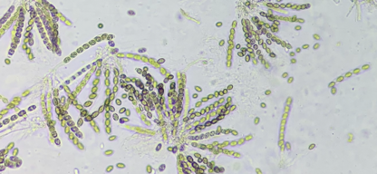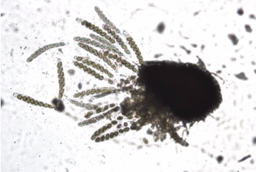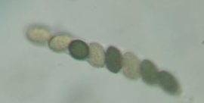
Discussion:
From the pictures above we can conclude that crossing over occurred in both tan and grey ascospores during prophase stage of meiosis I. In general, they follow either 2:2:2:2 or 2:4:2 color patterns. As a matter of fact, genetic diversity was created with the help of crossing over. Not all of the asci followed 2:2:2:2 or 2:4:2, some of them had 4:4 ratio, which indicated that crossing over didn’t occur. According to Saleem “recombination generates new combinations of existing genetic variation and therefore may be important in adaptation and evolution.”
Reference:
Hochwagen, Andreas. “Meiosis.” Current Biology, vol. 18, no. 15, 2008, pp. R641–R645.
Saleem, M, et al. “Inherited Differences in Crossing over and Gene Conversion Frequencies between Wild Strains of Sordaria Fimicola from ‘Evolution Canyon’.” Genetics, vol. 159, no. 4, 2001, pp. 1573–1593.

