**References**

<http://www.scielo.br/scielo.php?pid=S1678-77572012000100007&script=sci_arttext>

<http://www.scielo.br/scielo.php?pid=S1806-83242010000100005&script=sci_arttext>

<http://www.jodjournal.com/article/S0300-5712(09)00207-3/abstract>

<http://www.webdental.com/profiles/blogs/toothbrush-terror-can-your>

<http://www.ncbi.nlm.nih.gov/pubmed/19832908>

<http://www.hindawi.com/journals/nrp/2012/420630/cta/>

<http://www.jispcd.org/article.asp?issn=22310762;year=2011;volume=1;issue=1;spage=20;epage=26;aulast=Gujjari>

**Pictures**

<http://www.goacuzone.com/media/catalog/product/cache/1/image/5e06319eda06f020e43594a9c230972d/p/e/peroxide.jpg>

<http://pestcemetery.com/wp-content/uploads/2009/04/listerine-splash-pestcemetery.bmp>

<http://www.webdental.com/profiles/blogs/toothbrush-terror-can-your>

<http://www.just4teeth.com/Violight-Toothbrush-Sanitizer>

<http://www.girl.com.au/toothbrush-colgate.htm>

<http://products.howstuffworks.com/emerson-mw8999sb-09-cu-ft-900-watt-microwave-oven-review.htm>

# Toothbrush Sanitizing Devices

***Keep it rinsed.*** *Wash off your toothbrush thoroughly with tap water every time you use it.*

***Keep it dry.*** *Bacteria love a moist environment. Make sure your brush has a chance to dry thoroughly between brushings. Avoid using toothbrush covers, which can create a moist enclosed breeding ground for bacteria.*

***Keep it upright.*** *Store your toothbrush upright in a holder, rather than lying it down.*

***Keep it to yourself.*** *No matter how close you are to your sister, brother, spouse or roommate, don’t ever use their toothbrush. Don't even store your toothbrush side-by-side in the same cup with other people's brushes. Whenever toothbrushes touch, they can swap germs.*

***Keep it away from the toilet.*** *The single act of flushing the toilet releases millions of bacteria into air.*

**Toothbrush Storage Tips**

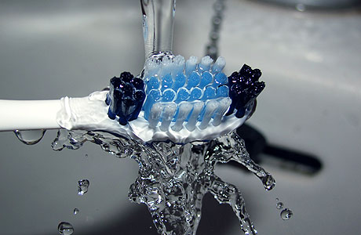

***How clean is the toothbrush that cleans your teeth?***

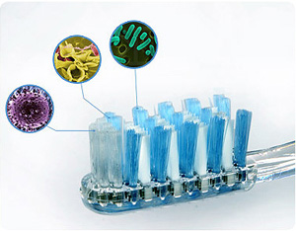

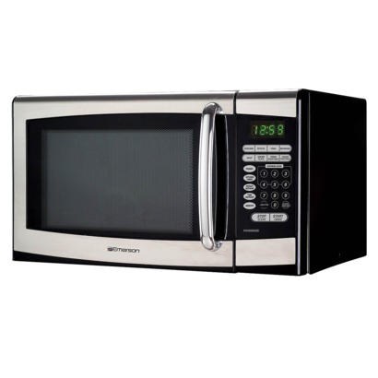 **Methods of disinfection**

**Cathy Chen**

**Inesa Legrian**

**Karolina Maksymiuk**

For information on open positions or to submit your resume, please visit our Web site at: www.lucernepublishing.com

**UV light toothbrush sanitizers** **Effectively reduce an average of 42% total cultivatable bacteria on a toothbrush by using Germicidal Ultraviolet Light, which physically destroys the DNA of microorganisms.**

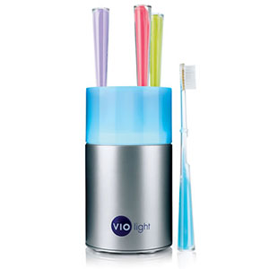

**Microwave sanitization**

**Microwave irradiation can disrupt the biofilm structure; also, the thermal effect of microwave exposure can destroy the microorganisms.**

**Before placing the toothbrush, make sure to shake off excess water from the bristles. Place the tooth brush into the microwave oven (2450 MHz) for 5 minutes.**

**0.12% Chlorhexidine Digluconate** **Chlorhexidine digluconate is usually indicated as the first-choice antiseptic in dentistry due to its high antimicrobial activity and effectiveness for pre-surgical antisepsis. Use of chlorhexidine causes a reduction in *Streptococcus mutans.***

**Disinfection of toothbrushes using 0.12% chlorhexidine digluconate for 20 hours shows total destruction of microorganisms.**

**3% Hydrogen Peroxide**

**Hydrogen peroxide kills bacteria by its ability to penetrate the extracellular polymeric substances (EPS). It breaks down molecules into water and oxygen.**

**Studies show that treatment of toothbrush for 7 minutes in 3% Hydrogen Peroxide solution is effective in reduction of both aerobic and anaerobic bacteria presented on toothbrush heads.**

**Listerine ®**

**Listerine kills microorganisms by disrupting their cell walls and inhibiting their enzymatic activity thus preventing bacterial aggregation, slowing multiplication and extracting endotoxins.Treatment of toothbrush head in Listerine for 7 minutes reduces** **the number of** **aerobic and anaerobic bacteria.**

**History of the toothbrush**

* **Primitive tooth cleaning devices called “chewsticks” used by ancient civilizations.**
* **The first toothbrush dates back to around 1000AD in China and was made of natural bristles.**
* **The first mass produced toothbrushes were often made of gold, ivory or ebony, and they were too expensive for every person to use.**
* **In the late 1930’s, the affordable plastic handle, nylon filament toothbrushes became available.**

**Toothbrush contamination**

**Toothbrush is most commonly used mean of maintaining good oral hygiene. Toothbrushes can become contaminated from the oral cavity, environment, hands, aerosol contamination, and storage containers. Contamination is the retention and survival of infectious organisms that occur on animate or inanimate objects. Bacteria which attach to, accumulate, and survive on toothbrushes may be transmitted to the individual causing local and systemic diseases.**

**Microorganisms on toothbrush:**

* ***Streptococcus mutans- dental caries***
* ***β hemolytic streprtococcus- sore throat***
* ***Candida albicans- thrush in babies***
* ***Coliform bacteria- found in bathroom***
* ***Herpes simplex virus 1- cold sores***

