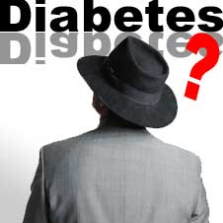

## See YOU THEre!

Held at the

Geriatric Wellness Center 2AB-121 on April 29, 2015 at 10 a.m.

S

on

# By New York City College of Technology Nursing Students

# Come and join us for a

Diabetes Teaching

presentation

[Insert DateS]

✹

✹