19th century fashion
Kiara Martinez
New York City College of technology

My daily life at home is wearing loungewear. I feel comfortable sitting, standing, walking, and doing chores such as housework. Loungewear is more comfortable, because I feel better and I can move around. I don't feel tight in my clothes. The least comfortable is winter clothes, because I have put on a coat, pants, sweater and boots. It's layers of clothing in the winter season. I wear a waist trainer for 3 or 4 hours and I remove it after 3 or 4 hours.

Why do I wear a waist trainer?
I wore a waist trainer, because I wanted to lose weight. I gained a lot of weight in the past and I want a nice shape.

Why do I wear loungewear ?
I wore loungewear, because I feel very comfortable wearing it and it's not tight or restricted from moving around.

1.The essentials of Victorian clothing for men were suites, a top hat, vest, gloves, and boots.
2.The essentials of Victorian clothing for women were corsets, layered outerwear.
3. I think Victorian men were more comfortable than Victorian women, because women have more layers of clothing than men. Men don't have as many layers of clothing as women.
4. Victorian women felt that it was important to wear a corset, because to feel accepted to a high level such as middle class or set the standards for Victorian women. A corset-less woman will represent in terms of morality is not proper or not fit for high class for women society.
5. I wouldn't wear a Victorian dress, because I watched a video and according to the video, women was suffering internally, their organs was squeezed together and very uncomfortable.

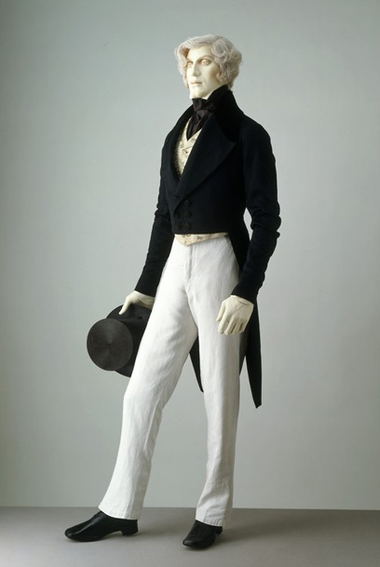

Dress coat and linen trousers, late 1840s - early 1850s. Museum no. T.177-1965. Given by Capt. Raymond Johnes

Dress coat and linen trousers,

Late 1840s - early 1850s

Museum no. T.177-1965

Given by Capt. Raymond Johnes

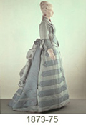

Day dress, 1873-75. Museum no. T.112 to B-1938. Given by Miss M. Eyre-Poppleton

Day dress

1873-75

Museum no. T.112 to B-1938

Given by Miss M. Eyre-Poppleton

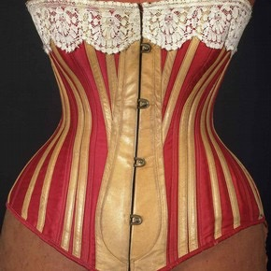
Corset, (front), 1883. Museum no T.84-1980

References
http://www.vam.ac.uk/content/articles/c/corsets-and-bustles-1880-1890-from-over-structured-opulence-to-the-healthy-corset/
http://www.vam.ac.uk/content/articles/i/introduction-to-19th-century-fashion/

