

**What is the Role of Dental Hygienist?**

# **Reference**

Cartee, Deborah L., et al. "Sjögren's Syndrome: Oral Manifestations and Treatment, a Dental Perspective." *Journal of Dental Hygiene*, vol. 89, no. 6, Dec. 2015, pp. 365-371. EBSCO*host*,

"Sjögren Syndrome." *Sjögren Syndrome - Health Encyclopedia - University of Rochester Medical Center*. N.p., n.d. Web. 14 Mar. 2017.

 Administrator. "Sjögren's Syndrome Foundation - About Sjögren's." *Sjogren's Syndrome Foundation*. N.p., n.d. Web. 14 Mar. 2017.

Cartee, Deborah L., et al. "Sjögren's Syndrome: Oral Manifestations and Treatment, a Dental Perspective." *Journal of Dental Hygiene*, vol. 89, no. 6, Dec. 2015, pp. 365-371. EBSCO*host*,

"Sjögren Syndrome." *Sjögren Syndrome - Health Encyclopedia - University of Rochester Medical Center*. N.p., n.d. Web. 14 Mar. 2017.

Administrator. "Sjögren's Syndrome Foundation - About Sjögren's." *Sjogren's Syndrome Foundation*. N.p., n.d. Web. 14 Mar. 2017.



## Sjogren Syndrome

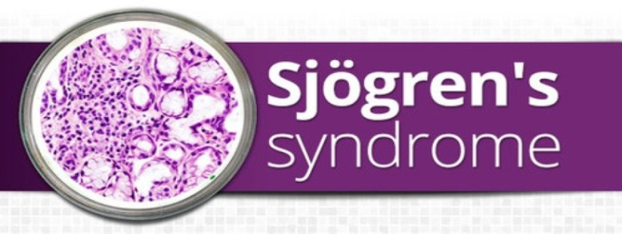

[http://www.therabreath.com/guides/dry-mouth.html](https://outlook.office.com/owa/redir.aspx?REF=dPpYRhL3gyIf9vHw9CQqLG_-BWm-eXnXpa3tQJhjedt2YwlvnG3UCAFodHRwOi8vd3d3LnRoZXJhYnJlYXRoLmNvbS9ndWlkZXMvZHJ5LW1vdXRoLmh0bWw.)

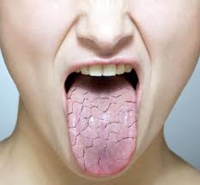

Dental Practitioner’s are the first ones

to detect signs of the disorder. They will

refer the patient to a rheumatologist

for diagnosis and systemic intervention.

Each patient should be given meticulous

and personalized Oral Home Instructions

to improve their quality of life & avoid

complications. Most include: Mechanical

toothbushing 2 to 3 times daily with a

**Picture Citied**

*Rosacea Treatment Natural*. N.p., n.d. Web. 17 Mar. 2017.

*Rosacea Treatment Natural*. N.p., n.d. Web. 17 Mar. 2017.

Chitralekha Khati, Working at Army College Of Medical Sciences,New Delhi Follow.

"Sjogren's syndrome." *LinkedIn SlideShare*. N.p., 29 June 2014. Web. 17 Mar. 2017.

"Dry Mouth Guide." *TheraBreath*. N.p., n.d. Web. 17 Mar. 2017.

ToothFairyTools. "Login." *ToothFairyTools*. N.p., n.d. Web. 17 Mar. 2017.

"SJÖGREN'S SYNDROME & DRY MOUTH." *Dry Mouth (Xerostomia) Causes:*

*Sjögren's Syndrome | Biotène®*. N.p., n.d. Web. 17 Mar. 2017.

"Tips to Improve Rest During the Night." *Wedge pillow*. N.p., n.d. Web. 17 Mar. 2017.

"Tonsil Stones Bad Breath - How to Stop?" *Get Rid Of Tonsillolith*. N.p., 02 Sept. 2014. Web. 17 Mar. 2017.

Chitralekha Khati, Working at Army College Of Medical Sciences,New Delhi Follow. "Sjogren's syndrome." *LinkedIn SlideShare*. N.p., 29 June 2014. Web. 17 Mar. 2017.

"Dry Mouth Guide." *TheraBreath*. N.p., n.d. Web. 17 Mar. 2017.

ToothFairyTools. "Login." *ToothFairyTools*. N.p., n.d. Web. 17 Mar. 2017.

"SJÖGREN'S SYNDROME & DRY MOUTH." *Dry Mouth (Xerostomia) Causes: Sjögren's Syndrome | Biotène®*. N.p., n.d. Web. 17 Mar. 2017.

"Tips to Improve Rest During the Night." *Wedge pillow*. N.p., n.d. Web. 17 Mar. 2017.

"Tonsil Stones Bad Breath - How to Stop?" *Get Rid Of Tonsillolith*. N.p., 02 Sept. 2014. Web. 17 Mar. 2017.

prescription fluoride gel containing 1.1%

sodium fluoride, or remineralizing

dentifrice

• Interdental aids such as a

waterpik or proxybrush in addition to

flossing

• Dietary counseling

• A complement of chemotherapeutic

agents • More frequent recall care, 3 to 4

months.

Salivary substitutes and stimulants are

commonly advised. The Dental

Professional must be knowledgeable

about a range of products the patient

could use. Always keeping in mind the

opinions of the patient **Living with Sjogren's syndrome**

Caption describing picture or graphic.

**Keisha Fraser Seonyeong Ahn Alecia Watson**

**What is Sjögren’s syndrome?**



**Sjögren’s syndrome causes Xerostomia**

**What is Xerostomia?**

**Xerostomia is a medical term meaning dry mouth due to lack of saliva; individuals with xerostomia do not have enough saliva to keep the mouth wet - there is reduced or absent saliva flow.**

Saliva is necessary to maintain optimal oral health. It acts as a lubricant, buffer, and has antimicrobial properties (Clinical Practice of the Dental Hygienist, 12th Edition- Wilkins)

Loss of salivary function can lead to the manifestation of these conditions: Dental Erosion, Dental Caries, Angular Cheilitis, Erythematous Tongue, & Malodor.

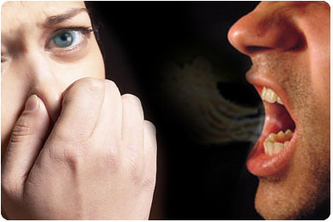

Dietary restrictions: avoid alcohol and foods that are spicy, hard, crunchy, or acidic. All of which can worsen the symptoms

Sjögren’s Syndrome is a systemic autoimmune disorder that affects the entire body. It is currently incurable. The most common and well-noted symptom is excessive dryness (exocrine and secretory organs), as well as, constant fatigue, chronic pain, major organ involvement, neuropathies, and lymphomas.

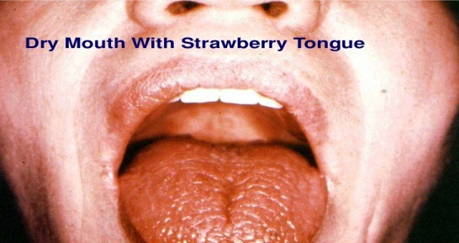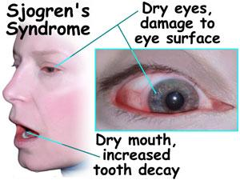

Avoid medicines that might further dry you r mouth, and eyes, such as certain antihistamines and antidepressants. Talk with your healthcare provider about these choices.

Do not sit near air conditioning or heating vents. The dry air can also contribute to dry eyes.

Try using a room humidifier





[https://www.slideshare.net/Drchitra/](https://outlook.office.com/owa/redir.aspx?REF=q10SAD0XzbuBXxQDkCIYG5bzi6VL4nqmRreMMPioU9t2YwlvnG3UCAFodHRwczovL3d3dy5zbGlkZXNoYXJlLm5ldC9EcmNoaXRyYS9zam9ncmVucy1zeW5kcm9tZS0zNjQyODkyNg..) http://tonsilcure.com/bad-breath.html http://rosaceatreatmentnatural.com/ /

sjogrens-syndrome-36428926 / 7-tips-for-how-to-reduce-redness-on-face