Kyle Djemani
COMD 1112 Digital Media Foundations
February 17, 2020
Professor Tanya Goetz

Twitter’s Logo Takes Flight

Twitter today, has turned into one of the biggest communications technologies of the last 100 years. As of 2019, Twitter’s annual revenue came to 3.46 billion US dollars. Back in 2006, it first started as a side project of Odeo, a podcast company, founded by Evan Williams alongside fellow entrepreneur, Noah Glass. During this time, Apple had launched iTunes which made Odeo’s main service obsolete. Williams had asked a team of 14 employees to brainstorm their best ideas for the flailing startup. Among these employees was one of the company’s engineers, Jack Dorsey, who came up with the concept of a service allowing users to share personal status updates via Short Message Service (SMS) to groups of people. This concept became the foundation of what will later become Twitter.

By March 2006, a working prototype going by the name of Twttr, since it was a popular trend to drop vowels in the name of companies and services to sometimes gain a domain-name advantage. There was also the prototype logo for Twttr, which was created by Noah Glass. The logo was a green slimy blob with a rounded typeface. However, the name and branding for Twttr would be updated for the official launch.
Prototype Logo for Twttr, created by Co-Founder, Noah Glass

For the official launch of Twitter on July 15, 2006, the updated logo that replaced Glass’ prototype logo was designed by Swedish graphic designer, Linda Gavin. Gavin was given three days to design the complete identity and website. Gavin’s hallmarks are bursting colors, anime characters and bubblegum type, which eventually became famous for the first Twitter logo. She had made the logo, the cloud, and partly responsible for the blue, turquoise, and white color scheme.
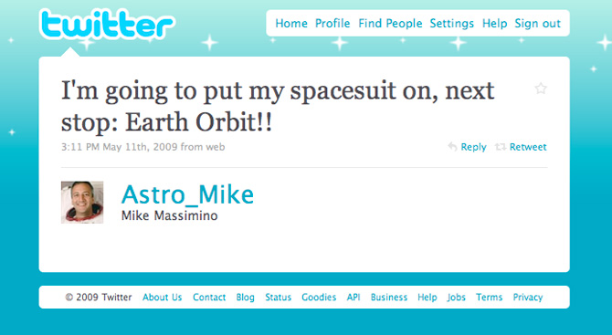
Redesigned Twitter Logo, designed by Graphic Designer, Linda Gavin
Twitter Website in 2009, designed by Graphic Designer, Linda Gavin

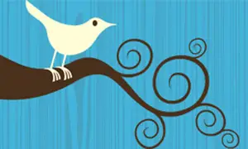
We know today of the iconic Twitter bird, but much like the company itself, this bird had gone through its fair share of changes. The very first Twitter bird was designed by Simon Oxley, a British graphic designer who has since produced many mascots for online companies. Oxley had designed a bird in a tree for iStockPhoto, a subscription-based site that offers thousands of pictures for customers to use in designs and other projects. He also created a broken robot image he dubbed, Failbot, for when the platform is down. Someone at Twitter had bought it for about 15 dollars, Oxley wasn’t even aware of the company’s existence when they selected his design. Oxley’s “Larry the Bird” named after the Boston Celtics legend, was a slender, serene fellow, adorned only by a stylized eye and perched on a branch that splits off into an elegant Japanese-influenced gathering of curlicues. However, companies weren’t permitted to use iStock images as official logos, so Twitter soon left Oxley’s bird behind.
Original Illustration for iStockPhoto, designed by Graphic Designer, Simon Oxley
Twitter’s Failbot, designed by Graphic Designer, Simon Oxley
Since the company couldn’t use Oxley’s bird, Biz Stone, a company founder, came up with the initial design for the first in-house bird logo, fine-tuning it by 2009 with the help of Philip Pascuzzo, a designer. Their initial design was a cartoony bluebird, a year later, they created yet another version of the logo, this time removing the cartoonish features and leaving only a silhouette. This iteration of the bird paved the way for Douglas Bowman, the social networking company’s former creative director, latest and current version of the iconic Twitter Bird. Bowman’s new bird was a sleeker update, resembling a mountain bluebird with a dash of hummingbird thrown in. His Twitter bid had its beak and body point toward the skin in what Bowman called “the ultimate representation of freedom, hope, and limitless possibility.”
“Larry the Bird,” and Silhouette, designed by Company Founder, Biz Stone & Designer, Philip Pascuzzo
Current Iteration of the Twitter Bird, designed by former Creative Director, Douglas Bowman
Sources Cited

“About Twitter” https://about.twitter.com/en_us.html

“Twitter Revenue” https://www.macrotrends.net/stocks/charts/TWTR/twitter/revenue

MacArthur, Amanda. “The Real History of Twitter, in Brief” 12 Nov. 2019
https://www.lifewire.com/history-of-twitter-3288854

Meyer, Jack. “History of Twitter” 18 Jun. 2019
https://www.thestreet.com/technology/history-of-twitter-facts-what-s-happening-in-2019-14995056

“Twitter Launches” 28, Jun. 2019 https://www.history.com/this-day-in-history/twitter-launches

Rehak, Melanie. “Who Made That Twitter Bird?” 8 Aug. 2014
https://www.nytimes.com/2014/08/10/magazine/who-made-that-twitter-bird.html

Carter, Dom. “The Evolution of Twitter’s Logo” 21 Mar. 2016
https://www.creativebloq.com/logo-design/evolution-twitter-logo-31619677

McCormick, Rich. “Twitter’s early name and logo experiments reveal a Smssy past”
12 Nov. 2013 https://www.theverge.com/2013/11/12/5094724/old-twitter-logos-show-original-names-were-twttr-smssy

Love, Dylan. “The Guy Who Designed Twitter’s Logo Only Made About $3” 9 Jul. 2013
https://www.businessinsider.com/simon-oxley-twitter-logo-2013-7

Stephanie. “The Wonderful World of Linda Gavin” https://www.eyeem.com/blog/the-wonderful-world-of-linda-gavin

Graphic Designers’ Websites

“Douglas Bowman” https://stopdesign.com/about

“Simon Oxley” https://www.idokungfoo.com/

“Linda Gavin” https://cargocollective.com/jusum
“Philip Pascuzzo” http://www.pepcostudio.com/

