Kelvin Delgado
New York City College of Technology
TCET 4140
November 20, 2013

Homework #5

3-9. Prepare a composite (weighted) index for housing construction costs in 2008, using the following data:
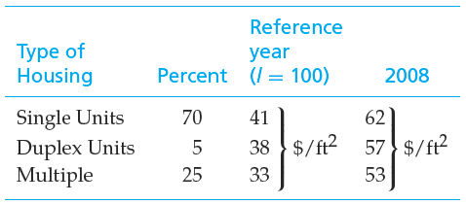
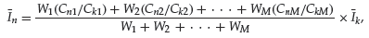
Weighted index= $\frac{70\left(\frac{62}{41}\right)+5\left(\frac{57}{38}\right)+25(\frac{53}{33})}{70+5+25}*100=$153.51
3-16. Four hundred pounds of copper go into a 2,000- square-foot, newly constructed house. Today’s price of copper is $3.50 per pound. If the cost of copper is expected to increase 4.5% per year into the foreseeable future, what is the cost of copper going to be in a new 2,400 square foot house 10 years from now. Assume the cost capacity factor for increases of copper in houses equals 1.0.
Cin10years=(2400/2000)*(400lbs)*(3.50$/lb)*(1.045)^10=2608.98
3-17. The structural engineering design section within the engineering department of a regional electrical utility corporation has developed several standard designs for a group of similar transmission line towers. The detailed design for each tower is based on one of the standard designs. A transmission line project involving 50 towers has been approved. The estimated number of engineering hours needed to accomplish the first detailed tower design is 126. Assuming a 95% learning curve,

a. What is your estimate of the number of engineering hours needed to design the eighth tower and to design the last tower in the project?
Z8=126(8^(log 0.95/log2))= 108.03 engineering hours
Z50=126(50^(log 0.95/log2))= 94.33 engineering hours

b. What is your estimate of the cumulative average hours required for the first five designs? (3.4)

T5= $126\sum_{u=1}^{5}{u^{(\log{0.95/log2)}}}$=126(4.66214)= 587.43
3-19. In a learning curve application, 846.2 work hours are required for the third production unit and 783.0 work-hours are required for the fifth production unit. Determine the value of n (and therefore s) in Equation (3-5).
Z3=846.2 hours
Z5=783 hours
U=3, U=5
$\frac{k(3^{n})}{k(5^{n})}=\frac{846.2}{783}$ ln (0.6)^n= ln 1.08 n=ln1.08/ln 0.6=-0.15
n=10g5/logs = .0.15=log(s-2) = 0.707= s-2 =s=2,707

