Jafes Veras
TCET 4140
11/4/2013
Network Management

3-9. Prepare a composite (weighted) index for housing construction costs in 2008, using the following data:
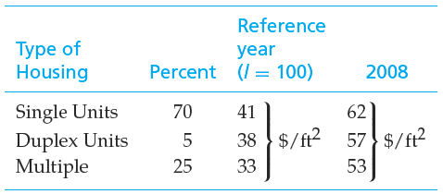
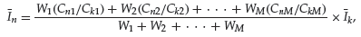
Weighted index= $\frac{70\left(\frac{62}{41}\right)+5\left(\frac{57}{38}\right)+25(\frac{53}{33})}{70+5+25}*100=$2704.67
3-16. Four hundred pounds of copper go into a 2,000- square-foot, newly constructed house. Today’s price of copper is $3.50 per pound. If the cost of copper is expected to increase 4.5% per year into the foreseeable future, what is the cost of copper going to be in a new 2,400 square foot house 10 years from now. Assume the cost capacity factor for increases of copper in houses equals 1.0.
Price of 2,000 square feet= (400 pounds* $3.50 pre pund) = $1,400
Inflation for 10 years = 4.5%*10= 45%
=$3.50*45%=$ 1.575+3.50= $5.08 cost of copper
400punds/20=20 40*4=80
2,400 square foot has 480 pounds of copper =480*$5.08= $2438.40 cost of copper for 2,400 square foot

3-17. The structural engineering design section within the engineering department of a regional electrical utility corporation has developed several standard designs for a group of similar transmission line towers. The detailed design for each tower is based on one of the standard designs. A transmission line project involving 50 towers has been approved. The estimated number of engineering hours needed to accomplish the first detailed tower design is 126. Assuming a 95% learning curve,

a. What is your estimate of the number of engineering hours needed to design the eighth tower and to design the last tower in the project?
Z8=126(8^(log 0.95/log2))= 108.03 engineering hours

b. What is your estimate of the cumulative average hours required for the first five designs? (3.4)

T5= $126\sum_{u=1}^{5}{u^{(\log{0.95/log2)}}}$=126(4.66214) = 587.43
3-19. In a learning curve application, 846.2 work hours are required for the third production unit and 783.0 work-hours are required for the fifth production unit. Determine the value of n (and therefore s) in Equation (3-5).

