Julian Townsend-Taylor

Digital Media Foundation

History of the Volkswagen

The Volkswagen is a famous automobile car company that has been around for years. The V over the W concept since the beginning in 1939 but the logo itself went through a lot of changes throughout time. The first Volkswagen logo was created/designed by Franz Xavier Reimspiess who was an engineer and surprising worked for Ferdinand Porsche.

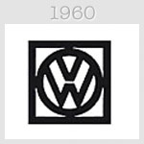

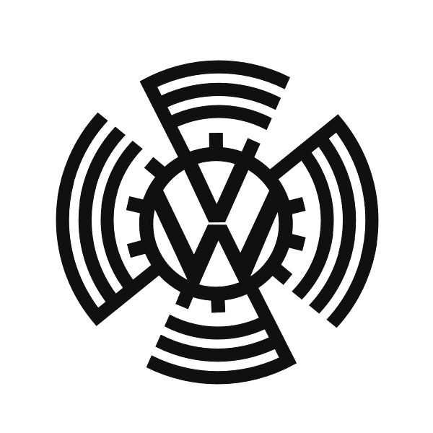

The above photo is the first designed Volkswagen logo in 1939 about the same time the company came out. The idea of the Volkswagen was for German families can have an affordable family car. When the car was first released it was known as the Beetle. Around 1971 the famous car brand become one of the top selling automobile and become very popular in Europe selling over 21 million dollars. Volkswagen logo was the face of Germany for a couple years post World war 2 and inspired by the Nazi Livery. After world War 2 the VW logo took off the gear shaped around it to just a Black box around the logo in 1960. Around that time Famous Car companies like Ford has to hand over their right to Volkswagen (Germany) because they had such a high selling rate. This gave the Car Company to have more materials and allowed their cars to look more “flashier”

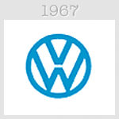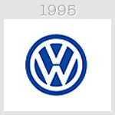

Shortly later in 1967 the Company removed the black Company to put a light blue color creating a warmer and comfortable feeling to the company. Almost every couple years the company improved their logo till 1995 they gave the logo a more 3D Shade to make it look more modern and not so plan, in addition the blue became dark. Till this day the Volkswagen still symbolize how technological advance Germany is and has become.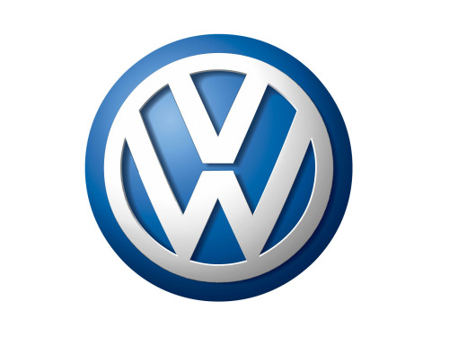

Today the logo adopted a white/silver color in their logo to make it POP more and of course catch up with the modern look every goes with to make to make their logo more appealing. The car Company something uses a shiner silver/black color like in the 1960 on some of their cars. 