Jaicy Taveras
Week 11 Field Trip
11/22/19

Field Trip

In the field trip to the united federation of teachers I learned quite a few things that I didn’t know before and obviously facts that I learned in school. Before I get into what are the three items that interested me the most I want to say that the process that goes on to make all of these quality works come from dedicated people. Creating an idea and bringing it to life doesn’t happen overnight as it takes hard work and dedication. With all that hard work comes with partnerships that are dedicated to getting the job done in a fast but well-mannered time.

The first item that I liked was the Ryobi 3404DI offset press printer. This printer is a high-speed offset press printer that takes jobs and finishes them in a fast rate. The Ryobi is a four color offset press that brings advanced digital imaging to life. If you wanted to get a job done quickly you can use this machine.
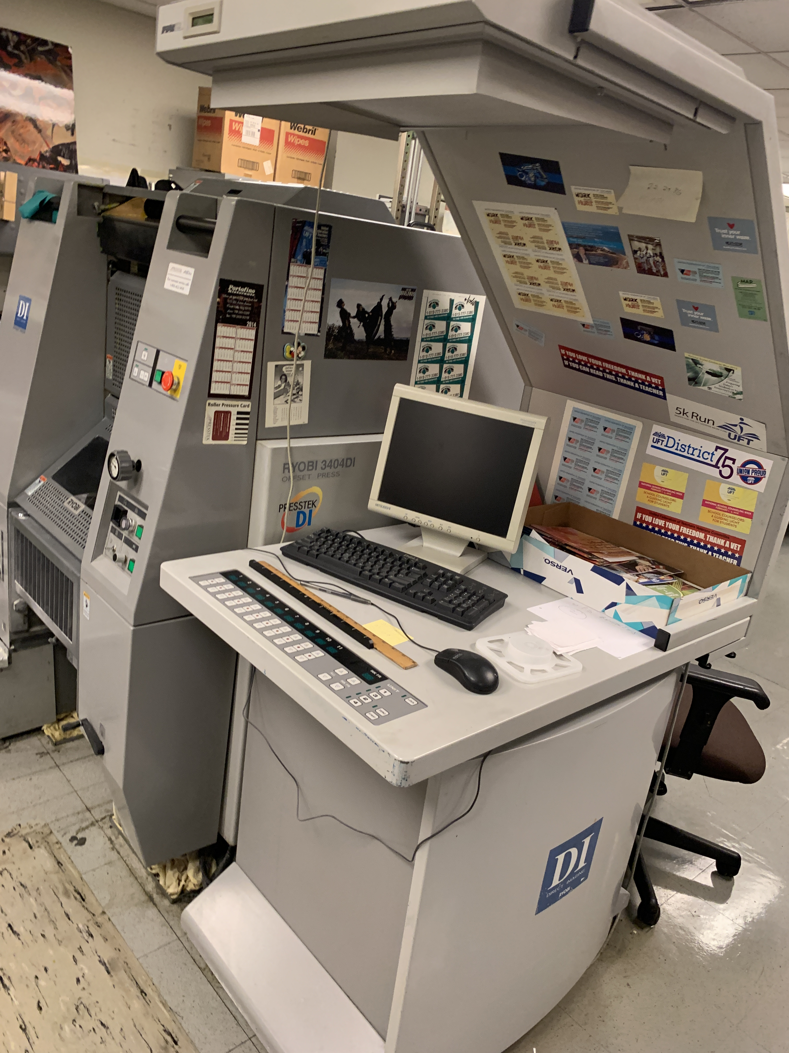

The next item I liked was the Ryobi 3200PFA because it was interesting as to how to use it. Unlike the last item I liked you have to do a lot of manual work to make sure your print comes out correct. The tour guide used a metal plate with a form plastered on it for an exact two way print. Its pretty much the same process just a lot of knobs to pull, it will take you a little bit longer than the Ryobi 3404.
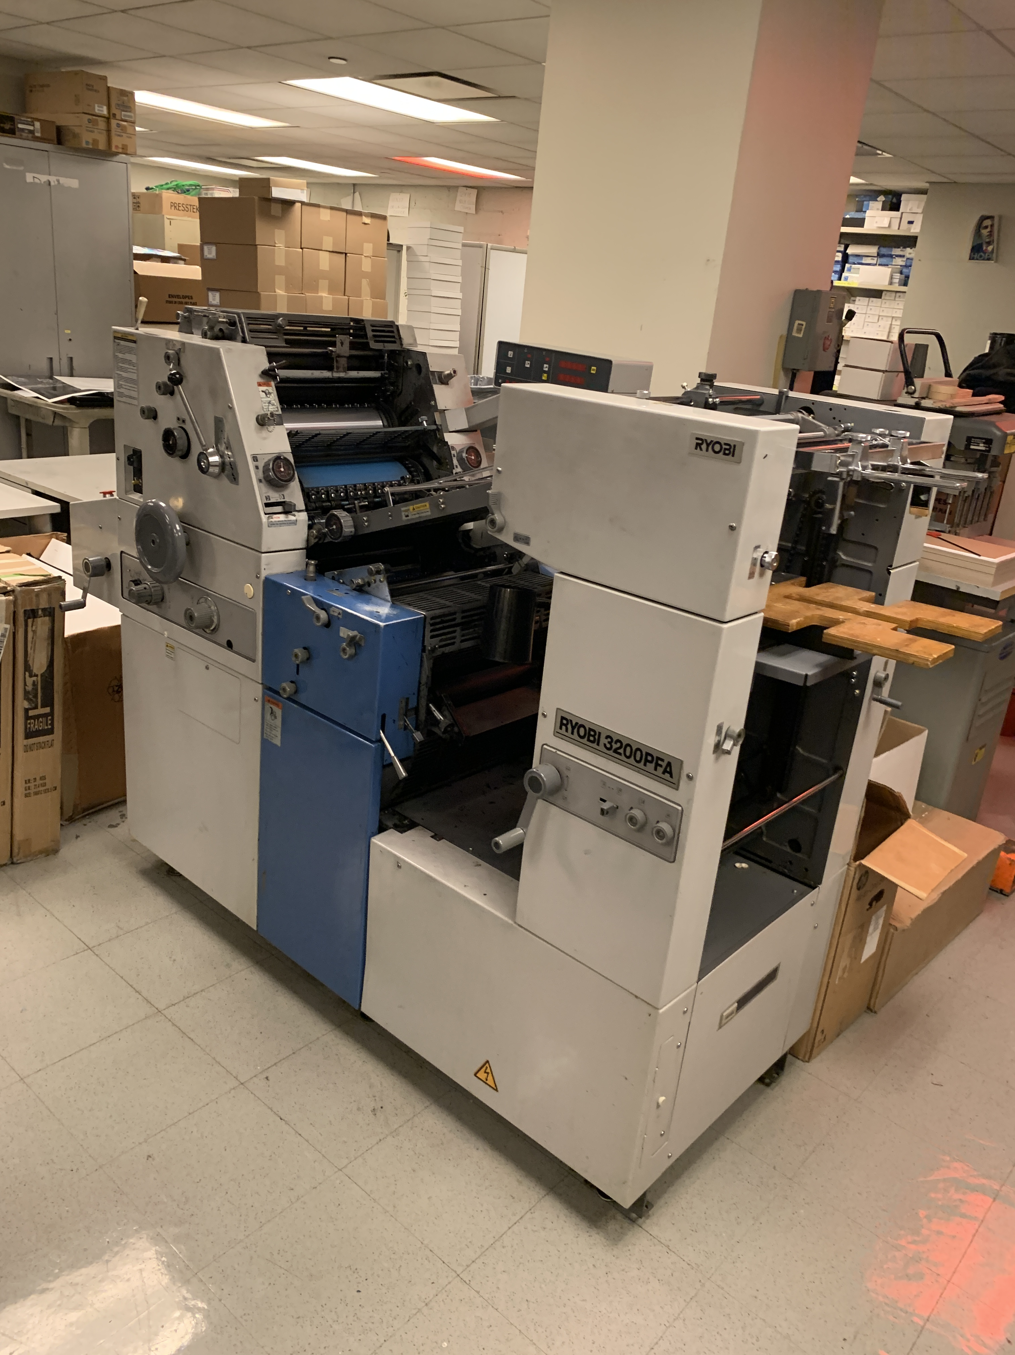

The last item I liked was the PRISM machine. This machine is a prime cut machine so it cuts business cards on the exact length you want. This machine must be used carefully as you can slice your hand in half due to the sharp metal machete like cutter that is separated from the machine. This massive machine can cut through anything but as I said before its main use is for cutting business cards.

