Jaicy Taveras
COMD 1112
Logo Research Paper

The Batman Logo

The logo I will choose to talk about its history and the development of the Batman logo. Since I was a child I’ve been a fan of the Batman, even as a little child I had a bed with all Batman covers and sheets. I think Batman can be relatable to most, a regular person who became a superhero just by using his resources around him rather than any god-given or mutant power. His logo throughout history had multiple changes within the decades, a different logo for each era.

The creators of the Batman logo and essentially the Batman character were Bob Kane and Bill Finger, and DC comics published the character. The thought process in this character and logo was to create a superhero that wasn’t like the rest. All of the superheroes of DC and Marvel as well have some type of powers due to either mutation or God-given powers, unlike the others, Batman doesn't have any powers other than the resources that he surrounds himself with because of the money his parents left him at their deaths. The process of creating this logo and character was an inspiration from DC comic’s biggest superhero Superman, Kane and Finger wanted to make sure they didn’t make a carbon copy of Superman so they made someone who does superhero things without the powers.

Since it’s creation in 1939, the Batman logo has gone through a process of change throughout the 80 years of its existence. The first Batman logo was a man in a cape, in Kane’s defense he felt the logo went with the times because the Batman of 1939 had a costume on and didn’t develop any high tech armor yet. The most recent Batman logo was created in 2016 for the “Batman v Superman’ movie, just like its first concept it is bulky but the reason for that is to put the Superman logo in the middle so it may fit. The logo itself is a bat; any images that are advertised by Batman and DC comics simply use the concept of a bat. Bats are dark, ugly, terrifying, and vile animals that live in rural caves with no inhabitation. Most bats are found in dark caves because they don't like the light. There's no typeface being used in creating the logo due to the fact it's just a picture of a bat, however the colors used around the logo are usually black and yellow or black and grey (colors got darker as the years went on).

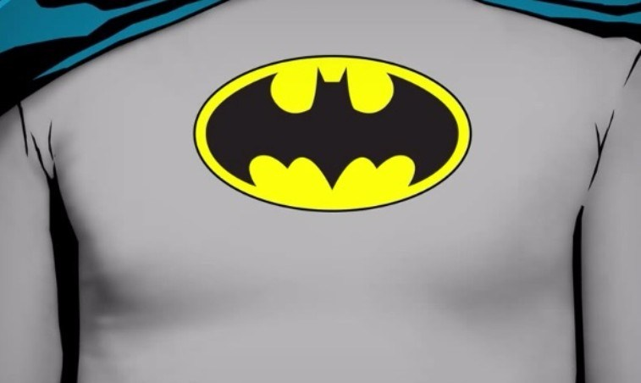 In 1966, one of the most famous Batman logos if not the one he was most known for was the single bat revolved around a yellow oval. This logo lasted for about 30 years in the comics before a change was made. I have different tank tops of this same logo just because it has been so iconic for so many years. In that same year, Adam West had a different bat symbol but the same yellow oval surrounding the bat. However, his bat is smaller.
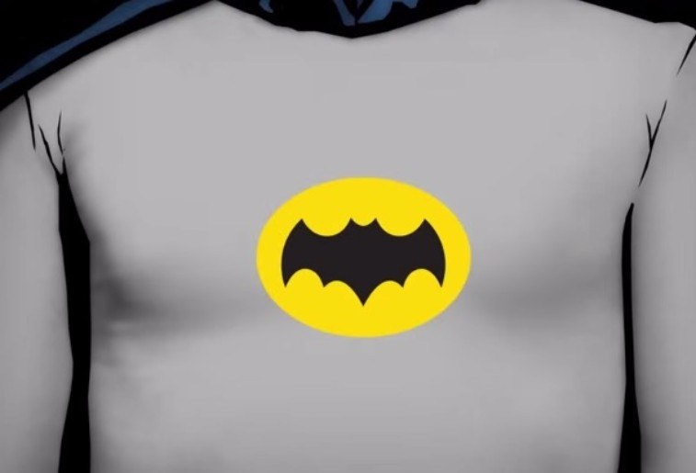

As mentioned before, the Batman logo was found and made by DC comics and its creation was quite simple. Creating the concept of the "Batman" didn't need a whole team plus others to come up with a complex logo for a character that isn’t as complex as people perceive Batman to be. Most of the copy and print that has the logo on it would be on DC comics and memorabilia of the Batman; on DCcomics.com he has his character Memoriam with information on the Batman. As for the logo itself and how it looks, the yellow oval that was a mainstay for 36-years took a step back during the 90's because of the movies created for Batman (Batman Forever, Batman & Robin). After the year 2000, the creators move to remove the yellow oval and just have the bat in the background with no oval surrounding it. 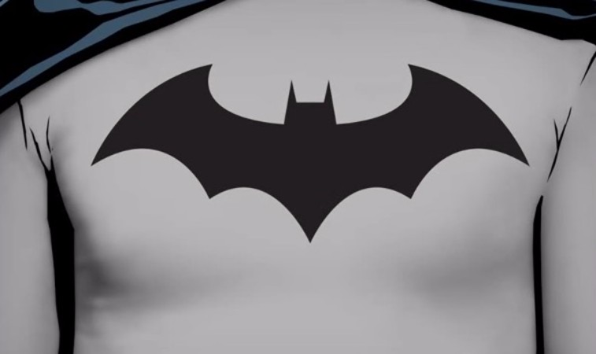

Looking back at all of the batman logos in our time, I’ve seen the evolution of such a logo with different ideas and simulations of the famous bat that even the newest of fans can find their top favorites. I have a few favorites but if I had to set atop three all-time batman logs would be the 1966 batman logo I previously spoke about. My second favorite would be the 2008 version of the logo for The Dark Knight and The Dark Knight Rises.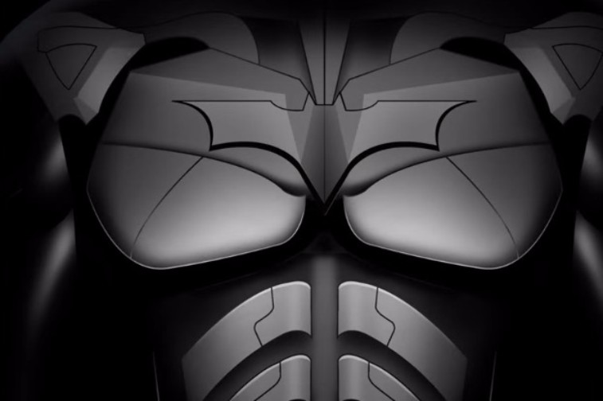
My third favorite logo of all time would be the 2005 introduction of the Batman logo to the movies that Christopher Nolan made. This particular logo was in Batman Begins, this one is wider than the Dark Knight versions.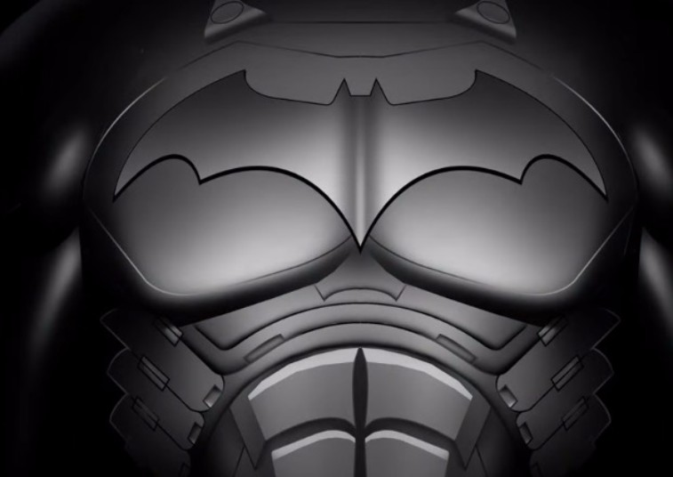

In conclusion, in my opinion, I do believe the Batman logo is a mainstay in American media and entertainment. His signature bat silhouette is compared to the famous “S” of Superman or the American shield of Captain America, these three heroes mentioned are famous superheroes everyone knows and you don’t need to look up anything to know what the Batman symbol represents. The Batman was represented in film from the years of 1943 to just recently coming out with a new Batman movie in 2021.

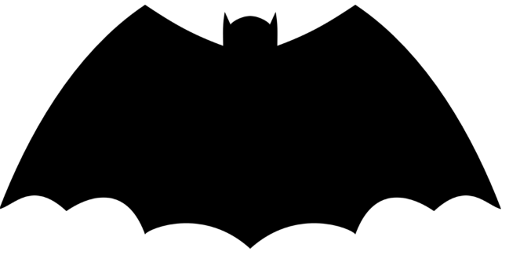1939 Batman logo
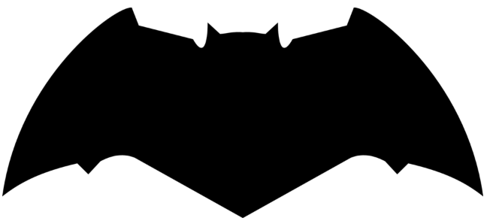 2016 Batman Logo
Resources
- Fussell, Sidney, “The incredible 75-year evolution of the Batman logo”, Business Insider, March 14, 2016

- “Batman.” Wikipedia, Wikimedia Foundation, 3 Nov. 2019, https://en.wikipedia.org/wiki/Batman#Creation.

- Cannata-Bowman, Nick. “The History of the Batman Symbol Over the Years.” Showbiz Cheat Sheet, 31 May 2018, https://www.cheatsheet.com/entertainment/history-of-the-batman-symbol.html/

- “Batman.” DC, 1 Nov. 2019, https://www.dccomics.com/characters/batman.

- “Batman Logo.” 1000 Logos The Famous Brands and Company Logos in the World, https://1000logos.net/batman-logo/

