**Treatment and Home Care Plan Case Study Assignment**

Group 2C

March,7,2023

Advisor: Dr. Nancy Ekelman

Case study 8

SOAP NOTE

DATE: March,07,2023

Initial Visit

S:

Patient is a 29-year-old African American female.

CC: “My gums bleed when I brush. I have sensitivity to hot and cold most of the time and I have a sore on my tongue.”

Med Hx: Patient came to the dental clinic stating that she is in good health. She referred that she is not currently under the care of a physician. She is reluctant to have a physical examination. She is currently taking (drospirenone and ethinyl estradiol) Yasmin birth control. Her BP is 138/89, Pulse is 80 bpm and Respiration is 18 pm. The patient BP corresponds to Hypertension Stage 1. ASA 2.

Social Hx: Patient is currently smoking one pack of cigarettes daily. She did not report using alcohol or any other drug.

Dental Hx:

The patient’s last dental visit was over ten years ago when she had a wisdom tooth extracted. She rinses with a phenol-based mouth rinse several times daily. However, she mentioned that she mixes it with water to reduce the burning sensation. She is currently using a medium bristled toothbrush once daily and reported that she has never flossed or used other interdental aids. She is not sure if her toothpaste contains fluoride. She stated that she would like to know why her tongue has a white spot. She is worried because her grandmother had oral cancer 5 years ago.

O:

EO:

All extra-oral findings were within normal limits. No enlargement of lymph nodes was detected today.

IO:

Cheeks, lip, and pharynx were all within normal limits during clinical examination.

White rounded well- demarcated papule was found in the left lateral border of the tongue. Patient reported pain upon palpation in this area.

Dental Charting: (Hard tissue findings, Occlusion)

Patient occlusion class 3 left side, no dental restorative treatment present. The maxillary arch is narrow and elongated and presents protrusion of the central incisor teeth. Patient has open bite.

Periodontal Assessment

Gingival Statement:

Patient presents generalized erythematous inflamed non-resilient and non-stippled gingiva. Generalized BOP. The oral mucosa is heavily pigmented, and the marginal gingiva appeared erythematous and edematous in numerous regions, more particularly the posterior lingual margins.

Perio Charting: (general statement of findings)

Patient presents generalized periodontal pockets with depths ranging from 4-6 mm, CAL ranging from 4-7mm in all 4 quadrants.

Calculus: Patient presents generalized heavy supra and sub-gingival calculus

Case value: H PI score: 2.5 Poor Stain: No stains

RADIOGRAPHIC STATEMENT:

Generalized horizontal bone loss that extends beyond 33% of the root. Presence of generalized calculus. No cavities encountered on the radiographic exam. Patient informed of the findings.

A:

Perio status:

Patient presents generalized Periodontitis Stage 3 Grade C

Caries risk: Low

P:

Procedures completed.

Medical Hx reviewed, EO/IO reviewed, Perio charting reviewed, FMS reviewed, Periodontal status reviewed. Tx plan developed and discussed with the patient. Discussed tobacco cessation with patient. Referral given to patient for physical exam, evaluation of white lesion in the lateral border of the tongue and orthodontic evaluation.

NV: Complete PI Score, Introduce manual toothbrushing technique, hand scaling quadrant 1

Johanna Suarez

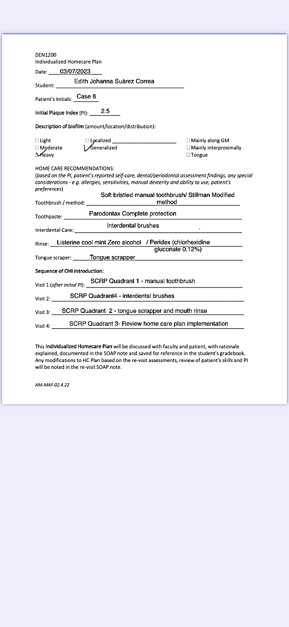

**Written explanation for Treatment, Home Care Plan and Procedures.**

29-year-old African patient presents to the dental hygiene clinic with Chief Complaint “My gums bleeds when I brush. I am feeling sensitivity to hot and cold most of the time and I have a sore on my tongue” after collecting her medical, dental, radiographic information and intra oral pictures the following procedures will be needed:

* Patient will be given a referral for a physician, oral pathologist and orthodontist to have a physical exam , pathological exam and orthodontic evaluation accordingly. The reasoning for this procedure is that the patient presents Hypertension Stage 1 and according to the BMI calculator from the CDC, the patient is overweight. During the Initial visit, the patient reported being reluctant about getting a physical exam. As dental hygienists, it is vital to emphasize the correlation of systemic health and oral health. Moreover, is our obligation to inform our patients about the dangers of cardiovascular diseases. Secondly, a referral for an oral pathologist is needed due to a painful white lesion on the lateral border of the tongue as the patient reported oral cancer in her family history. Lastly, an orthodontic evaluation is recommended as the malposition of the teeth in the oral cavity can contribute to the accumulation of biofilm and calculus and aggravate periodontal diseases.
* Patient reported smoking a pack of cigarettes daily. It is important to have a conversation about tobacco cessation with this patient as her systemic and periodontal status will be compromised by this habit. Patients need to be educated about the danger that tobacco can cause to their health.
* According to the clinical and radiographic exam. Patient presents generalized periodontal pockets with depths ranging from 4-6 mm, CAL ranging from 4-7mm in all 4 quadrants. Generalized Radiographic bone loss of more than 33% percent which puts her in stage 3 of periodontitis. Furthermore, the fact that she smokes a pack of cigarettes put her in grade C of periodontal disease. The periodontal therapy chosen is Scaling and Root planning. It will be done quadrant by quadrant according to the patient’s response. Oraquix anesthetic will be used as the patient referred sensitivity in the chief complaint. In addition to SCRP, 5% NAF varnish will be used at the end of the treatment to help the patient alleviate sensitivity and protect the enamel from decay. On the other hand, according to the Journal Dimensions of Dental hygiene, due to the advanced stage of the periodontal disease. Patient will need to be reevaluated 6 weeks after finishing SCRP in 4 quadrants to assess tissue response. This patient eventually might need to be seen by a Periodontist as the gingival tissue in some areas with deep probing depths might not fully respond to non-surgical periodontal therapy. After advanced therapy is performed, a patient should be seen every 3 months depending on her compliance with home care and her tissue response.
* Regarding the homecare plan, first a manual toothbrush with soft bristles together with a toothpaste with stannous fluoride, which has a broad antimicrobial spectrum, will help with sensitivity, gum bleeding and inflammation and control of biofilm. The technique chosen was Stillman modified. This method is ideal for patients with periodontal disease as it is effective in plaque removal, it is gentle on the gingiva, promotes gum healing by stimulating blood flow and it is easy to follow. Secondly, as the patient reported not using floss, it is recommended to introduce interdental brushes as the method to clean interdental spaces according to the article “An overview of different interdental cleaning Aids and their effectiveness “. Next, the mouth rinse that I would prescribe for this patient will be Peridex (Chlorhexidine gluconate 0.12%) for no longer than two weeks. According to the article “Recent Development of Active Ingredients in Mouthwashes and Toothpastes for Periodontal Diseases”. This will help to reduce biofilm and bacteria in the oral cavity. The patient will be advised that the mouth rinse that she is currently using might be damaging for her and as an alternative to this she could use daily Listerine Total Care which does not contain alcohol. Finally, to complete her Oral Hygiene patients will be advised to use a tongue scrapper. Depending on patient compliance during periodontal maintenance other interdental aids can be introduced to her routine.

**Expected outcomes.**

1. Reduced inflammation: The primary goal of treatment is to reduce gingival inflammation. This outcome can be achieved with periodontal therapy and implementation of the individualized home care plan to remove biofilm and bacteria that cause inflammation.

2. Improved periodontal pocket depth: With proper oral hygiene and periodontal therapy, the patient can expect to see a reduction in periodontal pocket depth, which can help prevent further deterioration of the gingival tissue and teeth.

3. Better oral health habits and improvement of PI Score: These habits may include brushing twice a day, using interdental brushes, using an antibacterial mouthwash, and avoiding tobacco products.

4. Reduced tooth loss: An essential goal of periodontal treatment is to prevent tooth loss. By maintaining good oral hygiene, the patient can expect to keep her teeth for longer and avoid the need for invasive treatments.

To conclude, My goal is that by executing an efficient periodontal therapy, comprehensive oral exam and by educating my patient she will reduce gingival inflammation, improve periodontal pocket depth, develop better oral health habits, improve her oral and systemic health and finally improve her quality of life.

**Resources**

* Mallonee, L. F., Wyche, C. J., & Boyd, L. D. (2020). *Wilkins' clinical practice of the dental hygienist*. Jones and Bartlett Learning.
* Harrel, S. K., Rethman, M. P., Cobb, C. M., Sheldon, L. N., & Sottosanti, J. S. (2022, June 21). *Clinical decision points as guidelines for periodontal therapy - dimensions of Dental Hygiene: Magazine*. Dimensions of Dental Hygiene | Magazine. Retrieved March 12, 2023, from https://dimensionsofdentalhygiene.com/article/clinical-decision-points-guidelines-periodontal-therapy/
* Centers for Disease Control and Prevention. (2020, November 3). *Healthy living widgets*. Centers for Disease Control and Prevention. Retrieved March 12, 2023, from https://www.cdc.gov/widgets/healthyliving/index.html
* Rajendiran, M., Trivedi, H. M., Chen, D., Gajendrareddy, P., & Chen, L. (2021, April 1). *Recent development of active ingredients in mouthwashes and toothpastes for periodontal diseases*. Molecules (Basel, Switzerland). Retrieved March 12, 2023, from https://www.ncbi.nlm.nih.gov/pmc/articles/PMC8037529/#!po=59.4017
* Ng, E., & Lim, L. P. (2019, June 1). *An overview of different interdental cleaning aids and their effectiveness*. Dentistry journal. Retrieved March 12, 2023, from https://www.ncbi.nlm.nih.gov/pmc/articles/PMC6630384/