Jose Sandoval
A graphic designer that has really inspired me throughout the years has been, David Carson. David Carson is a pioneer in the graphic design world. His extraordinary work through the 90s revolutionized the graphic design world in the years to come. His work in the magazine, Ray Gun secured his title as the godfather of" Grunge Typography
"( Biography.com)
Born on September 8, 1954, David Carson grew up in Texas and went on to study sociology at San Diego state university. He ended up graduating with a bachelor’s in arts degree. (Biography.com) His interested in graphic design didn't start until 1980. like most people, we don't find out true passion until we are further down the road of our journey. David Carson Embarked on his passion for the arts and started working for a magazine. The magazine focused on surfers’ interest (Biography.com) He also worked for Transworld Skating magazine which helped paved his experimental designing. It was this magazine that transformed him into an art director. He was the art director for this company in 1984, and he revised the style into what is now known as "dirty" Type photographic. (Biography.com)
It wasn't until 1989 he landed a job at Beach Culture, a magazine company. There he worked as an art director. However, the magazine did not do so good. After just 6 issues, the magazine folded. However, Carson still was still able to withstand the humiliation, and his work was recognized for its unique style of graphic design. (Biography.com)
His big break didn't come until 1992. He was offered a job at Ray Gun. The publisher of the magazine saw the true potential of Carson and offered him a job. Just like his previous jobs, Carson tripled the magazine's circulation and attracted new people. (Britannica) To add more gasoline to the fire, he did an interview with Bryan Ferry.
One of the many reasons why this graphic designer is one of my favorites is because he was chaotic. He used Chaotic Typography and pattern. Making it a show-stopping case. He was able to create disarray of photos by overlapping them. He was able to make something so little, have a bigger meaning. (Inkbot design)
Albert Watson stated, " The disorganized use of his typography has its own purpose, such as each stroke of a painter’s brush evoke different emotion, imagery, and idea, so does Carson’s designs possess such attributes.'(Dominic) It doesn't stop there. His style of radical and bold graphic design launched a career in history. Big corporations hired him for their brand advertisement. he signed contracts with a big-name brand such as Nike and Pepsi Cola. Some of his work below.
However, the big take away from this designer is that he was able to create art and have people really sit there and question why he did such things. His designs are immortal and will go down in history as one the best pieces of graphic design that their ever was.
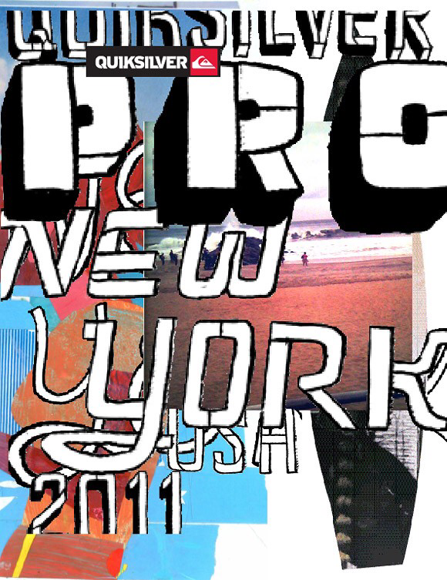
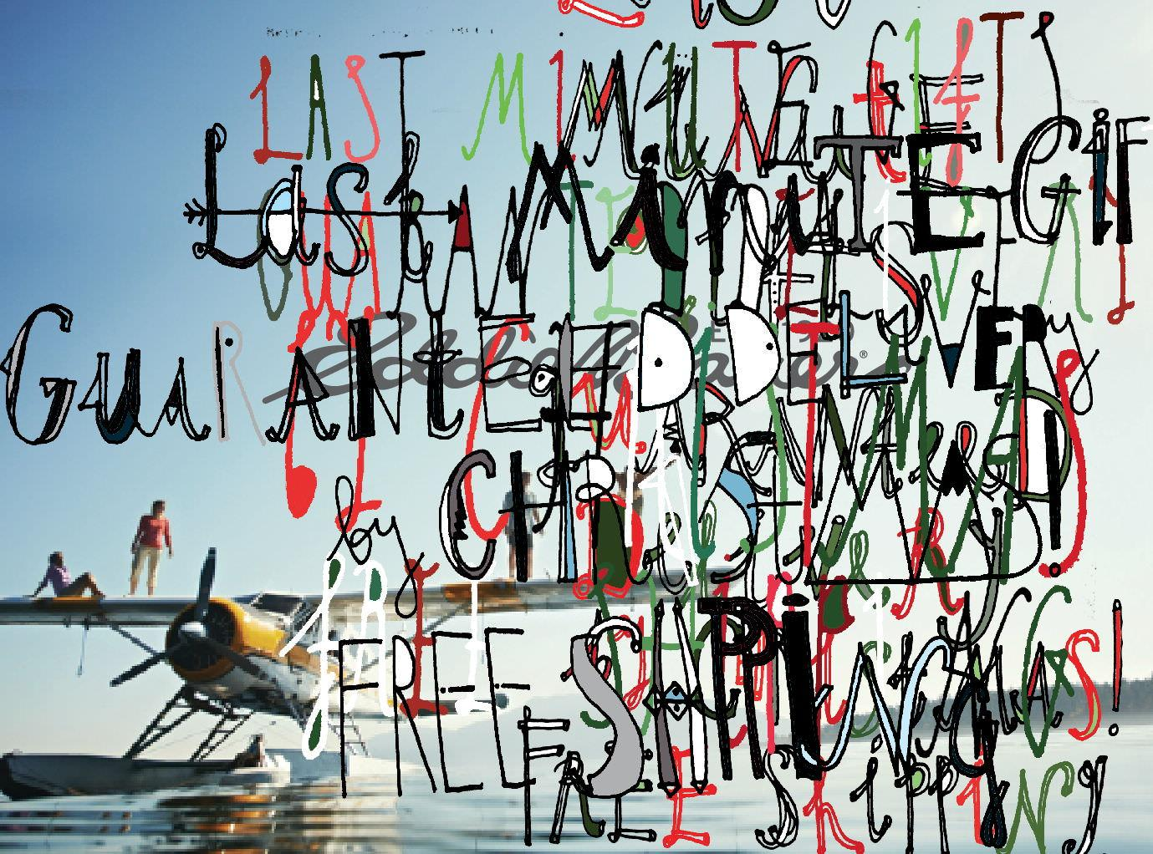
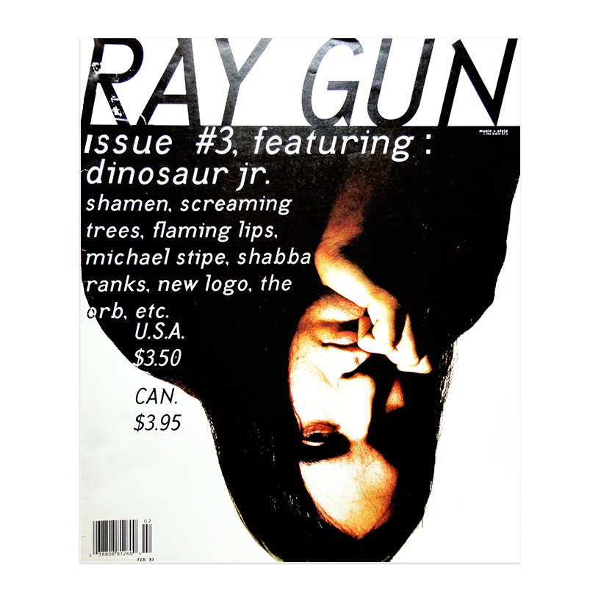

Worksite page

“David Carson | Biography, Designs and Facts.” Famous Graphic Designers, www.famousgraphicdesigners.org/david-carson.

Flask, Dominic. Joseph Albers : Design Is History, www.designishistory.com/1980/david-carson/

Britannica, The Editors of Encyclopaedia. “David Carson.” Encyclopædia Britannica, Encyclopædia Britannica, Inc., 4 Sept. 2018, www.britannica.com/biography/David-Carson

www.facebook.com/stuartlcrawford. “David Carson Graphic Designer - Work, Quotes & Biography.” Inkbot Design, 23 May 2018, inkbotdesign.com/david-carson/

