Jacky Sam Wu
Thelma Bauer
10/3/18
Logo Draft 2

Nvidia

Nvidia is an American technology company that mainly focuses on gaming hardware and software technology. It was founded by three people, Chris Malachowsky, Curtis Priem and Jensen Huang (current CEO as of 2018) in 1993. This company is mainly known for their manufacturing in graphics cards. Their release after a new graphics card tend to be highly ranked in performance status. But their products are highly priced in value. Most people follow their products but dislike that they are very expensive; however, they perform the best. The relationship of high cost and high performance leads to their logo design since the start. The bases of each Nvidia logo is having a spiral “e” shape colored in different ways and the words “nvidia” is captioned under the spiral “e” shape. Throughout all of the Nvidia’s logo changes, these principles have been used. There is a meaning behind the name.
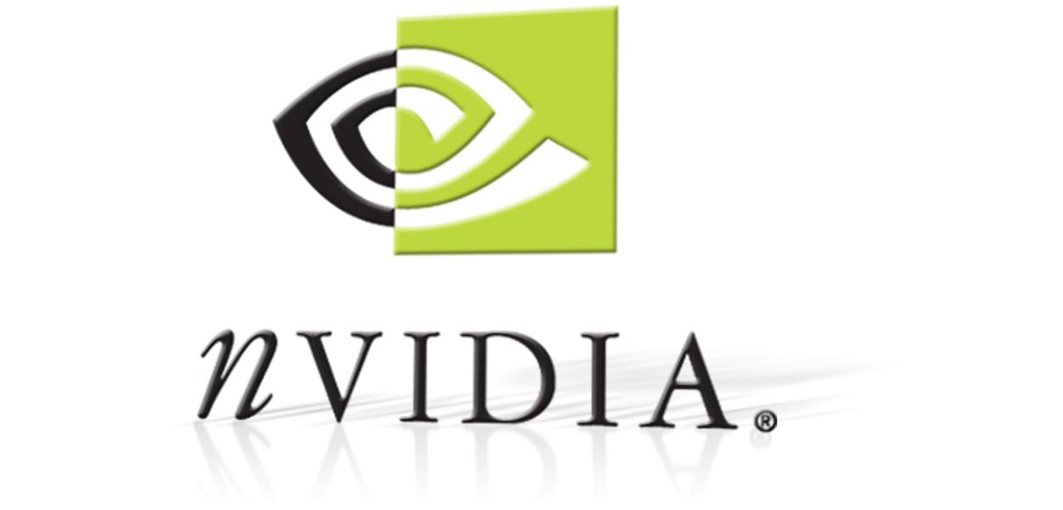
This is the first Nvidia logo that was created in 1996.

The very first logo of Nvidia had two parts with the colors black and green. Its font is undetermined with the letter “n” is shown as a serif font and the rest of the letters are san-serif. The “e” shape was half colored in black and white with its other half colored in green and white. Since the start of Nvidia, their logo represented metaphors towards two things. The phrase “nvidia” is pronounced as invidia, a Latin word for envy. This is associated with the evil eye, also derived from the Latin word, invidere (to look in a hostile manner). Nvidia takes this meaning along with the symbolic eye in the logo. The usage of green color reinforces the “envious” qualities of the products bearing this logo. The company has long loved to word-play and symbolize meaning to their products. Envy and vision is seen by connecting it to mythology. Nvidia’s highest-end gpu(graphical processing unit) is branded with the phrase “Ti” , which implies Titan from mythology. A name taken from ancient mythology with deep connections to the concept of vision is quite fitting for a gpu manufacturing company which aspires to create unparalleled visual experiences that would be considered “envy” of everyone to behold. Roman mythology gives an example to Nvidia’s logo meaning, “Her face was sickly pale, her whole body lean and wasted, and she squinted horrible; her teeth were discoloured and decayed, her poisonous breast of greenish hue, and her tongue dripped venom… Gnawing at others and being gnawed, she was herself her own torment - Ovid(about Invidia) in Metamorphoses.” There are other similar beliefs that the meaning behind the logo is based on the Egyptian God , Horus. Nvidia’s name is a metaphor to “invidia” from roman mythology. “Her face was sickly pale, her whole body lean and wasted, and she squinted horribly; her teeth were discoloured and decayed, her poisonous breast of a greenish hue, and her tongue dripped venom… Gnawing at others, and being gnawed, she was herself her own torment. - Ovid(about INVIDIA) in Metamorphoses.” While others think its meaning was based on the Egyptian God Horus, the company’s name “nVidia” is pronounced invidia. The pronunciation is tired to vision and envy which is connected to invidia from the roman mythology. This plays in Nvidia’s green theme and logo.

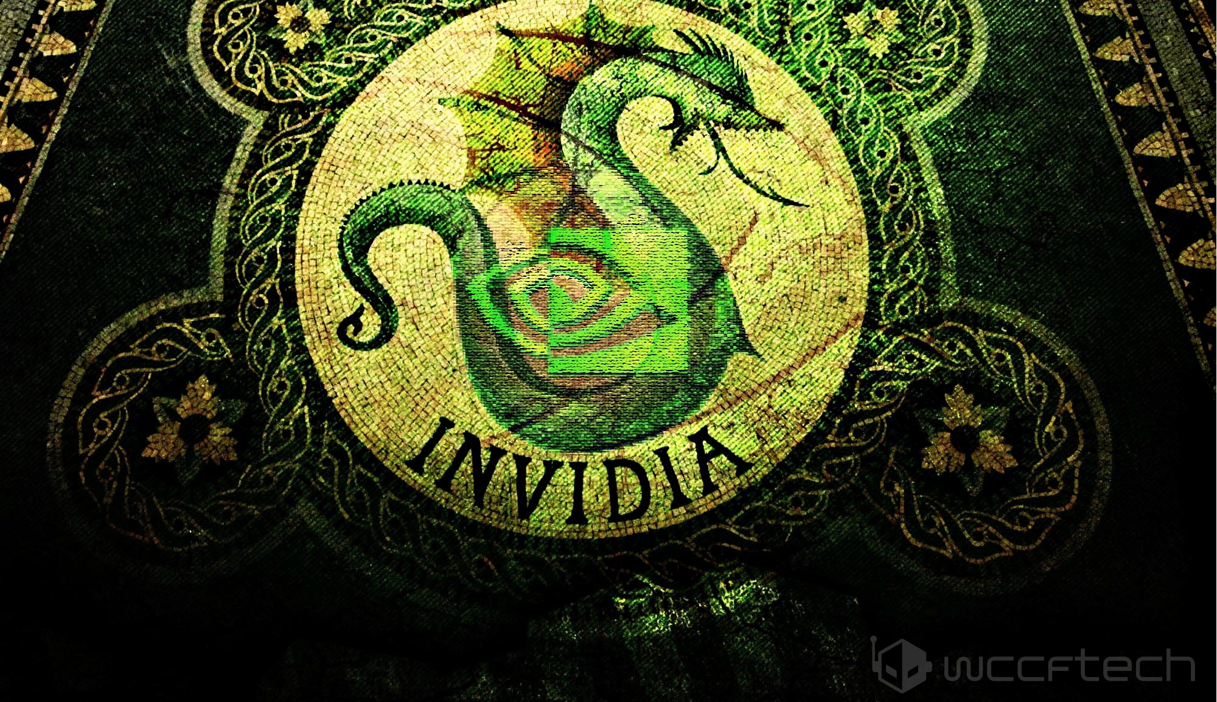
This image is Invidia from roman mythology.

To clarify more, Nvidia is a top GPU marketing manufacturing company that sells its products for a very high price while holding the best performance from any other brand. The company’s logo meaning is behind Invidia from roman mythology. It’s origins is used as a metaphor to Nvidia’s logo.

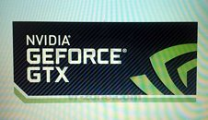

This is Nvidia’s logo brand name for their graphics card section for gamers in 2012. The word (GTX) is categorized as the “gaming graphics cards”

In March 8th, 2012, Invidia changed their logo for their gaming graphics cards. They went with the name “GTX” as a category for gaming. The logo has kept the basic outlines of Nvidia’s color choosing. Some responded with, “New windows logo, new Nvidia Logo, Damn, a months old rig is starting to look ages old. Not a bad design. They should added more of the eye”... Others said “Nvidia has a deadly disease called Logorea. We need no logos, we need cheap powerful gpus.” There are many controversies when a company changes their logo. Some think they look nice and others care for improvements on their products rather than the logo. Others believe that their logo wouldn’t affect their sales as stated, “One would think they would be working on there cards not some pointless logo that does nothing for the performance of the card. What is wrong with these huge companies lately? I think someone has a spiked the water cool! Yeah just what everyone needs some stupid logo no one is ever going to see! That will boost sales! These comments show how the community feels about their pricing in products and how it relates to their company’s logo and its meaning.

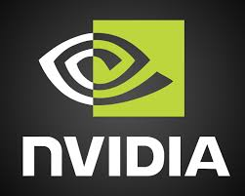

In 2006, the background was changed along with the added half black but the emblem is kept.

In 2006, the symbol and the wordmark was redesigned. The black background was deleted from the “eye” and the typeface became more bolder and its shape had changed. Nvidia used Handel Gothic font for their 2006 logo change. Handel Gothic is a Swiss sans serif designed for FotoStar with traditionally straight elements with curves.

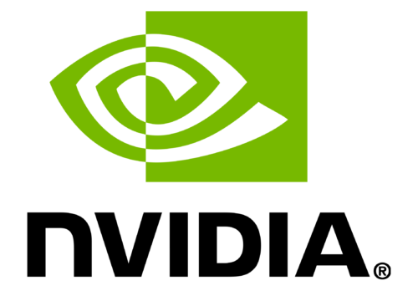
This is Nvidia’s current logo. It shares the same elements from their 2006 logo. The only difference is the colors. Handel Gothic font is still used in their current logo

Moammer, Khalid. “Nvidia, How The Company Got Its Name & Its Origins in Roman Mythology”, Wccftech, Khalid Moammer, 5 Oct, 2016.
https://wccftech.com/nvidias-name-origins-history-roman-mythology/

Btarunr, “New NVIDIA Geforce Logo Pictured” March 8th, 2012.
https://www.techpowerup.com/162026/new-nvidia-geforce-logo-pictured

Weikang Sun, “What does the NVIDIA logo signify?” Oct 13,2016
https://www.quora.com/What-does-the-NVIDIA-logo-signify

https://1000logos.net/nvidia-logo/
https://www.famouslogos.net/nvidia-logo/

