To: Professor Viviana Vladutescu
From: Jonathan Rivera
Date: May 12, 2015
Subject: Field Trip to City College Atmospheric Research Lab

We took a field trip to City College to learn and get a better visual and understand of sensors and remote sensing. On this trip we saw many tools and instruments used for remote sensing and its applications.

Backscatter Lidar System:
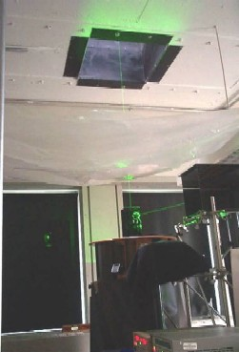
This Backscatter Lider System detectors aerosol in the atmosphere using 1064 nm (infrared) channel, 532 nm (green) channel and 355 nm (UV) channel. This certain Lidar ranges from 500m to 15km. The telescope is 20 inch Newtonian Reflector, F3.5. This Lidar is called backscatter because when a laser is sent out from this Lidar into the atmosphere, even though it wouldn’t hit a solid object in the are it laser still scatters because of the different dust particles or aerosol which is sent back to the Lidar.

Microwave Radiometer:
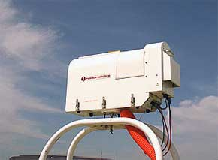 | 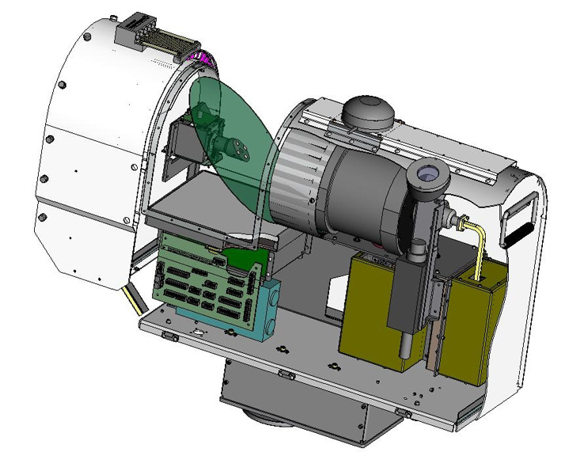
A microwave radiometer is a radiometer that measures energy emitted at sub-millimetre-to-centimetre wavelengths at high frequencies called microwaves. The model we saw was MP-3000A. This sensor is used to look at temperature, humidity and water vapor in the atmosphere. It does this by shooting up wavelength of different frequencies between 50 and 60 GHz, 10m in the atmosphere.
Ceilometer:
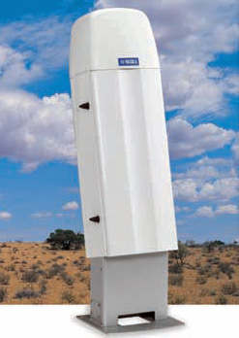
A ceilometer is a device that uses a laser or other light source to determine the height of a cloud base. Ceilometers can also be used to measure the aerosol concentration within the atmosphere. This ceilometer can measure up to three layers of clouds simultaneously using a high-powered pulsed laser diode in the infrared region at 910 nm.

MFRSR Shadowband:
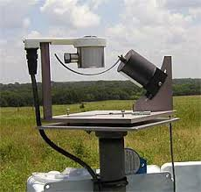
MFRSR Shadowband is used to measure atmospheric turbidity. It updates its measurements every 15 minutes of the day. It uses six wavelengths in the visible/NIR spectrum to get total, diffuse, and direct measurements. These wavelengths are 415, 500, 615, 673, 870, and 940 nm, each 10 nm FWHM.

CIMEL Sun Photometer:
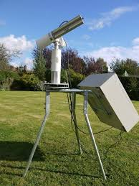
CIMEL Sun Photometer is used to find where the sun is located and also to measure the incoming solar energy or radians. The wavelengths used are 340, 380, 440, 670, 870, 1020 nm (aerosols), and 936 nm (water vapor).

