Salon du Chocolat

Jenniffer Quezada

New York City College of Technology

As a participant at the Salon du Chocolat event in the city of Manhattan, it had been expected to know this would be a crowded yet awaited event for not just chocolate lovers but as well fashion fanatics such as a fashion major or an induvial looking to explore. Walking into the event the smell of chocolate excited many surrounding the escalators. Samples were being handed out at the door Even as someone that isn’t a fan of chocolate, it was difficult to not enjoy the flavors of diversity during the event. It brought in networking opportunities for CEO’s and starter ups to diverse themselves amongst other fields. This was a workshop event due to the criteria’s and a possibility of chance to expand one’s field in fashion, as well learning how to conversate in events. (Image 2)
Fashionistas around the event main object was to watch the chocolate-based fashion show to where the students and fans can view how cacao can be formed to a dress with techniques that are unheard of. Personally, this was a learning experience on a production standpoint. This professional developing event not just only brought an induvial such as Jenniffer to write out and sketch out the event, but as well becoming an inspiration to many creators to explore outside the box when coming into a fashionable standpoint. Going into the diversity of the fashion show, not just certain ethnic backgrounds were a part of the show, instead diversity was shown to express how much Salon Du Chocolat is diverse as whole.
After the show had ended, many continued on by exploring around the floor for kiosk that offered worldwide taste, conversations, and even LinkedIn exchanges for future projects. The fashion show was not the only target to being there at the event but instead expanding and possibly forming ideas. Before leaving The Javits Center, there was one kiosk that caught my eye and brought in ideas for production teams to take when expanding methods on creation. A simple replica of a Chanel bag made out of chocolate excited me for the next professional event. (Image 1)

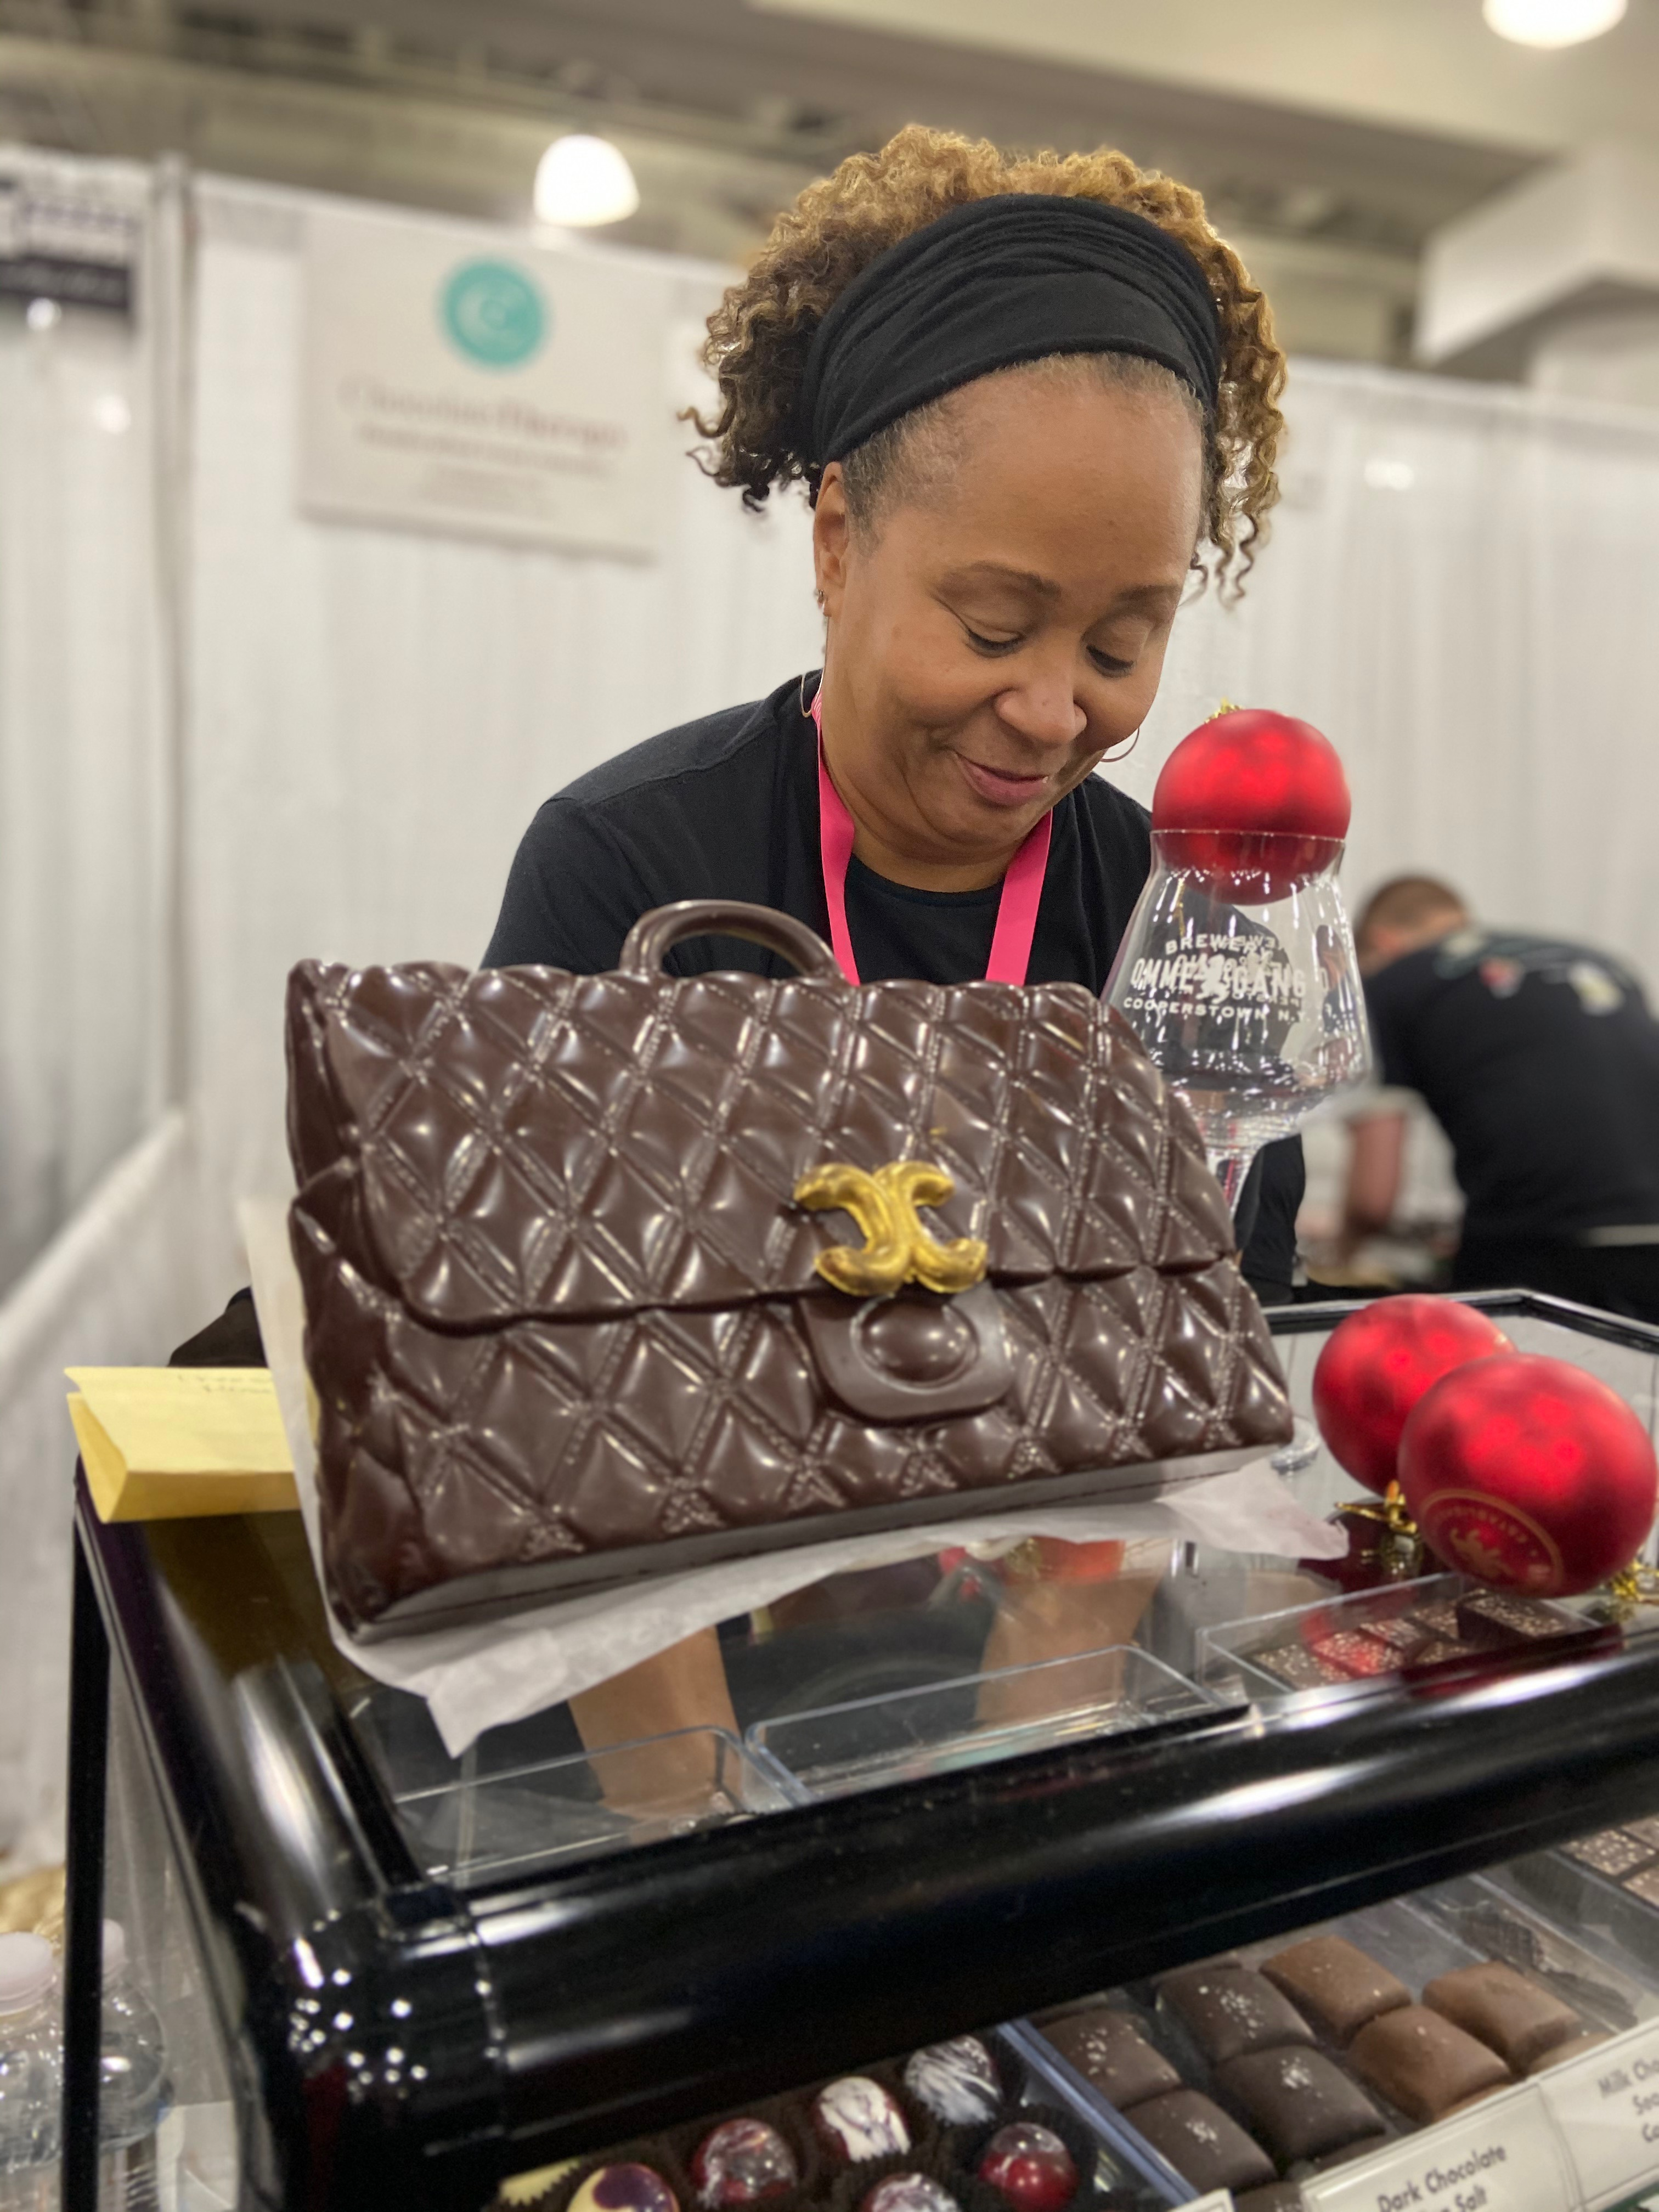
Image 1. Chanel Bag Replica
Decorated with fondant and patched up with icing

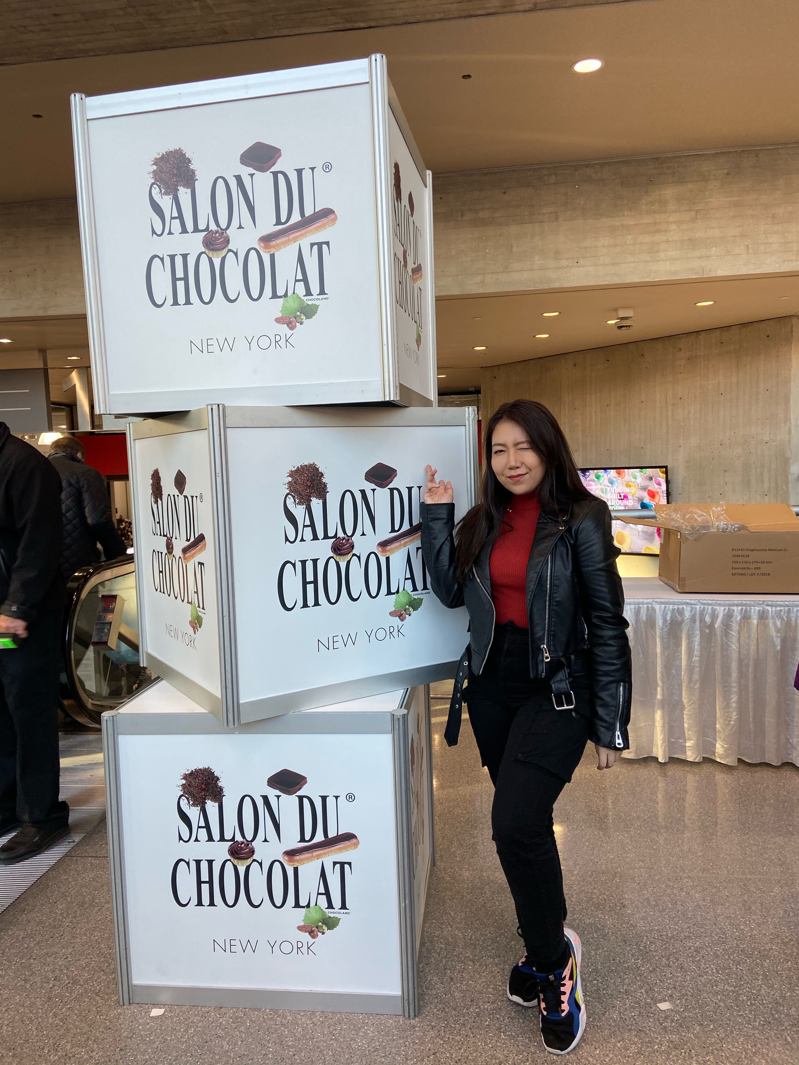

Image 2. The Entrance to Salon Du Chocolat
Jenniffer enjoying her time at the Event

