Jordiel Hidalgo
Professor T. Bauer
CDMG 1111
8 Feb. 2016

Hot Wheels is one of the most effective and popular toy cars ever known. As soon as the company launched in 1968, it was a complete success. Kids fell in love with the racing metal cars from the start. From designing 16 cars to producing thousands, the company has done a tremendous job at keeping up with real world cars and designing its own. The founder of Hot Wheels, Elliet Handler, thought of producing his own toy cars for kids due to the lack of satisfaction from his previous job.
Elliet Handler came up with the name “Hot Wheels” because his partner, Harry Bradley, had a classic car that caught Elliet’s attention. Elliet greeted his colleague saying “Man, those are some Hot Wheels!” so the name originated from a compliment. After the title, the logo was designed with “Hot Wheels” in flames and Elliet’s signature at the bottom right (Mattel). “The flame edges of the logo represent the speed of the toy cars.” (Logopedia). Over a period of time, the brand name was modified. Reducing in size, shape and text. Overall, the brand name is still similar to its original legacy.
Some organizations (The Hot Rod Hobbies and The Bowling Green Hot Rods baseball league) both display similar flame-like emblems. The Hot Rod Hobbies is an organization (originated in the 1990s’) used to compete with participants using small RC cars. Their logo is similar to the Hot Wheels brand name in which they both use flames. The Bowling Green Hot Rod baseball league’s emblem (Originated in 2009) shows a “Hot Rod” car with a flaming muffler. Similar to Elliet’s compliment to Harry Bradley’s “Hot Rod,” the team’s emblem has the same characteristics the Hot Wheel’s brand name originated from. The Hot Rod Hobbies club claimed, “to have their emblem designed by someone else” (Employee at Hot Rod Hobbies), with a different intention. The Bowling Green Hot Rods also use baseball stitching to present itself as a baseball team. In conclusion, there are no facts indicating that these logos were influenced by the Hot Wheels’ brand name.
Furthermore, The Hot Wheels’ title was designed close to a relating typeface called “Heavy Heap.” The flames of the W of the Hot Wheels title signify the designer used this typeface in the development. Elliet Handler designed the original logo but various designers modified it over time (including Michael Endreola). The typeface and flames were edified to target a clear brand name. The color and flame edges of the logo were modified continuously. The redevelopment of the logo was used to make the brand name look more faster every time.
Being the major toy car production in history, Hot Wheels has revolutionized from selling metal cars to having its own tv shows, movies and much more. This company is a complete success and to this day is working its way up to a future like no other. Hot Wheels’ owns a unique emblem with its flaming red logo and unique text. The company’s logo is very similar to what the company represents—toy cars with hot wheels.

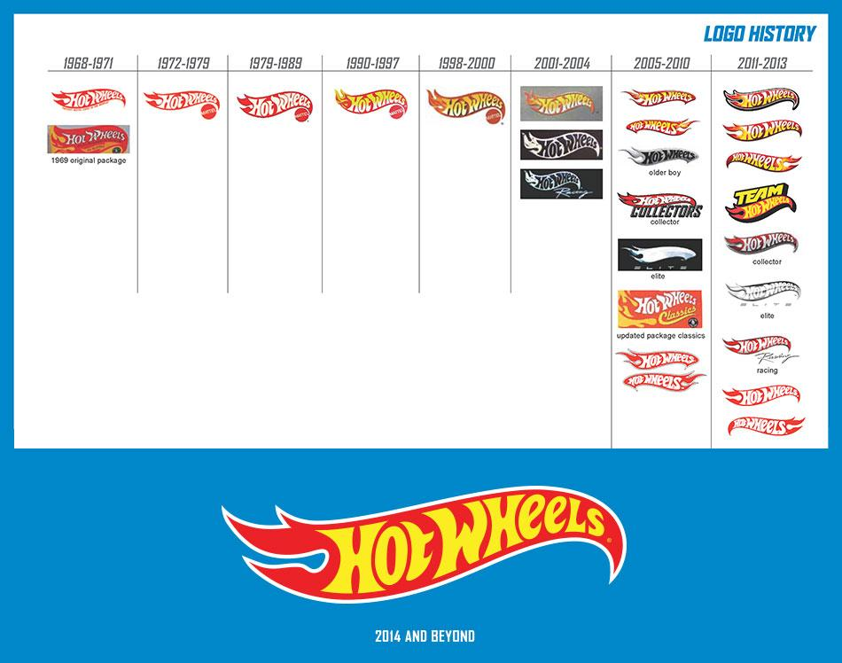
Endroela, Michael. Hot Wheels Logo. 11 March 2015

Works Cited

Logopedia. “Hot Wheels.” Wikia. n.d. Web. 8 Feb. 2016
<http://logos.wikia.com/>

Endreola Michael. “Hot Wheels Logo.” Endreola. 11 March 2015. Web. 8 Feb 2016.
<http://www.endreola.com/hot-wheels-logo/>

Godfrey, Mark. “History of Hot Wheels.” Hot-Wheels.Mlmoments. n.d. Web. 8 Feb. 2016

Cunningham, Tim [Employee at Hot Rod Hobbies]. Personal Interview. Phone call. 8 Feb. 2016

Miller, Aaron. “16 Things You Didn’t Know About Hot Wheels.” Thrillist. 8 Jan. 2015. Web. 8 Feb. 2016

Creamer, Chris. “Bowling Green Hot Rods Logo.” Sports Logos. 26 April 2013. Web. 8 Feb. 2016

