Joanne Lin
DEN2315 Pharmacology
Fall, 2019
Valerian
Valerian is a generic name of the drug, Valeriana officinalis, commonly called garden heliotrope, common valerian or all-heal. It is a perennial tall herbaceous plant of the genus Valeriana, which can grow up to 1.5 meters in height and clumped with scented flowers, leaves, stems and roots. Valerian is a natural product that is distributed from the Northeast to Southwest in China. It can be distributed up to 4,000 meters in Tibet. It also widely distributed in Europe and western Asia. Valerian is used as dietary supplement capsules sold via online or local marketplaces or pharmacies, it is also available in many forms such as an extract in powder or liquid form, or a dried herb in tea form, or in pills which are all made from its roots, rhizomes and stolons. The Valerian is an effective aid commonly use in treatment insomnia remains weak. There are not enough evidences proven with research for the treatment of anxiety, attention deficit-hyperactivity disorder, depression, epilepsy, infantile convulsions, menopausal symptoms, chronic fatigue syndrome, tremors and other conditions.
Valerian is considered a safe remedy. The potential contraindications have not been identified and well documented due to lack of information regards to safety and efficiency of Valerian usage during the pregnancy and lactation. The major drug interactions of Valerian are people who have taken it with alcohol, Alprazolam or other sedative medications such as CNS depressants or Benzodiazepines may cause drowsiness and too much sleepiness. Valerian has several unknown interactions with other drugs and fewer adverse reactions than positive effects of the drug such as headache, diazepam and diarrhea have been reported by users. The only oral manifestation experienced by some patients is xerostomia after taking Valerian.
Temazepam is a prescription medication that treats similar conditions as Valerian. However, it has much narrow margin of safety than Valerian. The contraindication of Temazepam is during pregnancy and breast-feeding because it can cause severe adverse effects that may contribute to birth defects or life-threatening effects to newborns, difficult breathing, swollen lips, tongue or throat. Valerian seems more attractive to the consumer compared to Temazepam not only because it has a relatively wide margin of safety, but also easier to obtain because it doesn’t require medical prescription of physician.
As a dental hygienist student, I must expand my knowledge field to update my information repository about natural products. Possessing comprehensive information about pharmacological classification, uses, adverse effects, drug interactions, contraindications and oral manifestation of natural products in general can increase my comfort level when I discuss with patients about possible dental outcomes regarding the products they are taking. I can also incorporate the interactions of natural product such as Valerian to adjust treatment plans based on my understanding on this product to lower risks and discomforts that involving in treatment such as reducing the use of saliva ejector and air-water syringe because patients who taking Valerian may experience xerostomia and have difficulty to tolerate frequent use of saliva ejector and air-water syringe.

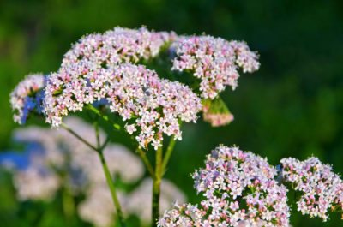
Figure 1: Valerian as it appears in nature
Source:https://www.gardeningknowhow.com/edible/herbs/valerian/growing-valerian-herb-plants.htm
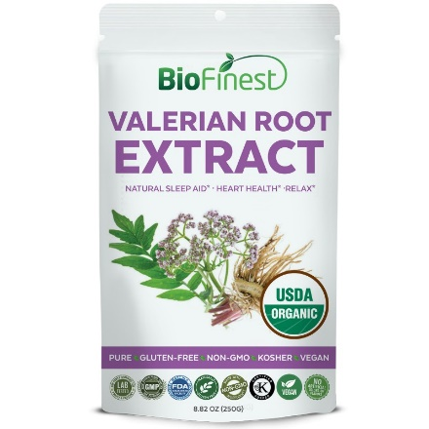
Figure 2: Packaged Valerian root extract powder for consumer use
Source:https://biofinest.com/en/supplement-powders/861-organic-valerian-root-extract-powder-250g.html

Works Cited
Wynn, Richard L., et al. Drug Information Handbook for Dentistry: Including Oral
Medicine for Medically Compromised Patients & Specific Oral Conditions.24th ed., Lexicomp, 2018.
“Valerian (Herb).” Wikipedia, Wikimedia Foundation, 10 Oct. 2019, en.wikipedia.org/wiki/Valerian_(herb).
“Valerian: Uses, Side Effects, Interactions, Dosage, and Warning.” WebMD, WebMD, www.webmd.com/vitamins/ai/ingredientmono-870/valerian.
“Valerian Uses, Benefits & Dosage - Drugs.com Herbal Database.” Drugs.com, www.drugs.com/npp/valerian.html.
“Temazepam: Uses, Dosage & Side Effects.” Drugs.com, www.drugs.com/temazepam.html.

