Jhenell nina "Good-Year Logo"
Goodyear manufactures tires for automobiles, commercial trucks, light trucks, SUVs, race cars, airplanes, and heavy earth-mover machinery. The Goodyear Tire & Rubber Company was founded in 1898 by Frank Seiberling. Today it is the third largest tire company in the world after Bridgestone and Michelin. The thirteen original employees manufactured bicycle and carriage tires, rubber horseshoe pads, and poker chips. The company grew with the advent of the automobile.
In the 1890s the timing couldn't have been better. The bicycle craze of the 1890s was booming. The horseless carriage some call it the automobile was a wide-open challenge. Even the depression of 1893 was beginning to fade. So, on August 29, 1898, Goodyear was incorporated with a capital stock of $100,000. The first recorded payroll amounted to $217.86 based on the prevailing wage of 13 to 25 cents an hour for a 10-hour day. After the first full month of business, sales amounted to $8,246.
In 1901 Frank Seiberling provided Henry Ford with racing tires. In 1903, Paul Weeks Litchfield was granted a patent for the first tubeless automobile tire. By 1908 Ford was outfitting his Model T with Goodyear tires. In 1909 Goodyear manufactured its first aircraft tire.
As for the company's trade mark name, which comes from Charles Goodyear, Goodyear invented vulcanized rubber in 1839. The first Goodyear Tires became popular because they were easily detachable and low maintenance. This how they began to separate themselves from the competition.
If you look at the Good Year logo, you'll notice a foot with winged sandals in between the words Good and Year. The winged sandals are a symbol of the Greek god Hermes, the god of travelers, thieves, merchants, and the messengers of the gods.
The look of the logo comes from his old home in Akron. On a shelf, there stood a statue of the famous god of mythology; known to the ancient Romans as Mercury, and to the Greeks as Hermes. Mercury. Mr. Seiberling's attention was turned to the statue, and he felt that it portrayed many of the characteristics for which Goodyear products were known. The idea of speed had much to do with Goodyear’s selection of the symbol, for the wing-footed Mercury was regarded as a fleet herald of good news. But it is as a herald or carrier of good tidings to users of Goodyear products everywhere that the Wingfoot now stands in the minds of the people of the world.
Then later on in Aug. 1900 the had a meeting to talk about trade marking the logo. Everyone present agreed that this should be the symbol for the company, with the Wingfoot to be set in the middle of the word "Goodyear." The original Wingfoot, however, was much larger in relation to the word "Goodyear" than the one in use today. it remains an integral part of the Goodyear signature, a symbolic link with the company’s historic past.
On July 10, 2008, the Goodyear Tire & Rubber Company was recognized as one of America’s most respected companies by the Reputation Institute (RI) and Forbes magazine. Goodyear ranked 16th on the magazine’s third annual listing of companies with the best reputations in the United States. Today, Goodyear measures sales of more than $20 billion, although it took 53 years before the company reached the first billion-dollar-year milestone. And it all began in a converted strawboard factory.

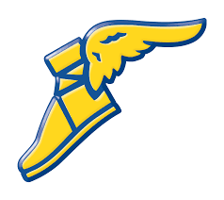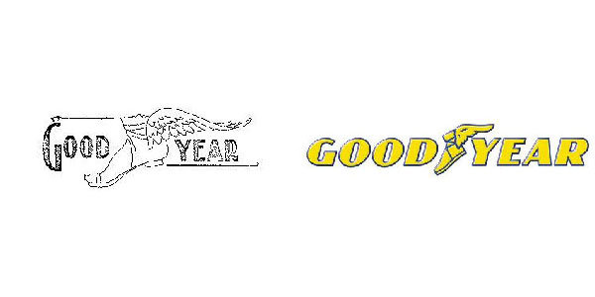 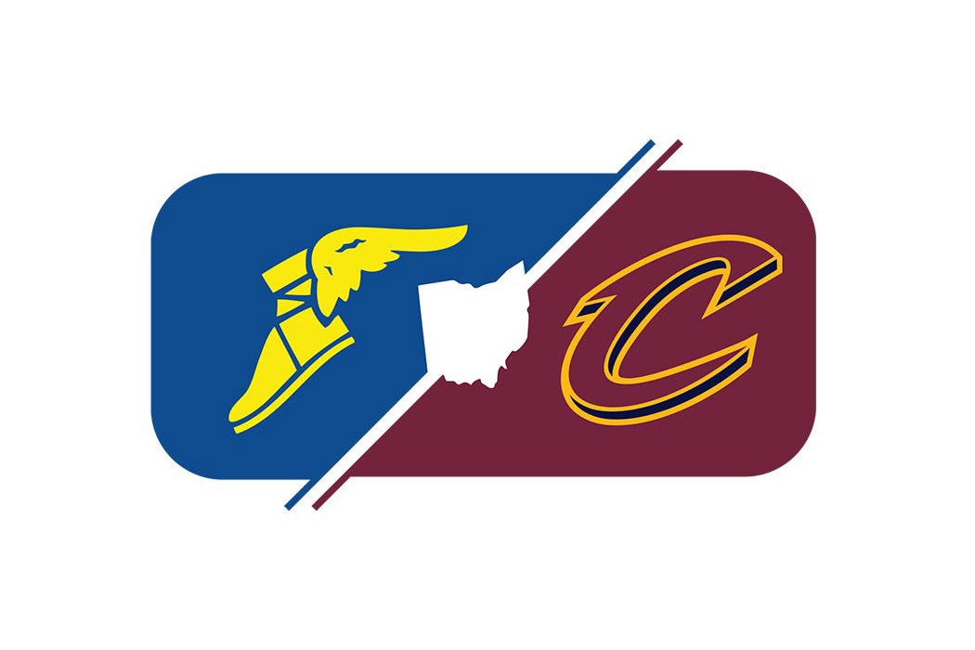<^ talkabout this