Jailyn Lavado
BUF 2246-HD22
In the streets of New York City, during the cold weather, we see a lot of people walk around with coats. The typical jackets are made with down, but you’ll also notice fur coats. Fur itself is problematic in the fashion world, so it’s mostly likely these coats are made with faux. That begs the question why was fur a problem? What lead to the creation of faux fur? Well, you have to start by learning about the history of fur.
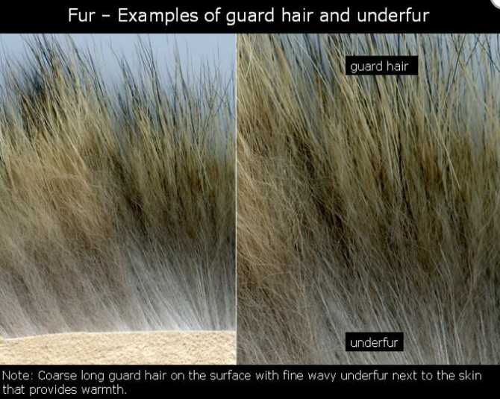
First, what is fur? Fur is a natural protein fiber, which can come from rabbits, mink, fox, and many other animals. Fur is usually used for colder climates as it is able to maintain heat. The fur is able to do this by having the under fur and guard hair. The under fur is hair that is shorter and finer. This is closer to the skin while the guard hair is the layer on top which is coarse, long and lustrous. Certain animal’s fur can have different characteristics, for example, mink fur is ”shiny with soft guard hair and dense underfur.” Due to its underfur being uniform and the factors mentioned , mink fur is very expensive. Another example is coyote fur, which is cheaper compared to mink, is thick and durable. Now that we have a foundation of what fur is, it begs the question: when did people start to capitalize on fur?
Before answering this, we have to understand that fur was not discovered in recent times, as it was used in ancient times. Those who lived in cold climates were seen using fur but also seen in other civilizations. Fur was used by royalty, similar to the color purple. Even today, fur is associated with being of high class/ rich as throughout time those who had power and status were able to wear fur. It’s stated that, “In later days of civilized England, furs became very fashionable...the use of furs and other costly materials became so extravagant...” Even around the early 1000th's when King Henry II was alive, the rage for furs existed. As we know, if someone of power wears something, civilians are quick to imitate their fashion; to feel like they belong. The desire for fur only grew over time.. Fast forward to early 1600’s, “Fur trading was the leading activity during the period of the Dutch supremacy in our continent...” , Alice Llyod-Jones describes the reason why fur trading became so prominent. The discovery of many exotic/ foreign animals in America fueled the fur trade causing countries such as France and Britain to start competing for revenue.
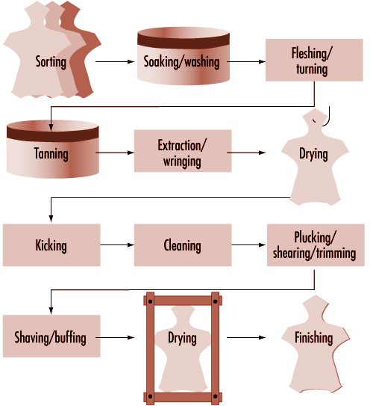
For the fur trade to continue and not die down as quickly as the animals are being hunted, fur farming began. With the help of fur farming, these farmers can control and estimate how much they can produce. Workers feed the animals with grains and fish. Once its mating season the process for obtaining fur starts. The process starts with the animal being killed by getting skinned. “skins are then dried in drums... stretched and sewn onto boards. During the finishing tasks, the skins are brushed and then stored in dry, air-conditioned rooms. The raw skins are preserved and transported to be auctioned directly or are sent to dressing firms. The auction centers also have huge storerooms, where the skins are sorted for sale.” ￼The end use of fur is usually found in apparel such as hats, coats, vest, scarves and earmuffs. Fur trims, which is also another end use can be used for the apparel items mentioned above. Trims are placed on jackets, hats and gloves.
Tying back to why certain animal’s fur is expensive, the size of the animal helps to determine this , but the end use is taken to account as well. If the animal is small, the more the farm needs to produce. If demand increases, the supply can be matched with these farms BUT this raises the question with how ethical is this practice. Are these farms allow to continue due to the greed of those who can profit? The treatment of these animals is one of the reasons why fur became problematic. People have seen that fur farms just dump the bodies somewhere after getting what they need from the animal. Sometimes the animals do not free roam in the farm and are stuck in a small cage. To most , the animals are treated as objects and not as living creatures. Organizations that are vocal about animal cruelty, such as PETA, have pushed for laws to be put in place to protect the animals and public awareness. Magazines “... showed a model trailing a fur coat oozing blood on the catwalk with the slogan: 'It takes up to 40 dumb animals to make this but only one to wear it...” With this gruesome picture, some pledged not to wear fur. Another example of people being pro-active include protesters pouring paint onto those wearing fur coats. This helped for the production of fur to decrease but also the cost was too high, “felt that the luxury status of fur was becoming a thing of the past. Demand began to fall.” A mix of these factors had caused fur its downfall amongst the general public.
Not only did public awareness of fur production increase but the government took part in minimize the harmful treatment of animals. Laws were put in place around the height of the fur rage which in this case we’ll talk about the 20’s and 30’s. In this time period,, women were sold on the idea that fur was the “it” thing. Only someone who truly loved you would purchase a fur coat for you. Many celebrities helped sell the idea of fur being a luxury item and these women wanted to be apart of that. In order to protect a lot of animals the government placed,, “Protection in some states for the first time was afforded certain fur animals...foxes, civet cats and opossums were added to the protected list in Iowa...” This helped decrease the range of furs people could take and the population of these animals.It’s quite mind boggling that a lot of animals were starting to get protected but fur farmers were using whatever had fur to gain profit. But even with laws in place, it’s hard to say that this is the end of fur’s journey.

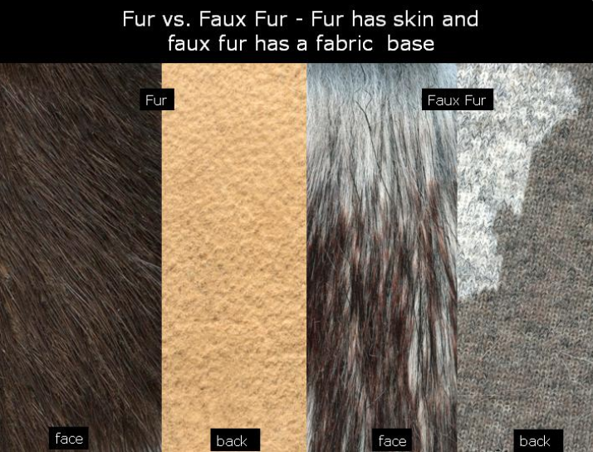
With the practice of fur farming being illegal in the certain parts of the world, fur was re-invented. The idea of faux fur came into light as synthetic fibers rose in the fashion industry. Not only is it cheaper but it takes away the idea of animal cruelty so a range of people can now wear faux fur.. Now those who want to feel “luxurious” but stay on a budget can now buy faux fur coats. Faux fur began to be used in apparel but also for interiors such as pillows. “Innovations in synthetic materials have helped to make numerous leather substitutes and faux fur more realistic in both feel and look.” As technology progresses so does the look and feel of faux fur. Maybe one day it’ll be as realistic as fur without the cruelty.

Bibliography:
1.Dyhouse, C. (2011). Skin Deep: the Fall of Fur. History Today, 61(11), 26–29. Retrieved from http://search.ebscohost.com.citytech.ezproxy.cuny.edu/login.aspx?direct=true&db=a9h&AN=67076199&site=ehost-live&scope=site
2.Hannah Schlomann Staff. (2018, January 3). Faux fur makes inroads in high fashion. Christian Science Monitor, p. N.PAG. Retrieved from http://search.ebscohost.com.citytech.ezproxy.cuny.edu/login.aspx?direct=true&db=a9h&AN=127075000&site=ehost-live&scope=site
3. Earnshaw, Grimes, United States. Dept. of Agriculture., & United States. Bureau of Biological Survey. (1929). Fur laws for the season 1929-30. ; Farmers' bulletin (United States. Dept. of Agriculture) ; no. 1618. ; Farmers' bulletin (United States. Dept. of Agriculture). United States. Department of Agriculture.
4. Uitti, J., Rustemeyer, T., Elsner, P., John, S., & Maibach, H. (2012). Fur Farming and the Fur Industry. In Kanerva's Occupational Dermatology (2nd ed., pp. 1479-1482). Berlin, Heidelberg: Springer Berlin Heidelberg.
5. Lloyd-Jones, A. (1918). The fur industry.
6. Itextiles.com , Online textbook

Remember this when figuring out whether a coat is authentic or not.
According to Itextiles.com, Chapter fabrics, section fur
Lloyd-Jones, A. (1918). The fur industry. Page 12
The fur industry by Alice Llyod-Jones Page 3
Uitti, J., Rustemeyer, T., Elsner, P., John, S., & Maibach, H. (2012). Fur Farming and the Fur Industry. In Kanerva's Occupational Dermatology (2nd ed., pp. 1479-1482). Berlin, Heidelberg: Springer Berlin Heidelberg.
Dyhouse, C. (2011). Skin Deep: the Fall of Fur. History Today, 61(11), 26–29
6 Dyhouse, C. (2011). Skin Deep: the Fall of Fur. History Today, 61(11), 26–29.
Earnshaw, Grimes, United States. Dept. of Agriculture., & United States. Bureau of Biological Survey. (1929). Fur laws for the season 1929-30. ; Farmers' bulletin (United States. Dept. of Agriculture) ; no. 1618. ; Farmers' bulletin (United States. Dept. of Agriculture). United States. Department of Agriculture. Page 5
Hannah Schlomann Staff. (2018, January 3). Faux fur makes inroads in high fashion. Christian Science Monitor, p. N.PAG.

