Elderberry is a deciduous multi-stemmed shrub with brittle branches that easily bend under the weight of its fruit clusters (1). It can be found in drugstores among other over-the-counter (OTC) treatments for influenza and immune stimulation. The flowers and berries of the Sambucus nigra plant species is used medicinally, as they contain flavonoids, found to have antioxidant and immunological properties to treat conditions such as influenza, bacterial sinusitis, and bronchitis. It is also an excellent source of anthocyanins, vitamins A and C, and a good source of calcium, iron, and vitamin B6 (1). Elderberry has also been claimed to benefit cardiovascular disease risk, constipation, gingivitis, hyperlipidemia, and obesity. It is available in a variety of brand names and combinations. Three were available at my local drugstore, including Zarbees Naturals Elderberry Immune Support (elderberry fruit extract, sugar, corn syrup, pectin, citric acid, natural flavor, color added: vegetable juice, grape skin extract Enocianina), Sambucol Black Elderberry Immune support (black elderberry extract, cane sugar, tapioca syrup, purified water, pectin, citric acid, sodium citrate, natural flavors: raspberry, lemon, vegetable oil, carnauba wax), and Nature’s Truth Black Elderberry Extract (black elderberry extract, glycerin, water, citric acid). Dosing of the three brands vary, as they come in chewable gummy and liquid syrup form. The serving suggestion for Zarbees Naturals is 3 gummies daily, for individuals aged 12 and older. Sambucol’s directions for use is to chew 1-2 gummies daily, for adults and children over 4 years. Nature’s Truth only indicates that adults should take 1 teaspoon daily, preferably with a meal.

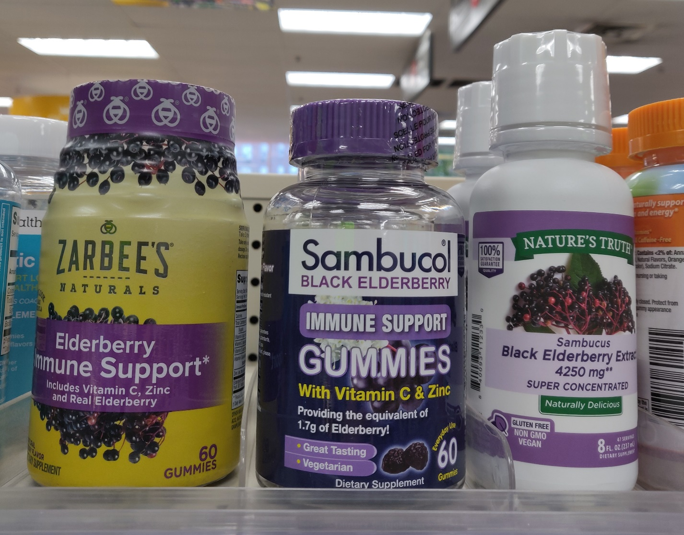
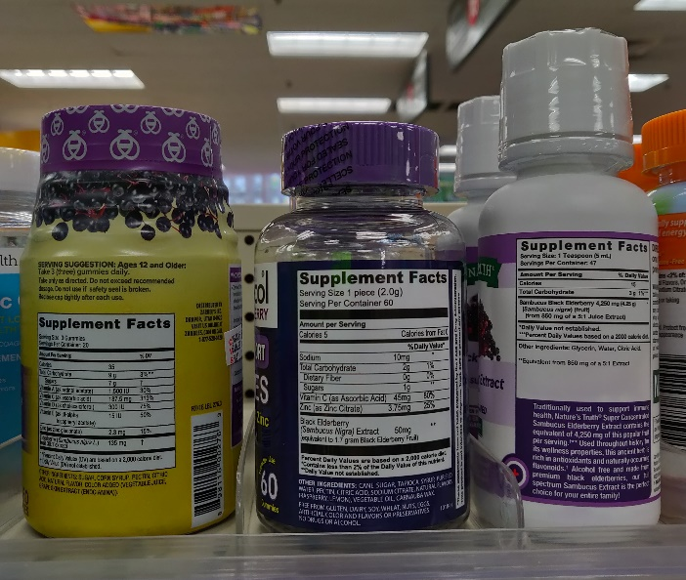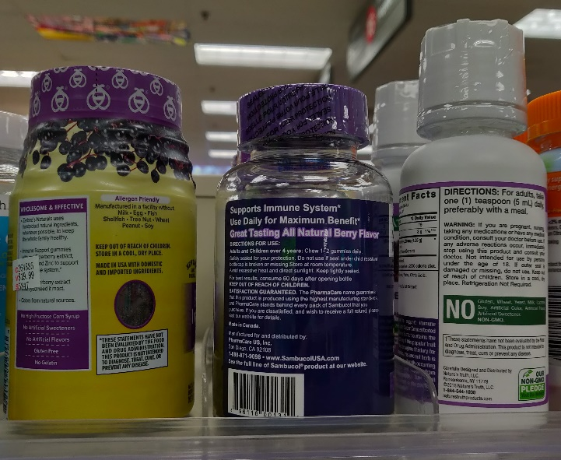

The bark, leaves, seeds, and raw or unripe elderberry fruit contain the cyanogenic glycoside sambunigrin, which is potentially toxic (2). This risk is eliminated when elderberries are cooked. Side effects of cyanide toxicity include nausea, vomiting, diarrhea, abdominal cramps, and weakness. Individuals with known allergies to elder or plants in the Caprifoliacea (honeysuckle) family are advised against taking elderberry, as lectins from Sambucus nigra may have the ability to stimulate cytokine release and induce type 1 hypersensitivity (2). Adverse effects include cyanide poisoning in incorrectly prepared elderberry products. Elderberry should be taken under the direction of a qualified health-care provider due to the risk of cyanide toxicity. It is contraindicated for a long list of individuals including patients on blood pressure medications, undergoing chemotherapy, with CNS disorders, with dermatological conditions, with diabetes or those taking antidiabetic agents, taking diuretics, with diarrhea or conditions causing diarrhea, with eating disorders, females, with gastrointestinal disorders, with hypokalemia, with migraines, with muscle pain, and with respiratory disorders/taking theophylline (2). Elderberry reportedly tends to exhibit beneficial interactions with drugs such as antibiotics and anti-inflammatories, by improving outcomes of the conditions that these drugs treat. However, possible cyanide poisoning has been shown to affect individuals undergoing treatment with cardiovascular agents, causing tachycardia. Many other contraindications involve the risk of cyanide poisoning, which can be avoided by proper preparation of elderberries.

Like all other dietary supplements, elderberry does not require approval from the U.S. Food and Drug Administration (FDA). Manufacturers are responsible for ensuring the safety of their products. However, they are not required to prove the safety and efficacy prior to introducing the supplement to market. For this reason, dietary supplements are often found to contain differences between labeled and actual ingredients or their amounts (3). Elderberry is in many ways like raspberry, cranberry, strawberry, blueberry, or even grape (1). My research has shown that elderberry is quite beneficial due to its antioxidant and immunological properties. After watching the Frontline documentary regarding supplements in general, I am especially aware that we have no way of ensuring that the manufacturers are providing cooked elderberries, void of bark, leaf, and seed remnants. It was interesting to find that elderberries are claimed to have a beneficial effect on gingivitis; one day I may come across a patient who tells me that he/she is taking elderberry for this. I would then know to ask whether they have ever exhibited any symptoms of cyanide poisoning, as this is possible due to the lack of FDA regulation on dietary supplements.

Charlebois, D. (2007). Elderberry as a medicinal plant. Issues in New Crops and New Uses. ASHS Press, Alexandria, VA, 284-292.
Ulbricht, C., Basch, E., Cheung, L., Goldberg, H., Hammerness, P., Isaac, R., ... & Weissner, W. (2014). An evidence-based systematic review of elderberry and elderflower (Sambucus nigra) by the Natural Standard Research Collaboration. Journal of dietary supplements, 11(1), 80-120.
https://www.ncbi.nlm.nih.gov/pubmed/30000895

