Jason Griffin

Saul Bass

Saul Bass was a graphic Designer and Filmmaker, but he was most known for his Trademark Title Sequences. Title sequences from classic movies like “Goodfellas”, 1960’s “Ocean’s Eleven” and “It’s a Mad Mad Mad World.” To me the way he did his Illustrations of hands coming from different places and how they would interact with his drawing is really appealing. A very simple aspect of his work but very effective in its own way. It gives a feeling of surprise and the way they’re placed really makes them pop. It’s usually the first thing people see in his work. Bass was also called in to work for major advertising companies which helped get his name out nationwide, but he also didn’t want to be trap behind a desk doing logos, letterheads, or trademarks for commission. He saw his work being put into bigger places. His work in film posters always had a darker undertone that was easily understood but also cleavely hidden behind his use of colorful backdrops and his text that would catch your eyes. Even if some people find his style dated, it’s still relevant and Iconic. Most people don't even realise how much of his style influenced how modern art is perceived. He puts it best in his own words “I want to make beautiful things even if nobody cares” something that he said in an interview on making money VS Quality work.

Movement from this piece goes from bottom to top. Exodus shows how real life elements like fire can be used to enhance his work. The work itself is nothing abstract, its simple but powerful enough to hold the message behind the images. Fire is alway eye catching and the use of it always has a deeper meaning.
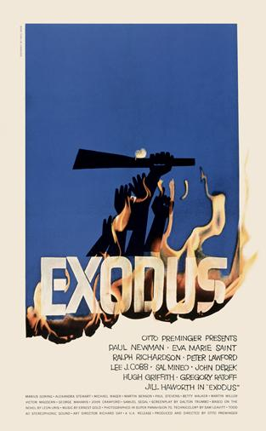

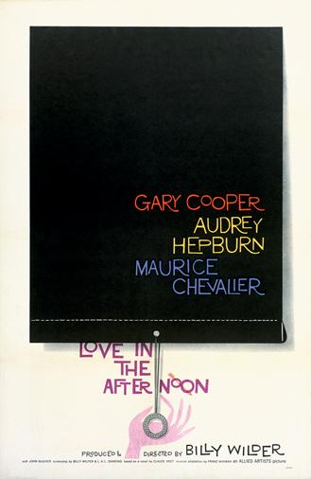

Love in the afternoon, a drama/crime film released in 1957. Variety is key to keeping people’s attention when it comes to film posters, advertisements, or just artworks in general. The contrast with the colors are perfect example of what variety can do to what would seem uncreative work. The best part of this piece is that Bass was still able to put his signature hand illustration in. Very subtle but very clean which I believe most people would agree with.

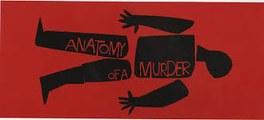

The “Anatomy of a Murder” is probably one Bass’s most famous works. Another film poster but this one stands out from his others because the tone is the most prominent theme in this piece. The bold colors black and red signify the mood of death, mystery, and horror. The word within the body reminds me of someone cutting up the body, or a killer marking his victim. The illustration follows a chalk outline, to help pull together the idea of death in the poster.
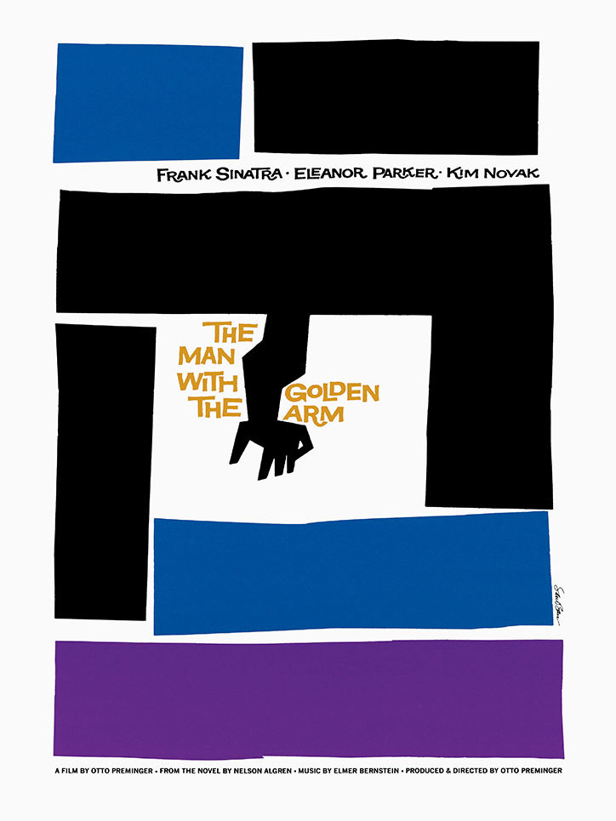

The Man with The Golden Arm by Otto Preminger. From his abstract approach there is still a sense of control in this piece. The film is about a jazz drummer who struggles with his drug addiction to heroin, which he nicknames “Gold”. Bass makes sure to put in his signature arm to symbolize that arm is dead but puts the title in gold to represent the main character’s potential to be something greater. The geometric shapes do a good job of filling in the space and making the piece feel full. Alignment is purposely off and sloppy looking to reflect the story of the film.

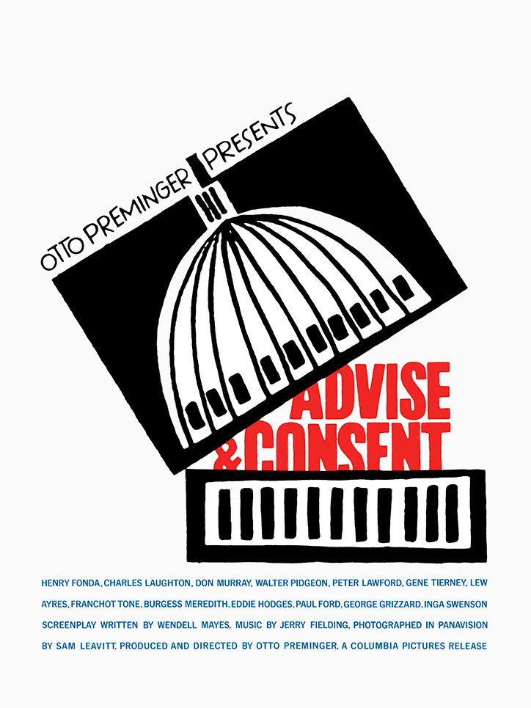

Advise and Consent. The best use of the design principle of size and shape from all of Bass’s work. He kept the color layout simple and chose to scale up his illustration and shape as a box that’s being open to the public. It looks like a political cartoon but it can easily be used for other concepts.
Saul Bass works will always be a good start for young designers learn from, since most of his work is simple to follow and give great value when it comes to certain key concepts of design. Simple but solid elements are always seen throughout all his work. Many artist and designers still refer back to his work whenever they need inspiration on how they could add something personal to their own work.

