Jason Griffin
Professor Bauer
COMD D106
May, 1 2019

Majority of people think too big or too loud when to it comes to designing a logo. It’s understandable since the main drive in making a logo is to stand out. To be this object that commands attention and creates a memory in the viewer’s mind. Often designers what to incorporate fonts, colors, or even cartoons characters to the logo, when most of the time all that does is create something that is easily forgettable. In a modern world where it seems like you have to be loud to stand out, it’s the simple things that stand out the most and stand out the longest.
The Nike Swoosh, McDonalds Golden Arches, and The New York Yankees team logo are probably the most recognizable symbols around the world. Each representing something different but their approach to logos are the same. Simple, bold and Iconic. One solid color that was strong enough to evoke a certain response in people. The deep navy blue in the Yankees logo contracts beautifully with their white uniforms. The key in standing out is to not to stand out, much like an actor having to act. If we don’t see them acting, rather we see a character come to life then the performance will be remembered, even though we know it was all an act. The same goes with anything that’s worth standing out.
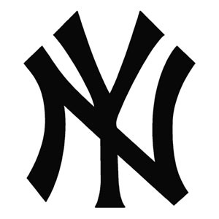

One of the coolest facts about the Yankees logo is that from it’s early draft it didn’t change a lot. Henry Alonzo “Lon” keller was an American artist and the man responsible for the creation the New York Yankees logo. Around 1940 post World War II an economic boom was ready to go off. Companies knew that everyone would want to spend money on something and they knew nothing screamed America more than baseball.
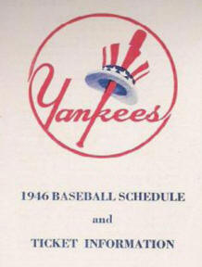

There’s a lot of different ways we can look at designing but best rule to follow is your instinct. Nothing will feel better to a creator then creating freely without the acknowledgment of what is seen as the proper way of doing things. If we allow rules or some sort of pattern to form then we’ll start missing the point of creating, Which is always to make something new and recognizable for everyone.

http://www.lonkeller.com/yanks/yankee_logo_story.htm

