Sehun Bolaji English: 1101

Final Portfolio Table of Contents:

Literacy Narrative………………………………………………………………………..2
Annotated Bibliography………………………………………………………………….4
Research and Audience………………………………………………………………….19
Personal Experience Essay……………………………………………………………....23
Research and Audience Presentation Prep………………………………………………24
Final Reflection Letter…………………………………………………………………...26

This piece I wrote is different from when i first started regarding my grammar, vocabulary, and my structure. My vocabulary had gotten better than it was when I had first started and my flow when writing is easier and better. Additionally, writing has gotten a little bit more fun since I started, it became more enjoyable.
Sehun Bolaji
Literacy in Writing

During my 11th grade year in highschool, my English teacher was trying to prepare us for the English regents. So she would have us all work on our vocabulary and sentence structure in class and have us do various amounts of essays to ensure ours success before the exam. I was pretty confident in myself due to the fact that I always had a 90 or above inEnglish tests during that time. She said to me the reason I had such a good grade on the essays is because she could hear my “voice” in my writing and that I use a lot of vocabulary words. But the day before the English exam however, she told the class that for the argumentative essay that we shouldn’t defend the side that we agree with the most, but defend the side that has the most backup information. This was not something I thought of before and it did sound like the logical thing to do so for the English exam I had started to do so, but because of this I had gotten a low grade on the ELA Regents. I didn’t fail the regents but I thought that the grade I got wasn’t good enough for me. So I was scheduled to take it the year after. During the gap in between I didn’t really study, all I did was do what I usually do, go to school and go home and watch anime and play video games and occasionally go out with friends. Then, when it was time for me to take the test again I came in with confidence, I was determined the write the way I see fit, which was basically the way people in the shows I watch speak because when I do that I use words I wouldn’t think of using before. Additionally it is more fun to me that way. Furthermore, I defended the side of the argumentative essay I agreed with, not the one with the most evidence. When the test grades came back I had gotten a 92 on the regents which made me feel better about myself, made me more confident in my writing abilities.

Due to that experience I went through I find myself able to connect with my writing. For instance, when I write you essays, they are always opinionated. This helps me able to gain a better understanding on what I am writing. Additionally, keeping it original. Furthermore, I never stress over an essay because of the confidence I have gained in my writing abilities because of my personal experience. For example, the first time I took the ELA regents I was scared and nervous and didn’t believe in my writing abilities and had a low score of a 69, then when I retook the the essay the second time with confidence in myself I scored a 92. Due to this experience I see no reason to believe that confidence isn't a huge factor for me when it comes to my writing. I had also gained a writing structure due to my English teachers lessons using the Schafer model. It helped me figure out ways to properly write an essay. I’ve been using Schafer Model to the point where I don’t realize I don’t even use it anymore. At this point in time I have realized that I use Schafer model and my own voice in writing in order to write my essays now. I had incorporated the words unfamiliar words from the shows I watch and the books I read into my essays which is how I came upon the writing style I have now. Since I noticed my writing got better in my opinion, I decided to write fictional stories in my free time when ever I’m bored and read it to my friends and see what they think about it. I find it entertaining and my friends do too. Some of them even started doing the same. I had also began to like my English class more. The topics that we go over in class gives me some more ideas to put into my writing, let it be stories or just into my tone of writing in general. The only thing that I disagreed with my 11th grade English teacher in was that we should only defend the side with the most information when it comes to arguments. I disagree with the statement due to the fact that if I defend a side I actually agree on it’s easier for me to use my writing style and put my voice into my writing, easier for me to find a sort of flow in my essays. It’s also easier to argue against the side I don’t agree with. In my opinion, it’s better for me if the other side has more information backing up their statements than mine, it gives me more things to rebuttal, which is something I enjoy doing. When I rebuttal it gives me more things to write about, which helps when I have to write long essays.

Sehun Bolaji
Annotated Bibliographies
Prometheus The Creation of Man and a History of Enlightenment

As shown by this story, Prometheus fights for human progression against the forces of nature. Prometheus gave humans the gift of fire which he had stolen from Olympus. The gift of fire can also be looked at as the spark of human intellect and knowledge which Prometheus bestowed onto mankind. Furthermore, We have learned that in the story that Pandora, regardless of letting the creatures of famine, disease, and plague into the word she still closed Pandora's Box before hope can escape. Hope helps the human race struggle for a better future while fire makes this hope for a better future possible. The theme of the story is that there are consequences for everything, good or bad.I feel that the target audience of this story is for highschool students who tend to make reckless decisions. The story is telling them to beware of the choices you make because everything comes with a price, as shown by Prometheus stealing fire to benefit the human race but still getting punished by Zeus by getting tied to a pillar and have a bird eat his liver for the rest of eternity. Furthermore, you might not always be right so you should heed others side of a story or advice. The tone of the story is warning and excitement. An example of a warning tone was when Prometheus and Pandora both didn’t think anything bad could come from their actions and ended up bringing about not only good but some terrifying realities to the humans as well. The reason I also said the tone is exciting is because the gift of fire helped the human race to find a way in the dark world where every other creature overpowered them. Furthermore, Pandora being able to keep hope in the box was able to give hope to the human race. The rhetorical appeal is pathos, as clearly shown by the author using mythical characters for us to try and bond and relate with to tell a story that will hit the heart of its readers, while also helping us find our way to the moral theme of the story in the end.

Work Cited
https://classicalwisdom.com/mythology/gods/prometheus-the-creation-of-man/

Sehun Bolaji

10/14/19
Story of Icarus and Daedalus

In the story of Daedalus ( A famous craftsmen in Greek Mythology) and Icarus (His Son) was locked in a tower above Minos (The King of Crete), to keep the secrets of the labyrinth hidden. In order to escape, Daedalus using his crafting skills had crafted two pairs of wings for him and his son to escape. Since Daedalus had crafted the wings using wax, he warned Icarus not to fly too high so the wax won't melt due to the sun or fly too low so the feathers wont get wet due to the seawater. On their way to freedom Icarus forgot his father's warning and flew too close to the sun, causing him to fall to the sea and drown. The purpose of the story of Daedalus and Icarus is that you should always heed your parents warning. The basic concept of the story Daedalus and Icarus is that hubris (Pride) is a bad thing. It could be said that the subtext is that you should always heed the advice and warnings of your elders, particularly your parents.

The story of Icarus and Daedalus targeted a younger audience, as shown by how Icarus was a young protagonist and fell to his doom not only because of his pride, but because he did not heed his fathers, Daedalus, a more experienced and wiser man warnings. The tone of the story is Egotistical, Arrogant, and Grim. It was egotistical due to the fact that he let his pride get in the way of his judgment. It gave off an Arrogant tone because he did not heed his father's warning even though he was warned about the consequences of it. Finally, a Grim tone was set because at the end he had faced due to his ignorance. The Myth uses the rhetorical appeal known to us as Pathos. This Myth has an emotional appeal as shown by it using a connection between father and son to get its moral lesson across. Pathos is more effective than ethos and logos due to the target audience. The target audience is a younger age group, to be more specific, those who don't respect or listen to their elders, anyone older than them. By using a pathos appeal it keeps the younger audience more entertained. Using stats from ethos and facts from logos would bore the younger generation, if they're not entertained they won't be able to get anything out of this mythical story, prohibiting the writer from getting its message across. For instance, icarus getting cocky and flying too close to the sun and falling to his death is more entertaining than that of someone simply saying that listening to our guardians will have a positive effect on us in the future.

Work Cited

https://www.greekmythology.com/Myths/Mortals/Icarus/icarus.html
Sehun Bolaji
Annotated Bibliography

The Story of Echo and Narcissus From The Book Of Ovid “Metamorphoses”

In the story of Echo and Narcissus, Narcissus was considered a very handsome man who everyone fell in love at first sight , but he was very narcissistic so he never returned the affection he received towards others. He literally carries around a spear to keep the girls away. A nymph that goes by the name of Echo( who got cursed to only repeat a person's last words by Hera/Juno) fell in love with him and began to stalk him. One day, he came across a lake to drink some water from after a hike and then he fell in love with his own reflection and stayed and admired himself until he eventually starved himself to death and died. The theme of this story is to beware of the trap of self-absorption. Sure there’s no problem with loving yourself but you shouldn’t love and adore yourself to the point where you refuse to give others the time of day. Furthermore, learn to take rejection because it’s a part of life. The target audience of this piece would be anyone looking for love around the globe. You can’t expect to find love if you refuse to give anyone the time of day, Furthermore, if your stuck on one person who wouldn't show the same affection you show them. There are “other fish in the sea” so you shouldn’t let one person discourage you, you shouldn’t let someone have a negative effect on your self-esteem. The tone of this story is cautionary. The author is trying to tell us to beware of our own narcissistic behavior for it could be our downfall. The Rhetorical Appeal of this story is pathos, as most Greek mythology stories are. They try to persuade the reader using emotion. The author made the readers feel bad for both echo and narcissus by the unfortunate way they died.

Work Cited
http://www.auburn.edu/allynbaconanthology/documents/EchoNarcissus.pdf

https://www.classics.uga.edu/sites/default/files/guanci_Final%20Draft%20Teaching%20Project_0.pdf

Sehun Bolaji
Rhetorical Analysis
Theseus and the Labyrinth

The story of Theseus and the Labyrinth is about how a boy named Theseus went to the labyrinth where boys and girls are being sacrificed to the Minotaur to kill the Minotaur and stop the sacrifices forever. He managed to slay the beast and get the daughter of the king to fall in love with him and celebrated his feat after. But then he forgotten to change the sails of the boat from black to white as his father asked him to and because of this his father thought he was dead and committed suicide thereafter. The theme of this story is that you shouldn’t let fun and happiness distract you from more important matters, as shown by how Theseus forgot to change the color of the sails making his father believe he had died in the labyrinth. One audience this myth could have targeted is college students. The reason I chose college students as a target audience is because they can let college parties distract them from doing more important things like studying and their hw, just like how Theseus forgot to change the sails because he was celebrating the death of the Minotaur. The tone of this myth is intense, ironic, and tragic as well as shown by Theseus fighting the Minotaur, finding a way out of the labyrinth, and his father killing himself for thinking his son died when he succeeds in his plan. The rhetorical appeal used in this myth was none other than pathos as shown by tragic ending appeared to be because of one little mistake the main protagonist made. It made the readers feel happy at first then despair as shown by his dad committing suicide for a little misunderstanding.

Work Cited
https://www-numi.fnal.gov/offline_software/oldiupages/simulation/theseus_story.html

Sehun Bolaji
Rhetorical Analysis
Orpheus and Eurydice

In the myth, Orpheus (Son of Apollo and Calliope) has fallen in love with a beautiful woman who goes by the name of Eurydice and had fallen in love with her and was happily married to her until she had met her premature death by being bitten and poisoned by a snake. In an attempt to get her back, he played his lyre in sadness which had moved even that of the Greek gods which allowed him passage and protection so he would be able to travel to the underworld and get his wife back but under one condition, the condition he doesn't look back at her until they both leave the underworld. In fear that he was being tricked by the god of the underworld Hades, he looks back at a time of weakness and uncertainty and sees her soul being dragged back to the underworld, unable to see her again unless he dies, which happened soon after. The theme of this myth is the importance of faith, the importance of trust. By him losing faith in the Hades his wife was forced back to the underworld, where they are unable to see each other for as long as Orpheus lived. The tone of the myth was romantic and cruel as shown by the unfathomable love Orpheus and Eurydice had shared for each other, and how sudden Eurydice has died and how Orpheus mistake caused him to lose her for as long as he lived. One target audience for this myth could be for married couples. In order for you to be with your loved ones till death do you must have faith in each other, to trust each other or just like Orpheus, you could lose that loved one forever, due to one little mistake. The rhetorical appeal for this myth is pathos as shown by love and sadness being the dominant emotions in this story. They use these emotions to get the moral of the story across and to move the readers.

Work Cited
https://www.greekmyths-greekmythology.com/orpheus-and-eurydice/

Sehun Bolaji
Literary Analysis

The Myth Of Perseus and Medusa

In the myth of Perseus and Medusa was about how a demigod named Perseus was tasked by King Polydectes to bring him the head of the gorgon famous in myths legends as Medusa, who was a beautiful monster which snakes for hair and eyes that legend says turns you into stone. With the help of Athena and Hermes he was able to slay the beast and not only bring it back, but use it in battle until he finally handed it to the goddess Athena. The main theme of this myth is courage and perseverance , as shown by him traveling to the ends of the earth to slay a legendary, undefeated monster without even having to look in her direction. Which is why he’s a symbol of great heroism and courage in Greek Mythology to this day. One target audience of this piece could be towards 12 grade students who are preparing for college. As shown by Perseus, if you try hard enough and believe in yourself, with the help of those around you anything is possible regardless of how impossible it may seem at first. The King Polydectes sent Perseus to slay Medusa thinking that it would be impossible so that he would be able to take Perseus mother (Danae) as his wife. But regardless of this with the help of the gods and goddess Athena and Hermes he was able to win the battle. Furthermore, gain a weapon to help him in the future battles. The tone of this myth is amusing and awes-trucking as depicted as the main protagonist beating a monster which has never been defeated before, even when to the readers they had thought it was impossible, additionally surprising and shown by how he defeated Medusa by him using the reflection on his shield to battle her. The rhetorical appeal of this story would be pathos, as shown by the author of this myth using emotions to keep the readers entertained throughout the story, and for us to be inspired by it.

Work Cited
https://www.greekmyths-greekmythology.com/myth-perseus-and-medusa/

Sehun Bolaji
Annotated Bibliography
The Story of Hercules

Hercules, a Demigod, son of Zeus, was a hero born with unfathomable amount of strength. Even with all this power however, his life was a living hell, due to the Goddess Hera putting a spell on him causing him to kill his wife and three sons that he loved so much. Although he was under a spell he couldn't forgive himself for his actions and sought some form of justice from Apollo, and even though Apollo knew it wasn’t Hercules fault for the crimes he committed, he still insisted that he make amends, ordering Hercules to perform the 12 Heroic labors, which is supposed to absolve him of his guilt and grant him immortality if he’s successful. The theme of this story is that life is supposed to be hard, and that it’s up to you to try and rise above them, and hopefully become better in certain events as you struggle through these hardships. You won’t learn anything by having an easy life. It might even cause personal stagnation in the end. The story of Hercules can relate to depressed and suicidal teenagers around the globe. Hercules story can be an inspiration to them, trying to motivate them that they should not give up due to the burdens of their past, that they should struggle to find something meaningful in their life. The tone of the story is depressing and inspirational due to how regardless of the struggles he had faced in the past, the wars, the murder of his family, and Hera constantly trying to ruin his life, he still tried to fight through all of it and make a name for himself, and in the end, gain immortality to join his father and the rest of his friends in Olympus. The rhetorical appeal used in this story is Pathos as shown by how the emotional struggles the main protagonist went though in the past affects his decisions in the future, how it changed him and turned him into the hero he is today. The author used his problems to grasp the reader and have the reader feel pity for Hercules, while showing us his character growth to motivate his readers on a worldwide scale.

Work Cited
https://www.google.com/amp/s/www.history.com/.amp/topics/ancient-history/hercules

Sehun Bolaji

Lliad: Poem by Hormer

The poem Lliad by the Greek author Hormer was a poem written in 762 B.C that tells the tale which takes place nine years after the start of the Trojan War was a battle between the Achaeans and Trojans that had involved many known demigods and Greek gods in Greek mythology such as Achilles, Zues, Apollo, Athena, and so on. Although the poem has many themes such as love, friendship, fate, free will, and the glory of war, I feel the main theme of this poem is the costs of pride as Achilles pride being the main reason so many people in his army got slaughtered by the Trojans. He didn’t want to battle in the Trojan War regardless of his human strength and invulnerability due to his war prize (Briseis) being taken from him by Agamemnon, King of Mycenae, for his own. The target audience of this story is for anyone who is getting drafted for war, forcing them to leave their family behind . As a matter of fact, in Book 6 of the Iliad, “Woman, I too take thought of all this...

Nor doth mine own heart suffer it, seeing I have learnt to

be valiant always and to fight amid the foremost

Trojans, striving to win my father's great glory and

mine own.” This clearly states that Hectors wife begged him to stay home instead of going to war and leaving his child to become an orphan, but hectors feels like finding true glory for his family is of utmost importance, that him bringing glory to them is better than him actually being there for them, regardless of his endless love for them. The tone of this poem is a serious and unpleasant ones as shown by the many horrifying events that take place in the poem, such as the Greek Camp being devastated by a horrifying plague, due to Chryses( a priest of the god Apollo) prayer to Apollo. The rhetorical appeal used in this poem is pathos as shown by the constant grief, longing, and anger shown in the story due to the effects of warfare. This gives the reader an insight on why war is such a serious thing and how it can change a person as they live on through their lives, no matter how strong or invulnerable they may appear to be.

Work Cited
https://www.planetebook.com/free-ebooks/the-iliad.pdf

Sehun Bolaji
Research and Audience Assignment
11/26/19

Student Loans: Why is it a problem and why should we care?
What is Student debt? Student debt is a form of debt owed by students who had attended a college and/or university. Student debt is most commonly used by many college students in the US in order to attend colleges and universities to gain an education. There are a vast list of problems with this however, and I don’t think people such as college graduates and highschool students, (My Target Audience), see the risks of not paying off your loans. For instance, student debt leads to negative credit report and wage garnishments ( Wage garnishment is when a court issued an order requiring your employer to withhold a certain amount of your paycheck and send it directly to the person on institution to whom you owe money, until your debt is paid off according to https://www.aft.org/highered/student-debt-crisis ) . In other words, student loans leads to student debt which students will have to pay on later in life. This has a direct impact on college graduates, which is one of my target audiences, since they would be unable to pay off student loans after college. The issue with this is that even after college, graduates are unable to land a job good enough to pay off these student loans, prohibiting them from paying it off, which would have a direct impact on your personal life. For example, student debt leads to bad credit reports, which according to https://www.aft.org/highered/student-debt-crisis affect credit, mortgage, and employment. This clearly states that not paying off your student loans gives you bad credit, which also has a direct and negative impact on your credit and employment. Additionally, means your chances of getting a job and/or house decreases tremendously. Another example of how hard it is to pay off their debt is how long it takes to pay it off. According to https://www.aft.org/highered/student-debt-crisis people take their whole lives to pay off student debt, which is most likely due to their inability to land a job that pays them well enough to get out of it, prohibiting them from living the life that they truly desire. Basically, they can’t pay off their debt after college because their education did not increase their earnings, which doesn’t seem like a fair deal to me. Another problem student debt can lead to is that is may stop you from pursuing your dreams. According to https://www.investopedia.com/articles/personal-finance/100515/10-ways-student-debt-can-destroy-your-life.asp there are two reasons why this is the case. Reason #1 is that You Might Have to Forego Grad School.
Student loan debt can hinder you from attending graduate school. The average undergraduate accumulates $30,000 in student loan debt. Students who are leaving their undergraduate programs with significant amounts of debt often cannot afford to take out another massive loan. Basically, if you don’t pay off your student loans you won’t be able to attend another college or university, stopping you from getting the education to gain the job you dreamed of having. Reason #2 is that now you would have to go for the job that pays the higher salary, rather than that of the one that makes you happy. For example, you might have a desire to work for nonprofit organizations; however, you are likely to forego these aspirations for a job that pays more to cover your student loan payments. You may find yourself sacrificing a job, which offers you more fulfillment and purpose, for the job with a higher salary. Another negative affect student loans will have on your life is that if you don’t pay off your debt in time you are most likely to default. According to google, default is when you fail to fulfill an obligation, especially to repay a loan or to appear in a court of law. The negative effect of defaulting (according to “https://www.valuepenguin.com/loans/what-does-it-mean-to-default-on-a-loan” ),”When a loan defaults, it is sent to a debt collection agency whose job is to contact the borrower and receive the unpaid funds. Defaulting will drastically reduce your credit score, impact your ability to receive future credit, and can lead to the seizure of personal property”. In simpler terms, not paying off your student loans in time can lead to defaulting, which not only lowers your credit score, but gives the government the right to take away your personal belongings as payment, which can end up leaving you with nothing, still leaving you in debt. Student debt also seems to have a negative impact on people’s relationships. As a matter of fact, as stated by https://www.google.com/amp/s/www.buzzfeednews.com/amphtml/venessawong/36-terrifying-financial-horror-stories , One person even admitted that while he loves his wife, he regrets marrying someone with so much debt. He told buzzfeed news that “ I married someone with a lot of student loan debt. Don't get me wrong, I love my wife more than anything in this whole world, but had I known the negative effect her loans would have on our life, I may have done things differently. Her loans are pretty much ruining our lives. They have made it so we basically can't do anything, even though we both make good money. There are no vacations, no new clothes, no new vehicles, no savings account, no retirement accounts, struggles every month and especially around the holidays, when we can't afford to buy our families presents. Every penny has to be thought about in our lives. I am almost 40, and I am a prisoner to her debt. I don't think people realize just how damaging student loans can be. She has now paid more back than her original loan was for, but still owes the same amount she borrowed. If you can't make double or triple payments, they just never go away. We are currently paying over $10,000 a year in INTEREST alone. It's killing us, both financially and mentally. There is no break from stress EVER. If I could go back, I'd stay with my wife but not marry her, and I would keep our finances separate. I know I sound like an insensitive dick, but the amount of worry I've done over her loans is enough for two lifetimes”. Based off of what what said, this man can’t afford to be happy and enjoy his life with the woman he loves due to her student loans. He and his wife make enough money to go out on trips, buy houses and cars and live an extravagant lifestyle but is unable to due to her student loans. Instead of taking it easy and living life to the fullest he is forced to stay at home with her working constantly to try and pay off that debt, while fighting the anxiety and interest of it simultaneously. Therefore, your purpose of writing this assignment was to inform Highschool Students the problems of not paying off student loans and to take these problems into consideration when taking them out, and to be financially literate enough to borrow what was needed.

Sehun Bolaji
Personal Essay
During my 11th grade year in highschool, my English teacher was trying to prepare us for the English regents. So she would have us all work on our vocabulary and sentence structure in class and have us do various amounts of essays to ensure our success before the exam. I was pretty confident in myself due to the fact that I always had a 90 or above in all of my English tests during that time. She said to me the reason I had such a good grade on the essays is because she could hear my “voice” in my writing and that I use a lot of vocabulary words. But the day before the English exam however, she told the class that for the argumentative essay that we shouldn’t defend the side that we agree with the most, but defend the side that has the most backup information. This was not something I thought of before and it did sound like the logical thing to do so for the English exam I had started to do so, but because of this I had gotten a low grade on the ELA Regents. I didn’t fail the regents but I thought that the grade I got wasn’t good enough for me. So I was scheduled to take it the year after. During the gap in between I didn’t really study, all I did was do what I usually do, go to school and go home and watch anime and play video games and occasionally go out with friends. Then, when it was time for me to take the test again I came in with confidence, I was determined the write the way I see fit, which was basically the way people in the shows I watch speak because when I do that I use words I wouldn’t think of using before. Additionally it is more fun to me that way. Furthermore, I defended the side of the argumentative essay I agreed with, not the one with the most evidence. When the test grades came back I had gotten a 92 on the regents which made me feel better about myself, made me more confident in my writing abilities.

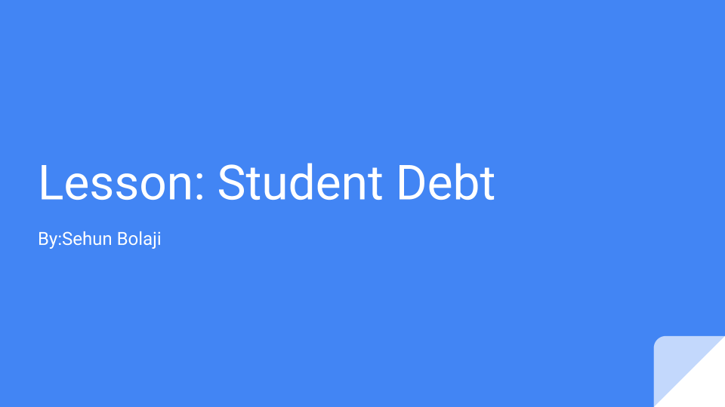

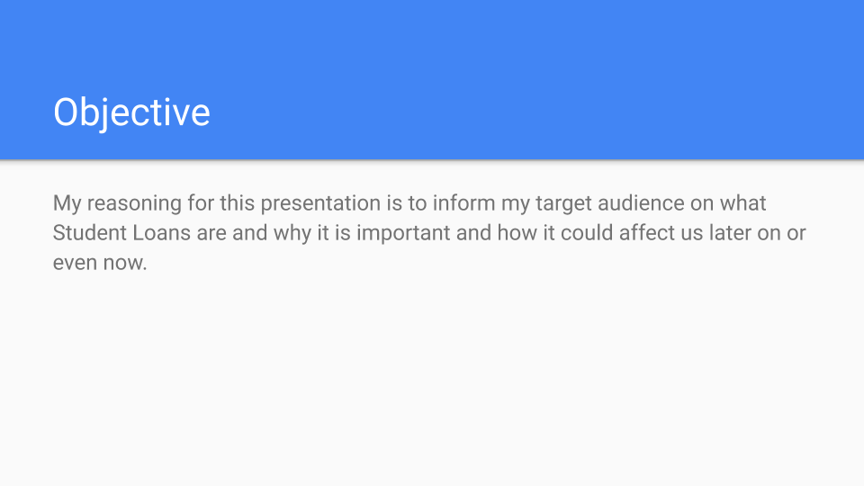

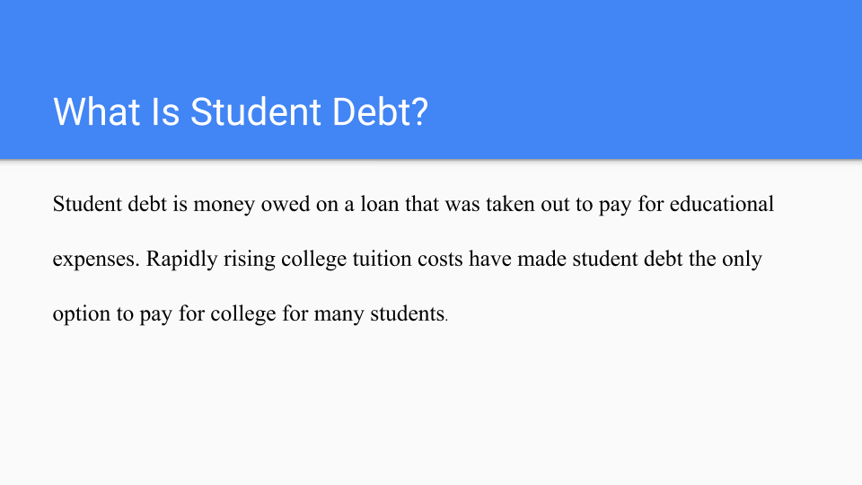

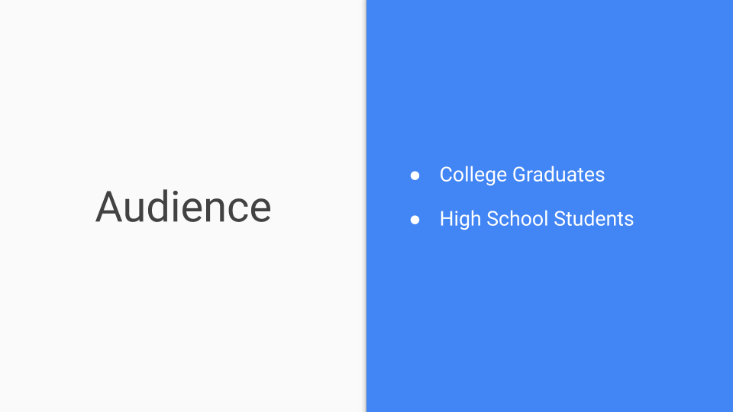

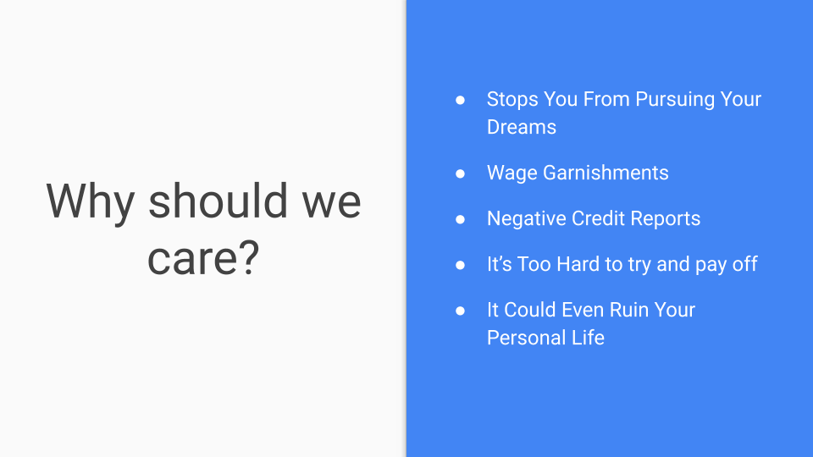

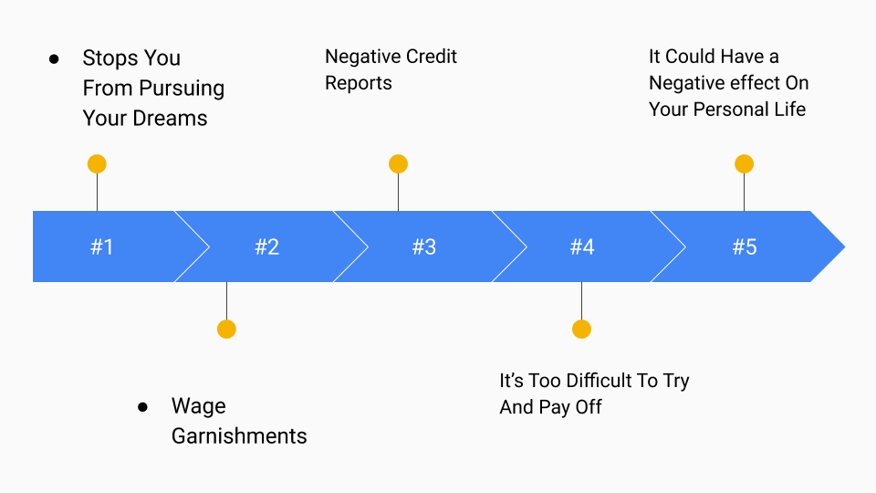

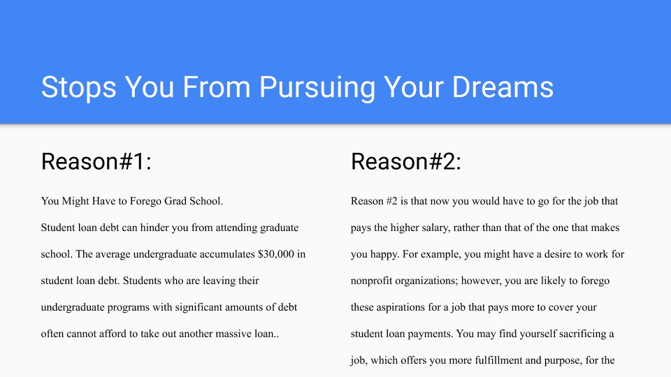

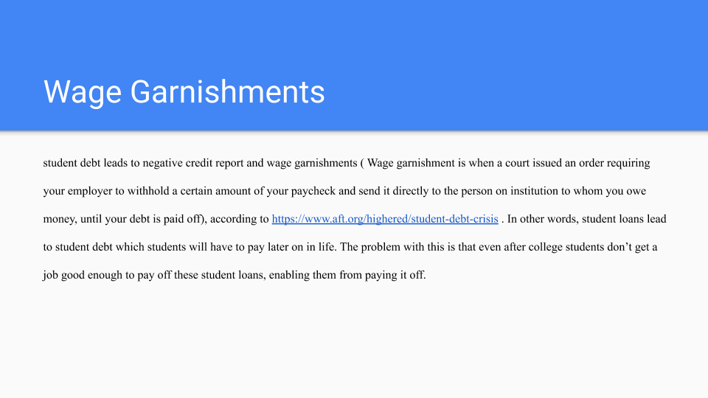

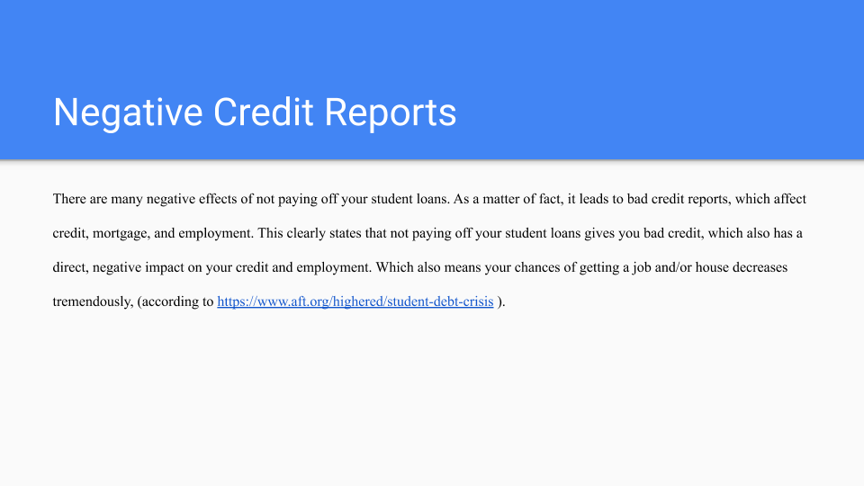

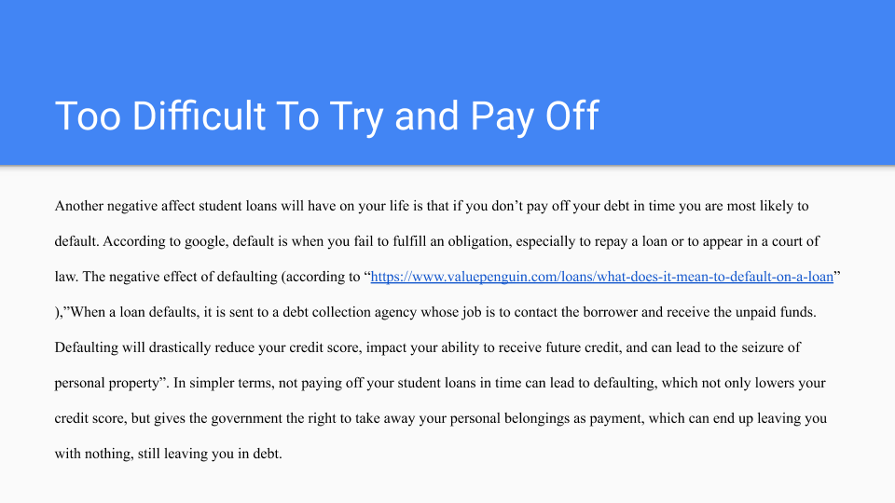

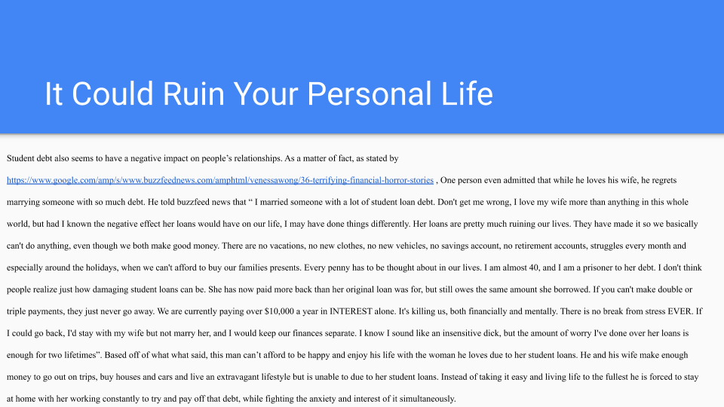

Final Portfolio

My literacy narrative from the beginning of had gradually changed from when I had first started writing due to the fact that the piece I wrote has better vocabulary and grammar than when I had first started writing. Furthermore my mood when writing has changed, I find it more enjoyable and easy to write essays. My annotated bibliographies helped me understand that even though I’m pretty good at writing that research essays are no joke. The research I did took me a long time to find and decipher to meet the criteria. Aside from that nothing much changed when writing this piece. I feel like the research and audience assignment was the one I best revised in my opinion. The reason I think this because I was able to take your comments on my paper and input it into my revision process enabling me to better my essay overall. It also brought about more room for more info and made me closer to meeting the requirements you so desire. One other essay from my final portfolio that I feel had a change. I had more fun time making my presentation even though i was unable to actually present it due to me not being able to make it to class. Overall I could say this English class had better increased my stamina and writing ability and had better my researching ability which could help me in the future classes I will be taking in the future.

