What Is Plaque?
Dental plaque is a sticky, colorless or pale yellow film that is constantly forming on your teeth. When saliva, food and fluids combine, plaque, which contains bacteria, forms between your teeth and along the gum line.

How Can Plaque on Teeth Affect My Oral Health?
Plaque is the primary cause of many oral health issues and diseases. The bacteria in plaque produce acids that attack tooth enamel causing cavities. The bacteria in plaque can also cause the early stage of gum disease called gingivitis and contribute to bad breath.

What happens if plaque is not removed?
If plaque is not regularly removed from your teeth by proper brushing and flossing, it hardens and mineralizes and turns into tartar, a hard, yellow or brown deposit that tightly adheres to the teeth and can only be removed by a dental professional. If tartar is not removed it can allow further bacteria that cause gum disease to adhere to the surface and cause damage to the tissue
Jebun C. Lourys M.
Kenia P. Saja M.

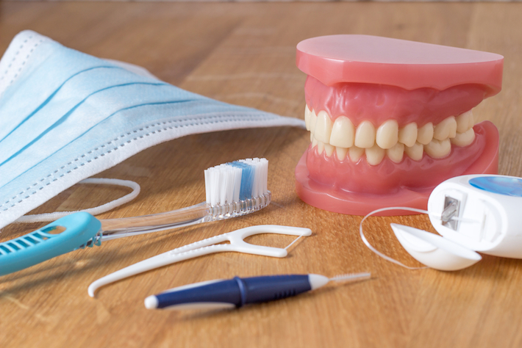

Date of publication
Every oral cavity is different and may require a few modifications when it comes to oral hygiene care. However, it is important to incorporate brushing, flossing, and rinsing into this routine of care. All this should be conducted twice daily, preferably once in the morning and once before bedtime.

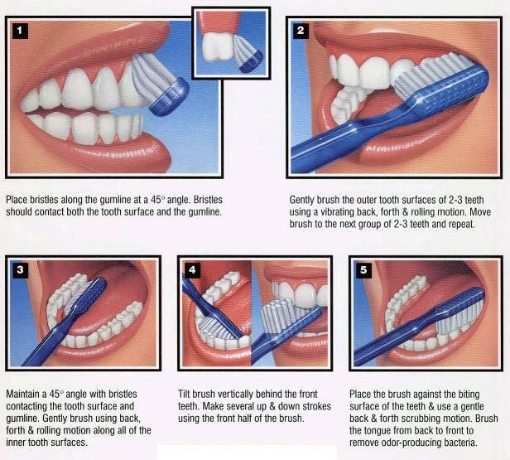

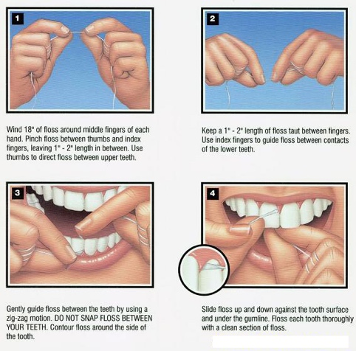

how to customize this brochure
Rinsing
Brushing

Modified Bass method
1.Hold the head of the toothbrush horizontally against your teeth with the bristles part-way on the gums
2. Tilt the brush head to about a 45-degree angle, so the bristles are pointing under the gum line.
3.Move the toothbrush in very short horizontal strokes so the tips of the bristles stay in one place, but the head of the brush waggles back and forth.
4.Do this for about 20 strokes. This assures that adequate time will be spent cleaning away as much plaque as possible.
5.Roll or flick the brush so that the bristles move out from under the gum toward the biting edge of the tooth. This helps move the plaque out from under the gum line.
6.For the insides of your front teeth, hold the brush vertically and use gentle back and forth brushing action and finish with a roll or flick of the brush toward the biting edge.
7. To clean the biting or chewing surfaces of the teeth, hold the brush so the bristles are straight down on the flat surface of the molars(back teeth).
Gently move the brush back and forth or in tiny circles to clean the entire surface.
8.Rinse with water to clear the mouth of food residue and removed plaque.

How to Rinse
- The most common method is to wrap the floss around the middle fingers then and guide it with your index fingers. Hold the floss so that a short segment such as is ready to work with.
- Guide the floss gently between two teeth. If the fit is tight, use a back-and-forth motion to work the floss through the narrow spot. Do not snap the floss in or you could cut your gums.
- Hold the floss around the front and back of one tooth, making it into a "C" shape. This will wrap the floss around the side edge of that tooth.
- Gently move the floss toward the base of the tooth and up into the space between the tooth and gum.

- Move the floss up and down with light to firm pressure to skim off plaque in that area. Do not press so hard that you injure the gum.

- Repeat for all sides of the tooth, including the outermost side of the last tooth.

workING with breaks
Flossing

How to Floss
For Listerine Users:
- Pour 20 mL (4 teaspoons) into a rinse cup.
- Do not dilute the solution with anything. Pour the solution into your mouth without swallowing any.
- Swish the solution around your mouth for 30 seconds. At first, you may not get to 30 seconds but after multiple uses, it will become easier.
- Towards the remaining few seconds, begin to gargle the rinse and then spit it out.
- Do not rinse with water or anything after spitting out.

