Jebunnaher Chowdhury

Benaigu, Cheng

DEN 2315 Pharmacology
Fall, 2018
Part A: Regional Parameters:
It may seem odd to say that anything other than the wide spreading of a disease can be an epidemic, but that has begun to be the case. The struggle with addiction and over dosing of opioid drugs has become an epidemic over the years. According to the Centers for Disease Control and Prevention (CDC), in 2016 alone 63,632 Americans died due to drug overdosing. The rate of addiction has almost tripled in the Southwest region of the United States, but especially in Texas. This is due to Texas being the border state to Mexico, which is the point of entry for all these drugs. Mexico is the number one foreign supplier for marijuana and cocaine into all Southwest states and mainly into Texas. Although cocaine is not made in Mexico, the drug cartels move Colombian cocaine into the US. With new laws in some states loosening their restrictions on marijuana, drug dealers needed to find new ways in which to increase their income, thus leading to more heroin pushing. Heroin has become more widely abused and brought in through Mexico as well.
Due to the Southwest border between the US and Mexico being the largest source of drug trafficking, Texas has many opioid drug addictions. The main drugs of abuse are Heroin, also called diacetylmorphine and cocaine, by the same name, followed by marijuana, known as cannabis. However, on the streets they are known by other names such as dope, smack, junk for heroin, coke, blow, snow for cocaine, and weed, pot, ganga for marijuana. Both heroin and cocaine can be seen as abused in people as young as 12 years old with average death at around 36 years of age and is equal opportunity for all people. What this means is that any one is at risk for developing addiction to these drugs, but those who live in poverty and in the poorest regions of the U.S. are at the most risk due to their economic disadvantage. All of these drugs are illegal if possessed, sold, or trafficked and may be the main cause for this drug epidemic solely based on their addiction capabilities. Heroin is a schedule I drug which means there is no approved medical use and has a high potential for abuse and cocaine is a schedule II drug which means there is a high potential for abuse leading to severe psychological or physical dependence.
The human body has natural opioid receptors and chemical messengers which heroin and cocaine can bind to thus making it highly addictive to its users. Heroin can be smoked or snorted, but is mainly injected. It then enters the brain rapidly and binds to opioid receptors on cells located in several areas but especially those involved in feelings of pain and pleasure and in controlling heart rate, sleeping, and breathing. Through long term abuse a tolerance can be developed but the side effects are dry mouth, warm flushing of the skin, heavy feeling in the arms and legs, nausea and vomiting, severe itching, and clouded mental functioning. As for cocaine, it can be rubbed onto the users gingiva, injected into the bloodstream, but is mainly snorted. Once snorted, cocaine increases levels of the natural chemical messenger Dopamine in brain circuits that are related to the control of movement and rewarding. The side effects of cocaine include constricted blood vessels, dilated pupils, nausea, raised body temperature and blood pressure, fast or irregular heartbeat, tremors and muscle twitches, and restlessness.
Even with the high potential for abuse through mimicking some of the body’s natural chemicals and receptors and the side effects of these drugs, the opioid abuse has still risen in Texas and Nationally as well. Surveys taken in Texas reveal that abuse of heroin has increased dramatically over the years, mostly due to sharing a border with Mexico and middle school users has increased to 3.3 % from 2.1% in just 2009. Nationally, the number of abusers has increased by almost 270% within the past few years. Along with abuse, drug overdose deaths have increased as well. The CDC reports that the rate of drug overdose deaths involving opioids in the country increased from 2.1 per 100,000 people in 1999 to 8.8 per 100,000 people in 2014. Although abuse of heroin and cocaine have increased in Texas in the years that have passed, it seems as though the rate of overdose deaths did not increase as widely. It went from 1.5 to 4.2 per 100,000 people within the span of 15 years while compared to other states, such as West Virginia, the overdose death rate is 10.1 deaths per 100,000 people.
With this epidemic becoming more and more of a crisis, it called for much needed oversight in the state. Texas, along with most other states, has begun to implement an electronic database that was used to collect and monitor prescription data for all Schedule II, III, IV, and V controlled substances dispensed by a pharmacy in Texas or to a Texas resident from a pharmacy located in another state. Beginning September 1, 2019, it will be required by all pharmacists and prescribers to check a patient's prescription history on the Texas Prescription Monitoring Program (PMP) before dispensing or prescribing opioids, benzodiazepines, barbiturates, or carisoprodols. Checking the patient’s PMP will aid in eliminating duplicate prescriptions, overprescribing of controlled substances and obtaining controlled substances history. Along with that, the Texas State Board of Pharmacy has issued new official prescription forms that contain advanced security features to avoid fraud. For example, a control number is written on each script which is reported on record when a schedule II drug is being dispensed and there is a pantograph that prints out the word void when and if someone is trying to duplicate the script. A thermochromic ink is used on the script in the form of a red symbol of Rx, which when heat is applied this red Rx will disappear briefly then reappear and the seal of the State of Texas is watermarked on the script as well.
Monitoring drugs was not the only response Texas made towards fighting this epidemic. More medical community response was needed as well. The Texas Targeted Opioid Response (TTOR) was established to provide services in treating, preventing and supporting people who are at risk or struggling with opioid use disorders and overdosing. In addition to that, people are becoming more educated on opioid overdose through community outreach programs and training on the subject. Effective September 1, 2015, Texas joined The Enactment of Senate Bill 1462. As a result, the access to emergency medical care for drug overdose has increased. Naloxon (An anti overdose drug) was issued to pharmacies and professional practices that were authorized under the law, to be distributed for medical purposes, such as someone who has an abuse issue or a family member who does. That makes the drug more accessible for people who need it, thus helps prevent drug overdose deaths and saving lives. The drug abuse epidemic is increasing worldwide and receives a significant amount of media coverage for it. This media coverage helps inform all others in the same state and others as well, exactly what is going on, what the drugs are leading to and that death is a very real possibility to abusers. Informing the greater public can help in reducing abuse and overdoses as well through enabling people to be more knowledgable as to what is going on in the world around them. The overdosing and addiction are increasing drastically and so are the methods in which to treat or prevent them but the overall goal should be to focus on decreasing these numbers worldwide.
Part B: Impact Story
The drug abuse crisis has hit home for thousands of people, especially Heather who lives in Dallas, Texas. She reigns from a family of addition to Heroin and alcohol. Heathers boyfriend, mother, father, grandfather, step dads father, are all addicts of which the later 3 have died due to their addiction. Heather has abused alcohol and marijuana for many years, but her true addiction started around when she was 28 years old to crystal Meth. It began with the death of her first child, then losing custody of her second child and was pregnant with a third and still addicted to Meth. Through continuously losing her children in one way or the other, Heather was pushed to finally go into rehab. Along with her, her boyfriend James entered rehab too. She was able to graduate the program, get a job, buy a house, and gets to see her daughter every weekend.
Coming from a family filled with addiction, Heather needed to get clean for her children’s sake in order to break the chain of drug abuse. The entire family was plagued with drugs, addiction, and unfortunate death. Being that Heathers parents and grandfather were all addicts and died from overdose, it was inevitable for Heather to develop an addiction as well. Reading about Heather, her family, and her getting clean made me connect to her story deeply. Reading about statistics in a certain region or state is one thing, but reading about people who have and are actually living through addiction hits the heart. The struggles she faced and even continuing to face with her battle of addiction were extremely difficult, especially losing your children. But these children were who helped her become clean so that she can prevent them from leading the path she has led. Along with that, living in Texas more than likely impacted this entire family. Texas has a high rate of addiction mainly due to being the entry port of many drugs from Mexico thus making it easily accessible for people to get drugs. Having a family addicted to drugs and having easy access to any drugs all added up to enabling Heathers addiction further. Drug abuse and addiction is happening all around us, whether it hits home directly or not. It has become of extreme importance to prevent future addictions and overdosing and to help those, like Heather, in need now.
Link to Heather’s Story:http://www.kut.org/post/how-one-family-trying-break-cycle-substance-abuse
Part C:
Being a Dental Hygienist in a region where drug abuse is very common, it becomes extremely necessary to educate yourself on the different drugs out there, the side effects, and intraoral lesion markers. It all begins with medical history. Understanding your patient’s medical history means fully grasping what the patient had, has, is taking and understanding their body as a whole. There fore it is crucial that the patient accurately fills out the form to avoid life threatening situations, but that is not always the case. Some patients lie when it comes to reporting their drug addiction, which can greatly impact the patient’s treatment. These patients may solely be visiting the office in order to obtain prescriptions to feed their addiction. However, they may the ones in most need of dental care and hygiene. Addicts usually have poor eating habits and poor hygiene care because their main concern is obtaining drugs for the next high.
Not only might they lie on their history form but their means of communication can be altered as well due to them most likely having taken the drug before the appointment. The drugs produce the feeling of euphoria and even sedation thus making it difficult to effectively communicate with the patient or the patient with the clinician. With improper medical history and inadequate communication, treatment planning becomes difficult. Patients can experience adverse effects from taking these drugs, such as hypotension, respiratory depression, and even nausea, which can impact clinical care. This can lead to a life threatening situation and affect the method of treating as well as the outcomes from treatment.
Thus self educating one’s self on regional drugs and abuse is important for all dental hygienists. Understanding the drugs, their effects, and adverse effects can possibly save a person’s life while they obtain a needed hygiene appointment. By educating yourself, you can pass on that information to the patient and explain the dangers of this continuing addiction. Being able to identify intraoral lesions that can be produced by the constant abuse of these drugs can help prevent further medical complications, such as identifying lesions that can become cancerous. In addition to that, identifying these intraoral markers can lead to knowing a patient has an addiction problem since they may tend to lie on their medical history as mentioned before.
This drug abuse epidemic is a serious issue where more and more people are becoming addicts so remaining up to date on abuse trends is crucial for proper patient care and treatment.

References
1. AAC Facility. “Texas Heroin Addiction Treatment, Rates and Statistics.” Greenhouse Treatment Center, www.greenhousetreatment.com/texas-treatment/heroin/.
2. Alcohol and Drug Foundation. “ADF - Drug Facts - Heroin.” ADF - Alcohol & Drug Foundation, 2018, adf.org.au/drug-facts/heroin/.
3. Alcohol and Drug Information Service. “What Is Heroin? .” Drug and Alcohol Services South Australia,www.sahealth.sa.gov.au/wps/wcm/connect/ca4209804f50b879ad87ed330cda8a00/What+is+heroin+%2800504%29+2017.pdf?MOD=AJPERES&CACHEID=ROOTWORKSPACE-ca4209804f50b879ad87ed330cda8a00-meDa0TW.
4. CDC. “CDC Newsroom.” Centers for Disease Control and Prevention, Centers for Disease Control and Prevention, 29 Mar. 2018, www.cdc.gov/media/releases/2018/p0329-drug-overdose-deaths.html.
5. CPPP. “Measuring and Responding to the Texas Opioid Crisis.” CPPP, 2017, bettertexasblog.org/2017/11/measuring-and-responding-to-the-texas-opioid-crisis/.
6. Davis, Corey. “FACT SHEET: TEXAS OVERDOSE PREVENTION LEGISLATION.” The Network for Public Health Law, sites.utexas.edu/ naloxone/files/2017/05/T exas-Naloxone- NPHL.pdf.
7. DEA. “Drug Scheduling.” DEA, www.dea.gov/drug-scheduling.
8. Desert Hope. “Arizona.” Desert Hope, 2015, deserthopetreatment.com/southwest- treatment-guide/arizona.
9. Doolittle, David. “Texas Medicine Today.” Texmed, 2018, www.texmed.org/TexasMedicineDetail.aspx?id=48385%5C.
10. Drug Abuse. “Drug Trafficking Across Borders.” DrugAbuse.com, 2012,
drugabuse.com/featured/drug-trafficking-across-borders/.
11. Feehery, Matt. “The Opioid Crisis and Its Effect on Texas.” Capitol Texas Gov, capitol. texas.gov/tlodocs/85R/handouts/C2102017082210001/cc0a3434-293c-4456-b103-77d96efdd7f9.PDF.
12. Stelter, Ann. “Five Fast Facts about the Opioid Crisis in Texas.” TEXAS HEALTH INSTITUTE, 2018, www.texashealthinstitute.org /blog/five-fast-facts -about-the-opioid- crisis-in-texas.
13. Taft, Isabelle. “Anti-Overdose Drug Becoming Easily Available.” The Texas Tribune, Texas Tribune, 21 June 2016, www.texastribune.org/2016/06/21/anti-overdose-drug-becomes- available- texas/.
14. Texas Board of Pharmacy. “Texas Prescription Monitoring Program.” Texas PMP, www.pharmacy.texas.gov/PMP/.
15. “Texas Heroin Laws.” Findlaw, State Laws, 2018, statelaws.findlaw.com/texas -law/texas-heroin-laws.html.
16. Tgarcia, Texas HHS. “Texas Targeted Opioid Response.” Texas Health and Human Services, 19 Apr. 2018, hhs.texas.gov/services/mental-health-substance-use/adult-substance-use/texas-targeted-opioid-response.
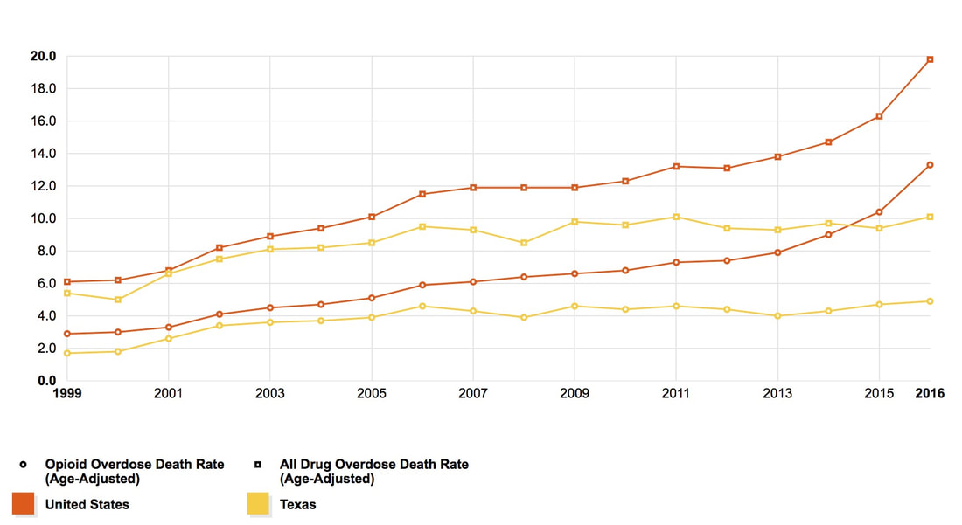

Drug | Generic Name | Brand name | Street Name
Heroin (Primary) | diacetylmorphine | Heroin | Dope, Smack, Junk
Cocaine (Secondary) | Cocaine | Cocaine | Coke, Blow, Snow, Yeyo
Marijuana (Other) | Cannabis | Marijuana | Pot, Weed, Ganga, Dope, Blunt, Joint, Mary Jane

Drug | Legal status | Schedule
Heroin | Illegal | Schedule I: no approved medical use and high potential for abuse
Cocaine | Illegal | Schedule II: high potential for abuse leading to severe psychological or physical dependence
Marijuana | Illegal | Schedule I: no approved medical use and high potential for abuse

