**Nicotine Stomatitis**  
By Jebunnaher Chowdhury  
Oral Pathology 2018  
Section: Thursday AM

**Overview**  
Nicotine Stomatitis, also known as Nicotinic Stomatitis or Smoker’s Keratosis, is a lesion located on the palatal mucosa of the oral cavity, both the hard and soft palate. It is when the mucosa becomes thickened and can appear white due to the layer or keratin on it, known as hyperkeratosis. In addition to the white bordering of these lesions, a red papule can appear in the center of the lesion. These small popular elevations in the center are openings of inflamed salivary gland ducts. In other words, multiple small white, hardened lesions with red, elevated centers develop on the hard palate and can extend to the soft palate as well. These lesions are usually asymptomatic and can go unnoticed by the patient.

**Etiology**  
A common mistake for the underlying cause of Nicotine Stomatitis is that it is due to the nicotine and other chemicals in tobacco. However, these lesions are caused by heat on the palatal mucosa mainly from reverse, cigar and pipe smoking. This is less common in cigarette smokers, but it can develop from heavy, extensive smoking of any kind. Intense heat from smoking for a long period of time will cause changes in the oral cavity especially on the palatal mucosa. These lesions are typically localized to the hard palate due to the heat from smoking being directed towards this area. The concentrated heat stream from tobacco smoking causes the mucosa to change and become keratinized as well as causing the minor salivary glands on the palate to become inflamed. What this means is that the chemicals in tobacco combined with the heat given off of it are local irritants that stimulate inflammation and epithelial keratinization on the hard palate.

**Clinical Presentation**  
Nicotine Stomatitis presents with lesions that are exclusively localized on the hard palate, and rarely extend to the soft palate. Objectively, for the Dentist or Dental Hygienist, these lesions are distinct and easily detectable. The mucosa is thickened and appears white and fissured due to this. Inside the white border is a red center, which is elevated, inflamed minor salivary glands. In other words, there are multiple white circular lesions with a red center along the hard palate that may or may not cause pain. Along with this appearance, the hard palate can feel leathery due to hyperkeratosis. However, subjectively, or from the view of the patient, these lesions may not be as apparent. Due to Nicotine Stomatitis not being accompanied with pain, it can go unnoticed. It is not until there is pain or slight irritation to the patient that these lesions become subjectively known. On the other hand, some patients will notice these lesions, have no pain or irritation, and report no changes over the years. For the most part, Nicotine Stomatitis is diagnosed clinically at a dental office setting with the patient having no prior knowledge of it.

**Demographic**  
With the decline of pipe and cigar smoking, Nicotine Stomatitis has become more uncommon. Although it is not rare, these lesions are not seen as often as before, but can be seen in patients who smoke extensively for a long period of time. When these lesions are present on the hard palate, it is usually amongst middle aged or older adults, however it can appear in younger people if they have had long term exposure to the heat from tobacco smoking. A patient can develop this according to duration, intensity, and the type of smoking. For example, there was a patient who is 31 years old that presented with Nicotine Stomatitis due to smoking 10 cigarettes a day for 16 years. In addition to that, men are more likely than women to develop these lesions due to less women smoking pipes. There is no specific race having more predilection. Nicotine Stomatitis is more common among middle aged men anywhere around the world.

**Biopsy / Histology / Radiographs**  
When patients present with Nicotine Stomatitis there is rarely any pain involved form the lesions. Due to this it can go unnoticed by the patient but not by a clinician or Dentist, thus making the diagnosis clinical. However, if there is pain, irritation, or concern by either the patient or clinician then a biopsy is needed. When doing so a scalpel or a 5mm punch biopsy is performed.  A scalpel biopsy is when a small portion of the lesion is removed and a punch biopsy is when a thickened portion of the skin is removed in a punch size and both are used for histopathologic evaluation. Upon viewing the biopsy, histological features are hyperkeratotic tissue and mild inflammation. Along with that there is acanthosis of the palatal mucosa and squamous metaplasia from the minor salivary gland ducts.

**Differential Diagnosis**  
Nicotine Stomatitis is characterized as white, thickened lesions with red, elevated centers and can be diagnosed as so through clinical means as well as a history of smoking. However, these lesions can be misdiagnosed at times. Differential diagnoses of Nicotine Stomatitis include Mucosal Candidiasis, Oral Leukoplakia, irritation from dental appliances, trauma from hot liquids, and even Oral Cancers. Although it is more likely to be an accurately diagnosis, these lesions can be said to be other conditions due to its clinical appearance resembling others.

**Treatment**  
Lesions of any kind in the oral cavity are of concern and should be addressed appropriately. In the case of Nicotine Stomatitis these lesions are not painful and are not of much concern but nonetheless should be treated to prevent further complications. The one treatment that is most effective is smoking cessation. With quitting smoking of any kind, there is no longer a chronic exposure to heat on the hard palate causing it to be irritated. No more irritation will prevent the palatal mucosa from becoming further keratinized. Now the mucosa can heal and return to the way in which it was previously. Tobacco products are dangerous and through stopping it will enable the palatal mucosa to heal and the lesions will go away. The patient should be educated on tobacco dangers as well as ways in which to quit. There are patches, gums, and even medications to aid in smoking cessation to treat nicotine stomatitis.

**Prognosis**  
The lesions from Nicotine Stomatitis are reversible being that it is caused from a frequent irritant. Once that irritant is removed, the lesions should go away. In majority cases, nicotine stomatitis does not lead to any further complications or cancers but for reverse smokers it is a possibility, thus it is of extreme importance smoking is ceased. Once the patient has stopped smoking and no longer irritating the palatal mucosa with constant heat, the prognosis of these lesions are great. If smoking is not stopped, meaning no treatment is done for nicotine stomatitis, these lesions will not heal and will remain on the palate. If heavy smoking is still continued, these lesions can possibly lead to the patient being at a higher risk for malignancies of the oral cavity. Smoking cessation is extremely important for more than one reason.

**Professional Relevance**  
The role of a Dental Hygienist is to be able to identify and properly diagnosis this condition and to review the patients history of tobacco use in any form. Being that one of the differential diagnosis can be cancerous and these lesions can potentially lead to malignancies, this condition must be accurately diagnosed with any other possibilities being ruled out. In other words, understanding this condition and its underlying cause is important to ensure there is no misdiagnosis for the patient. Once it is diagnosed, the Hygienists must know educate the patient on what exactly these lesions are, the dangers associated with excessive tobacco smoking, and methods of smoking cessation. As a Hygienist, our job is to educate and prevent any further complications from occurring. If done accurately, both the Hygienist and patient can now prevent any risk for malignancies in the future.

**Images**

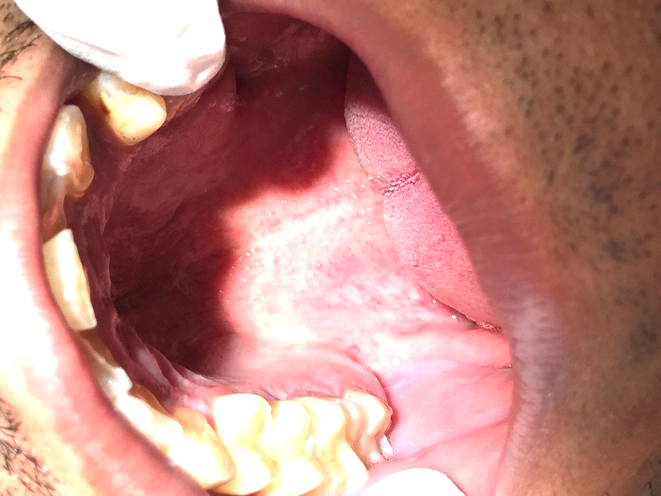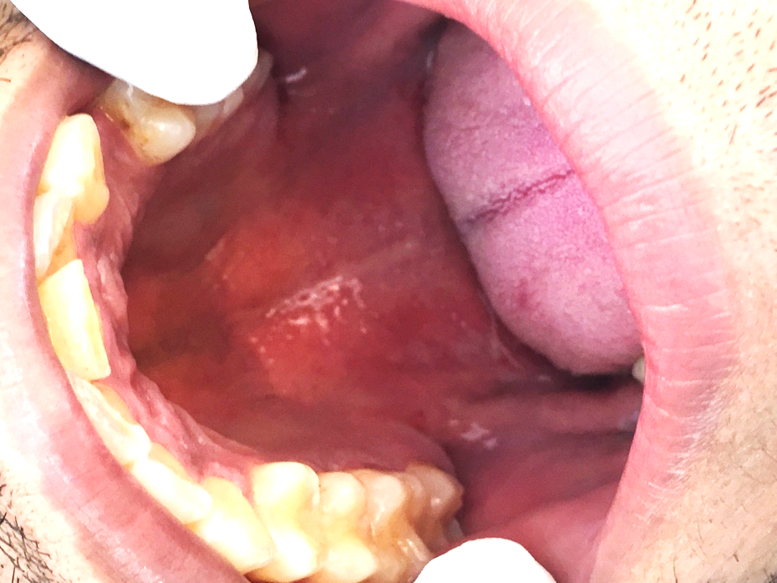

**Citations**  
1. Cade, James. “Nicotine Stomatitis.” *Sickle Cell Anemia Differential Diagnoses*, 10 Aug. 2018, emedicine.medscape.com/article/1076183-overview#a2.

2. Ramulu, C., et al. “Nicotine Stomatitis and Its Relation to Carcinoma of the Hard Palate in Reverse Smokers of Chuttas.” *Journal of Dental Research*, vol. 52, no. 4, July 1973, pp. 711–718, doi:[10.1177/00220345730520041201](https://doi.org/10.1177/00220345730520041201).

3. Reddy, C.R.R.M. “HISTOPATHOLOGICAL STUDY OF STOMATITIS NICOTINA.” *NCBI*, [www.ncbi.nlm.nih.gov/pmc/articles/PMC2008759/pdf/brjcancer00360-0029.pdf](http://www.ncbi.nlm.nih.gov/pmc/articles/PMC2008759/pdf/brjcancer00360-0029.pdf).

4. Rizzolo, Denise, et al. “Lesion on the Hard Palate.” *Journal of Family Practice*, vol. 57, no. 1, Jan. 2008, pp. 33–35. *EBSCOhost*, citytech.ezproxy.cuny.edu:2048/login?url=http://search.ebscohost.com/login.aspx?direct=true&db=a9h&AN=28387740&site=ehost-live&scope=site.

5. Scully, Crispian. “Stomatitis Nicotina.” *NeuroImage*, Academic Press, 2013, www.sciencedirect.com/topics/medicine-and-dentistry/stomatitis-nicotina.