Jose G Chiriboga Alcivar Prof. Viviana Vladutescu
12-06-13
TCET 2220

Load-Pull Systems and their Applications

In the journal paper by M. H. Hashmi and F. M. Ghannouchi, explain the “Introduction to Load-Pull Systems and their applications”. This article was published in the IEEE Instrumentation and Measurement Magazine. This article is suitable to the course level in the TCET 2220 where it helps to understand the Smith Chart methods and also, it presents applications of Load-Pull systems that are use in elements of transmission lines.

We use a load-pull system anywhere on a transmission line in the non-linear domain. Especially, when we need to estimate and optimize device performance. Note: we can use it in a transistor to check its performance and its conditions that can deliver to the transmission system. As we know impedance can varies at any point of the transmission lines. The load-pull system helps transmission lines keep the system balance by varying impedance. A load-pull system includes an active and passive impedance tuner.

The main difference between active and passive load pull systems are passive technique has rapid impedance synthesis than active technique. Since passive technique has high power handling capability, it measures high power devices without any non-linear effect. For a Passive technique has relatively low impedance cost and there is no oscillation. Passive load pull systems the maintenance cost is lower than an active load pull system. Active technique can synthesize reflection coefficients near and on the boundary of the smith chart whereas it is impossible for passive technique to synthesize appropriate matching impedance.
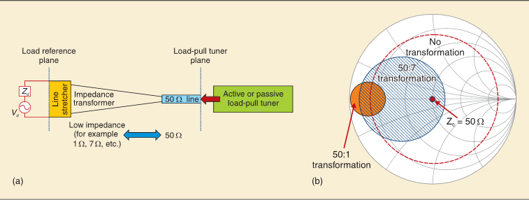Fig.4. Conceptual representation of broadband impedance transformer based load-pull setup (© IEEE 2010, IEEE Microwave Mag., used with permission, [5]).

Active load-pull technique can be categorized as open-loop systems and closed-loop systems. The output of DUT (transmitted traveling wave) is an open-loop active load-pull setup that requires custom algorithms to synthesize desired reflection coefficients. In close-loop active load-pull technique there is no requirements of any convergence algorithm. The main disadvantage of the close-loop setup is the risk of oscillations; it can happen as a result of using the close-loop structure.

The most popular passive load-pull technique is the Pre-matched load-pull. However, for some application that requires impedance less than 1 Ω the pre-matching technique is limited.

Hybrid LP is the combination of a passive impedance tuner and active load pull. Hybrid LP is designed to achieve the desired load-pull functionality. Since Hybrid load-pull is a combination of both active and passive load-pull we can say that it satisfies all the measurement needs. Both of the transformers reduce smith chart coverage. $λ/4$ Impedance transformers move the matched impedance environment from $50Ω$ to some other smaller value. The $λ/4$ impedance-transforming network with bandwidth of only about 5 to 10 percent of the carrier frequency prevents harmonic load-pull application, whereas this limitation can be overcome by replacing Klopfenstein transformer. One of the latest developments in load pull configurations is called the enhanced loop passive load-pull technique. It consists of an impedance tuner and passive loop cascaded together. Another latest development in load-pull configurations presented in this paper is envelope load-pull.
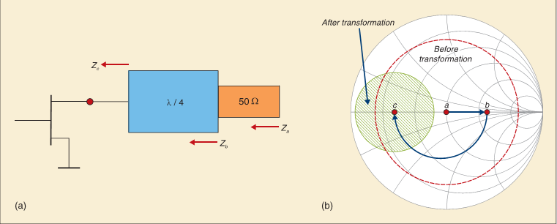
Fig.3. Pictorial representation of the quarter wave transformation technique (© IEEE 2011, IEEE Microwave Mag., used with permission, [5]).

We can conclude that Load pull analysis is used to construct of a Smith Chart, it determine the maximum power output achievable with a given load impedance. These contours are very useful in assessing the actual impedance a device should see when it is used in an amplifier. It subsequently reviewed the most common load-pull techniques along with their advantages and limitations. The article discussed two of the latest developments in load-pull configurations that have either brought or have the potential to bring a paradigm shift in PA design techniques.

